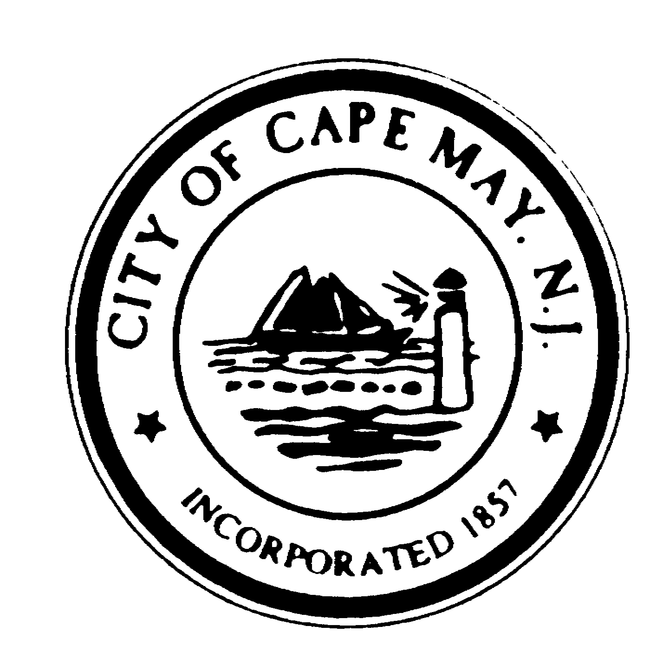City of Cape May Planning Board
CLARENCE F. LEAR, III
Mayor
SHAINE P. MEIER
Deputy Mayor, Councilmember
BEATRICE GAUVRY-PASSAGNO
Councilmember
ROGER M. FURLIN
Councilmember
PATRICIA G. HENDRICKS
Councilmember

NEIL YOUNG

Interim City Manager
PATRICIA HARBORA
Deputy City Clerk

City of Cape May

National Historic Landmark
City Hall – 643 Washington Street
Cape May, New Jersey 08204-2397
(609) 884-9525 * Fax: (609) 884-8589
www.capemaycity.org

Meeting Agenda
Tuesday, February 28, 2017, 6:30 PM
REVISED

Opening: In compliance with the Open Public Meetings Act of 1975, adequate notice of this meeting has been provided. If any member has reason to believe this meeting is being held in violation of this act, they should state so at this time.

Pledge to Allegiance:

Roll Call:

Minutes: January 10, 2017

Resolutions: 0-28-2017:1
Palavest, LLC
"Icona Cape May" Hotel - Signage & Pool/Additions
1101 Beach Avenue
Block 1115, Lot(s) 1, 2, 3, 32, 33

02-28-2017: 2
Gertrude Woehcke Trust c/o Richard Woehlcke, Trustee
1235-1239 Lafayette Street
Block 1061, Lot(s) 92, 93

Applications:

Discussion: 12-08-2016:3 2015 Zoning Board of Adjustment Report

02-23-2017: 5 2016 Zoning Board of Adjustment Report

Any and all matters deemed necessary by the Board, with possible action taken.

Adjournment:

Erin Burke
Board Assistant

All applications and decisions of the Board are on file in the Construction/Zoning Office of City Hall.

