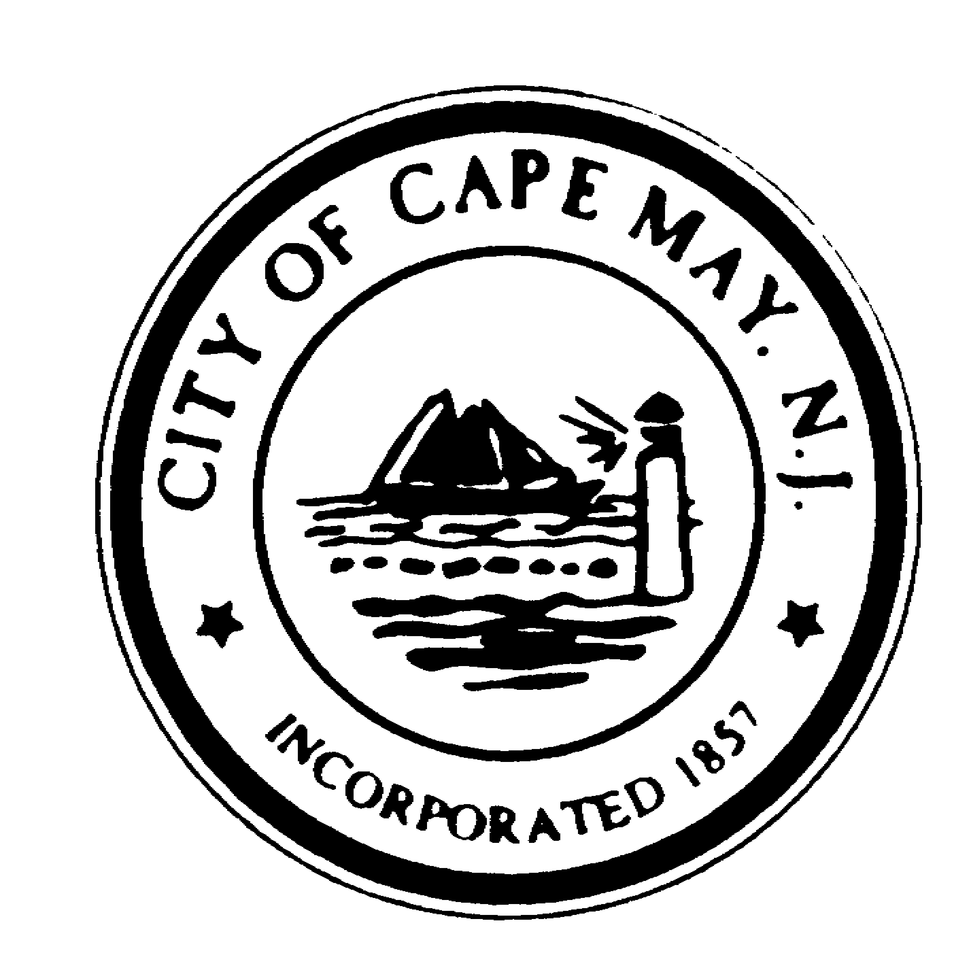+
DR. EDWARD J. MAHANEY, JR.
Mayor
WILLIAM H. MURRAY
Deputy Mayor
TERRI L. SWAIN
Councilmember
JACK WICHTERMAN
Councilmember
DEANNA FIOCCA
Councilmember
TERRI L. SWAIN
Councilmember

BRUCE MacLEOD
City Manager

LOUISE CUMMISKEY
City Clerk

City of Cape May

National Historic Landmark
City Hall – 643 Washington Street
Cape May, New Jersey 08204-2397
(609) 884-9525 * Fax: (609) 884-8589
www.capemaycity.org

City of Cape May Historic Preservation Commission
Meeting Agenda

Monday, January 28, 2013 - 6:30 PM

Opening: In compliance with the Open Public Meetings Act of 1975, adequate notice of this meeting has been provided. If any member has reason to believe that this meeting is being held in violation of this Act they should state so at this time.

Pledge of Allegiance

Roll Call

Minutes: December 10, 2012

Resolutions:

Appointment of Robert A. Fineberg, Esquire – Resolution #2013-01
Mentzel, 340 Congress Street, 1026/9, Not in Survey/Not Rated/HD, Resolution #2013-02
Sapp (Marmster LLC), 621 Columbia Ave, 1057/19, Not in Survey/Not Rated/HD, Resolution #2013-03

Applications approved in Review:

Kennedy, 913 Beach Avenue, 1081/21, Contributing/HD, Railings/Columns replacement
Kejzman Hospitality LLC (Victorian Hotel),223 Congress Place, 1029/6, NIS-NR/HD, Roof
Camelot Motel, 103 Howard Street, 1067/1, NIS-NR/HD, Steel Columns replacements
Columbia Gardens Condo, 933 Columbia Ave, 1090/14.01 NIS-NR/HD, 2nd Floor Decking replacement
Tapia, 118 Decatur Street, 1041/8, Contributing – HD, HVAC Unit

BUSINESS:

BEAUCHAMP…………………………………………………..……..….……….…329 CONGRESS STREET
ADDITION/RENOVATION – BLK 1031 LOT 61 (CONTRIBUTING - HD)

OPEN TO PUBLIC:

DISCUSSION: Matters deemed necessary by the Commission for discussion.

ADJOURNMENT:

