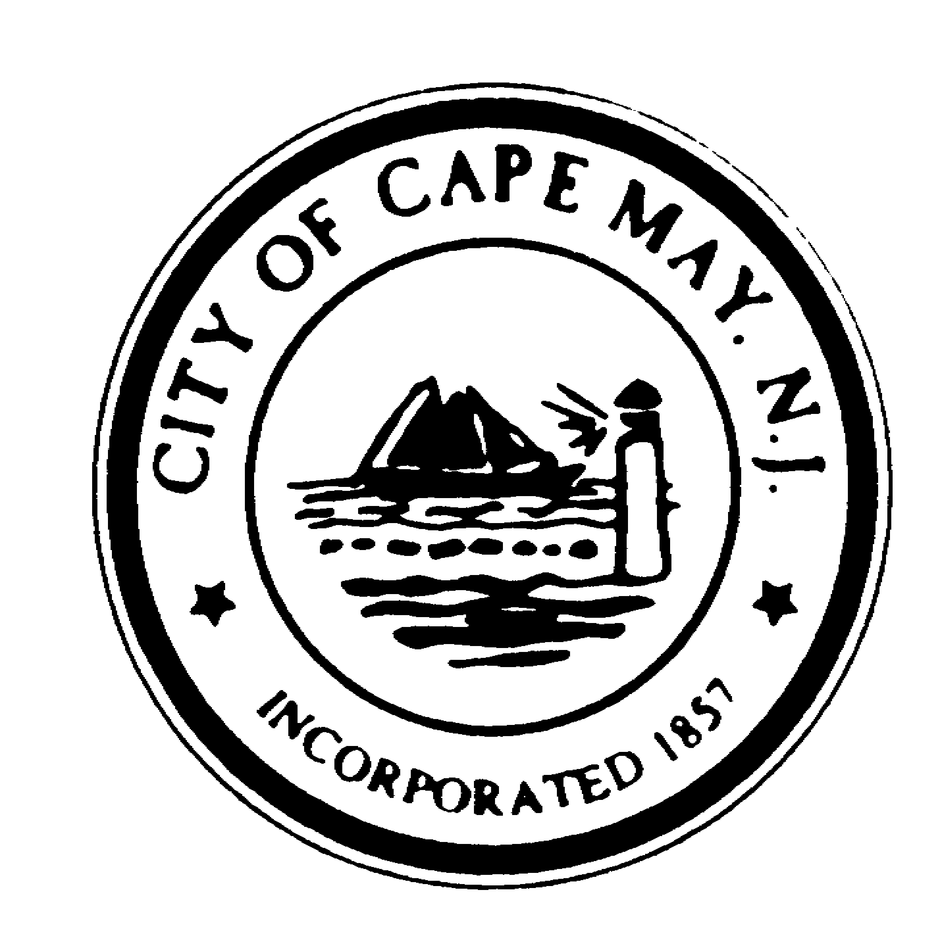
DR. EDWARD J. MAHANEY, JR.
Mayor

WILLIAM H. MURRAY
Deputy Mayor
TERRI L. SWAIN
Councilmember
JACK WICHTERMAN
Councilmember
DEANNA FIOCCA
Councilmember

BRUCE MACLEOD

City Manager

LOUISE CUMMISKEY
City Clerk

City of Cape May

National Historic Landmark
City Hall – 643 Washington Street
Cape May, New Jersey 08204-2397
(609) 884-9525 * Fax: (609) 884-8589
www.capemaycity.org

City of Cape May

Historic Preservation Commission

Notice of Meeting Cancellation

Monday, March 11, 2013

PUBLIC NOTICE is hereby given to all persons that the City of Cape May Historic Preservation Commission meeting scheduled for Monday, March 11, 2013 @ 6:30pm has been cancelled. The next meeting of the Historic Preservation Commission is scheduled for Monday, March 25, 2013 at 6:30 PM in the City of Cape May Auditorium located at 643 Washington Street, Cape May, NJ.

This notice is given in compliance with the Open Public Meetings Act of 1975, with adequate notice of cancellation being provided with said Act.

Edie Kopsitz Secretary, Historic Preservation Commission
March 7, 2013

VIA FACSIMILE – Please publish one time, next available publication

CM STAR & WAVE– cmstarwave@comcast.net

