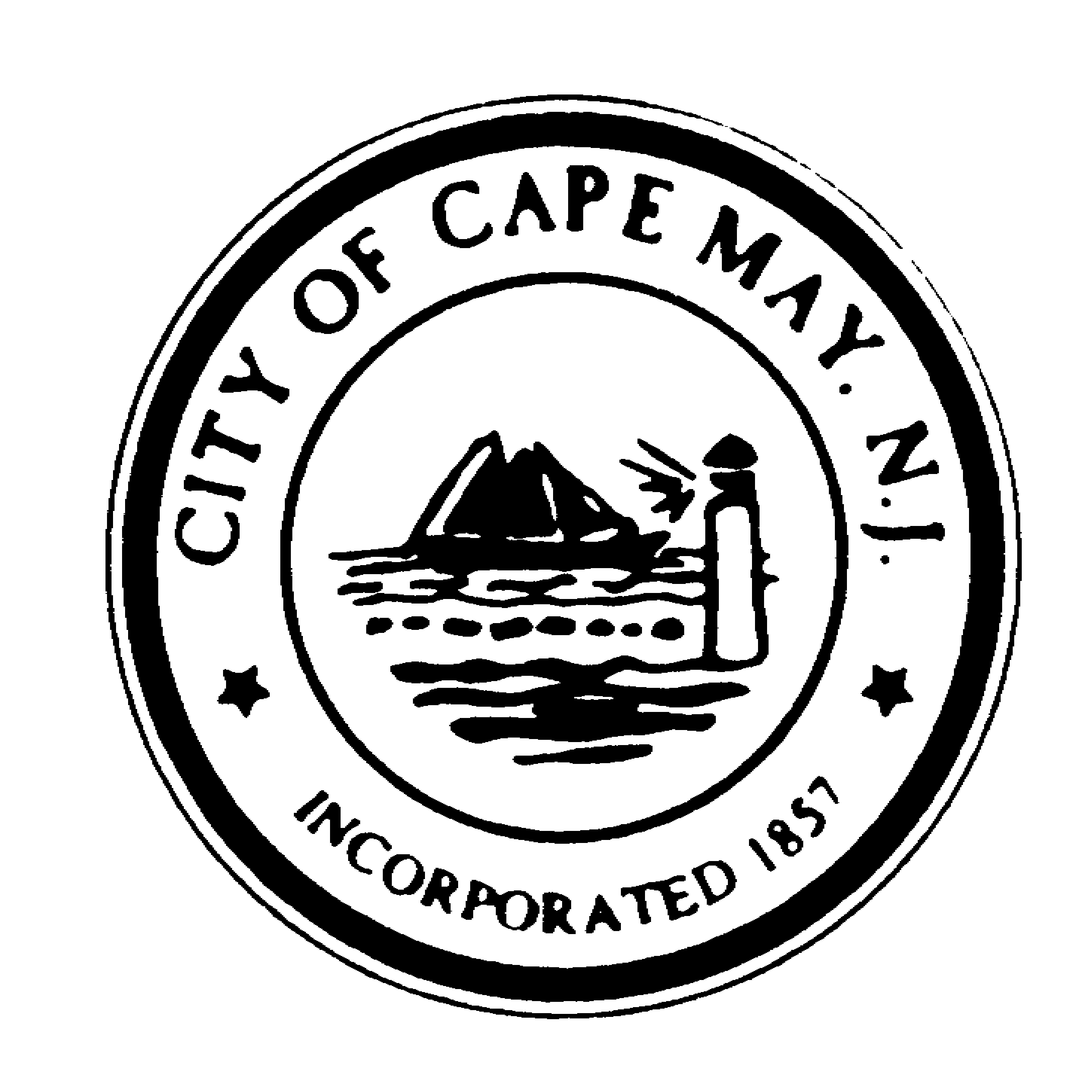+
DR. EDWARD J. MAHANEY, JR.
Mayor
JACK WICHTERMAN
Deputy Mayor
TERRI L. SWAIN
Councilmember
WILLIAM H. MURRAY
Councilmember
DEANNA FIOCCA
Councilmember
TERRI L. SWAIN
Councilmember

DIANE L. WELDON
City Clerk

BRUCE MacLEOD
City Manager

City of Cape May

National Historic Landmark
City Hall – 643 Washington Street
Cape May, New Jersey 08204-2397
(609) 884-9525 * Fax: (609) 884-8589
www.capemaycity.org

City of Cape May Historic Preservation Commission
Meeting Agenda

Monday, November 14, 2011 - 6:30 PM

Opening: In compliance with the Open Public Meetings Act of 1975, adequate notice of this meeting has been provided. If any member has reason to believe that this meeting is being held in violation of this Act they should state so at this time.

Pledge of Allegiance

Roll Call

Minutes: October 24, 2011

Resolutions:

Gilmartin, 1382 Lafayette Street, 1145/6 – Resolution #2011-26
Gibbons, 1325 New York Avenue, 1148/23, Resolution #2011-27
Scott, 264 Grant Street, 1019/8, Resolution #2011-28

Applications approved in Review:

Goodman, 118 Decatur Street, 1041/8, Not in Survey/Not Rated – HD, AC Unit
Ternova, 719-721 Franklin Street, 1080/32, Contributing – HD, AC Unit
Sick, 1103 Cake Street, 1110/23, Not in Survey/Not Rated – HD, Generator
Muscatello, 670 Washington Street, 1058/9, Contributing – HD, Roof
Hague, 817 Washington Street, 1092/23, Contributing – HD, Stone Foundation repair
Zayayzt, 1022 Stockton Street, 1095/7, Contributing – HD, Windows
Leitrim, 607 Jefferson Street, 1090/48, Not in Survey/Not Rated – HD, Sign
Kramer, 733 Columbia Avenue, 1066/10, Contributing – HD, Shed Roof
Tillman, 24 Ocean, 1047/3, Contributing – HD, Sidewalk Repair
Perdunn, 970 Sewell Avenue, 71089/24 Contributing - HD, Porch Repair
Rowan, 212 Congress Street, 1025/4, Contributing – HD, Windows

BUSINESS:

LIVINGSTON………………………………………………….………..……1017 NEW JERSEY AVENUE
ADDITION – BLK 1102 LOT 50 (CONTRIBUTING – HD)

DOUGHERTY…………………………………………………………512 WASHINGTON STREET MALL
ROOF ADDITION – BLK 1050 LOT 2 (NOT IN SURVEY/NOT RATED-HD)

OPEN TO PUBLIC:

DISCUSSION: Matters deemed necessary by the Commission for discussion.

ADJOURNMENT:

