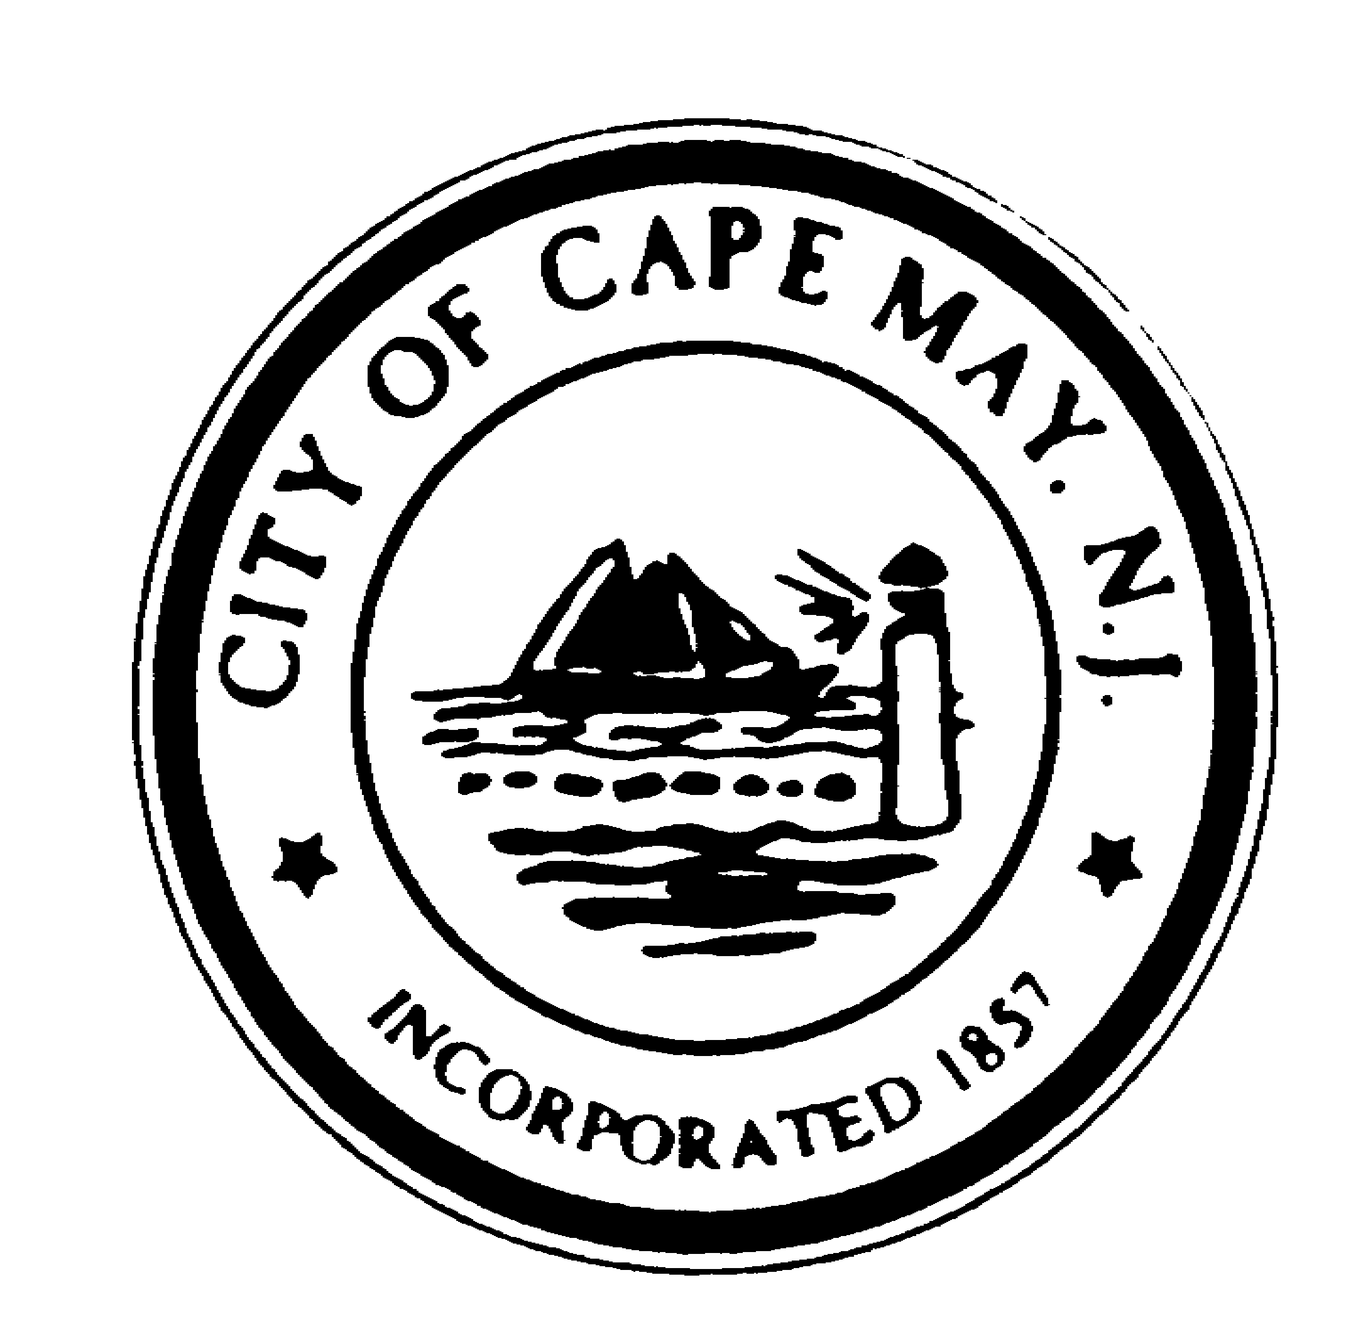+
DR. EDWARD J. MAHANEY, JR.
Mayor
JACK WICHTERMAN
Deputy Mayor
TERRI L. SWAIN
Councilmember
WILLIAM H. MURRAY
Councilmember
DEANNA FIOCCA
Councilmember
TERRI L. SWAIN
Councilmember

DIANE L. WELDON
City Clerk

BRUCE MacLEOD
City Manager

City of Cape May

National Historic Landmark
City Hall – 643 Washington Street
Cape May, New Jersey 08204-2397
(609) 884-9525 * Fax: (609) 884-8589
www.capemaycity.org

City of Cape May Historic Preservation Commission
Meeting Agenda

Monday, November 28, 2011 - 6:30 PM

Opening: In compliance with the Open Public Meetings Act of 1975, adequate notice of this meeting has been provided. If any member has reason to believe that this meeting is being held in violation of this Act they should state so at this time.

Pledge of Allegiance

Roll Call

Resolutions:
Livingston, 1017 New Jersey Avenue, 1102/50, Resolution #2011-29
Daugherty, 512 Washington Street Mall, 1050/2, Resolution #2011-30

Applications approved in Review:
Rowan, 212 Congress Street, 1089/24, Contributing-HD, Windows
Lambie, 110 Howard Street, 1064/40, Not in Survey/ Not Rated-HD, Construction Plans
Perdunn, 971 Sewell Avenue, 1089/24, Contributing-HD, Porch/Deck Repair
Rushlow, 30 Second Avenue, 1012/5, Not in Survey/Not Rated-HD, Windows
Rowan/Walters, 201 Ocean Street, 1058/32, Key – HD, Sign

BUSINESS:

HATCH………………………………………………….……….……..….…1142 WASHINGTON STREET
FENCE – BLK 1110 LOT 28 & 29 (CONTRIBUTING – HD)

BROADWAY BEACH……………………………………………………….…201-2011 BEACH AVENUE
ADDITIONS - BLK 1016 LOT 13 (NOT RATED/NOT IN SURVEY – HD)

LONG.………………………………………….…………………………….…...1012 NEW YORK AVENUE
ROOF – BLK 1102 LOT 6 (CONTRIBUTING – HD)

CAPPELLETTI………………………………………………………….…458-460 WEST PERRY STREET
ADDITIONS – BLK 1031 LOT 1 (NON CONTRIBUTING-HD)

PHILLIPS………………………………………………………………………1421 NEW JERSEY AVENUE ADDITIONS – BLK 1162 LOT 1.08 (NOT IN SURVEY/NOT RATED-HD)

OPEN TO PUBLIC:

DISCUSSION: Matters deemed necessary by the Commission for discussion.

ADJOURNMENT:

