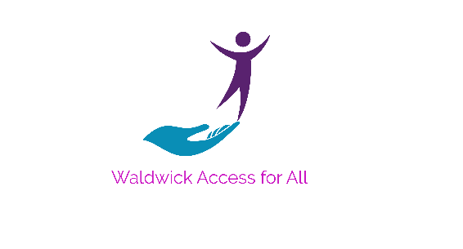
Waldwick Access for All
Meeting Minutes
September 29, 2025

The meeting took place virtually.

In attendance: Committee members: Jim, Angela, MaryBeth, Tommy Lavin, Cristina & Deb. And guest: Councilman, Mark Ramundo.

Meeting discussion in bullet points:

- MB & Angela Discussion about sharing Mahwah’s AFA events calendar on our site.

- Jim Illustrated the wildly uneven platform in the smaller S. Fisher Park.

- Angela Sophmore social media intern is doing good things.

- MB High School Parking lot has been completed. Curb cuts are in place to WAFA satisfaction.
Rest room access adheres to ADA guidelines.

- Jim Work still needed for crosswalk push-buttons.

- Jim Emmett Park. Limited parking. Upgrades something we should pursue?

- Angela Switch Tower area potential….example: picnic area.

- Councilman Ramundo 2.7 acres acquired for redevelopment. Exact address, remiss by yours truly (Deb)
Area is next to Waldwick Gardens Nursery and extends back to Brady.
Green acres concepts for this plot needed by 12/31/25.

Many of the above items require follow ups with our new Borough Administrator, Tatiana Marquis.

Please add to or correct this document and send revisions to Deb for re-distribution with changes.
Deb 12/8/2025

