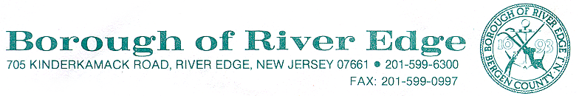

ZONING REVIEW

BLOCK:1413/ LOT:5/ ZONE:C-2

LETTER OF NONCOMPLIANCE

July 2, 2025

55 Kinderkamack Rd.

Paul Imbarrato (Prop. Owner)

52 Ackerman St.

River Edge, NJ 07661 201-206-4681 [@.com](mailto:greenpapayanj@yahoo.com)

Kenneth Norrell

27 Landmark Ln.

Fair Lawn, NJ 07410 551-305-9398 kcb.bagels@gmail.com

Re: Proposed Bagel Shop (Partial use)

Dear Property owner & Tenant

In doing a zoning permit review for the above referenced property we found the following with the information provided:

1. Proposed use is permitted in the C-1 zone.
2. An application is required to be presented to the River Edge Land Use Board for approval as per §350-4E of the Borough Codes for any type of use where a beverage or food handler’s license is required.
3. You will need to obtain Site Plan approval
4. You will need to obtain approval for any changes in signage and will need to submit a proposed sign package, if any changes are proposed from the existing sign, along with your application.
5. Please contact the Borough of River Edge Land Use Clerk at 201-599-6307 for further information on an application and instructions to present to the Borough’s Land Use Board.

Therefore, your application is Denied due to noncompliance of the Borough Codes.

Should you believe that your proposal is in compliance with the Borough Ordinance, you may appeal this decision to the River Edge Land Use Board. Alternatively, if you wish to seek variance relief from the Ordinance requirements, you may submit an application to the River Edge Land Use Board. You have the right to appeal this decision and ask for alternative relief in

the form of a variance at the same time. If you wish to appeal and/or apply for a variance, please contact the Borough Land Use Clerk at 201-599-6307.

Sincerely yours,

**Stephen A. Depken**

Construction Official / Zoning Officer

Borough of River Edge, 201-599-6322