Kenneth Norrell  
  
> On Aug 8, 2025, at 3:12 PM, [Norrellk@icloud.com](mailto:Norrellk@icloud.com) wrote:  
>   
> ﻿  
>

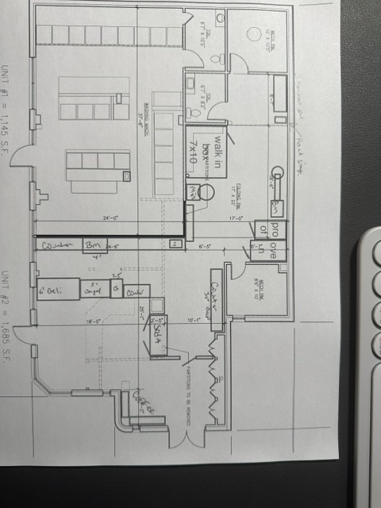

>   
> Floor design