MEETING AGENDA
Sharon Planning Commission
Wednesday March 04, 2026, 4:00 PM
Sharon Municipal Building

- CALL TO ORDER

Clancy Atkinson, Authority Chair called the meeting to order at ________________.

- ROLL CALL
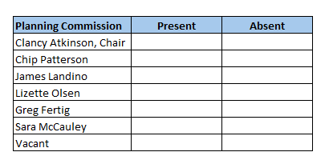
- COMMUNICATIONS FROM THE PUBLIC

- APPROVAL OF PREVIOUS MEETING MINUTES
- Planning Commission meeting Minutes 01-07-2026.docx

- INFORMATION ITEMS

- ITEMS SCHEDULED FOR ACTION

- Lot Consolidations:

Lot Consolidation – 2 AP 32A 32 and 2 AP 33 (Hall Ave) Berent/Logan
2 AP 32A 32 – 1348 Hall Ave (SFH with garage)
2 AP 33 – 1338 Hall Ave (vacant lot)

Lot Consolidation – 2 C 45 and 2 C 45A (5th Ave) Redevelopment Authority of the City of Sharon
2 C 45 – formerly 87 5th Ave (vacant lot)
2 C 45A – formerly 79 4th Ave (vacant lot)

Lot Consolidation – 4 AM 64 65 and 4 AM 63 (Haig Street) Sheilds
4 AM 64 65 – 1010 Haig Street
4 AM 63 – (vacant lot)

- Execution of Comprehensive Plan

- Discuss the Capital Good Fund’s BRIGHT lease program. Should the program be promoted to Sharon residents
https://capitalgoodfund.org/welcome-to-pennsylvania-bright-pittsburgh/
- ANNOUNCEMENTS

- ADJOURNMENT

