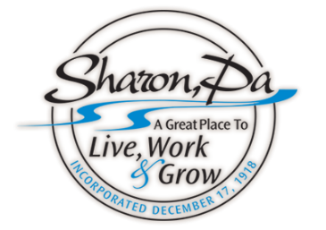
LEGAL NOTICE

The Sharon Zoning Hearing Board will continue a Public Hearing at 5:30 PM on Thursday, December 15, 2022, in City Council Chambers, Sharon City Building, 155 West Connelly Blvd, Sharon, PA 16146.
This is a “continuance” of the Zoning Board Public Hearing originally scheduled and held on Tuesday, November 29, 2022.
It is regarding a request for a “Special Exception” that would permit the existing building, (housing the former Shenango Inn & Juniper Village), located at 1330 Kimberly Road, to be renovated then operated as a Hotel/Restaurant in a Residential R-1 Zoning District.
The Zoning information surrounding this request can be found in the Zoning Ordinance book under newly amended Article 3, under Table 306.10 – Special Exceptions, page 7, under Section 309 – Special Exceptions. This amendment was passed on September 21, 2022, under Ordinance #11-22.
Comelot Shenango Inn LLC., from Nyack, NY, is asking for the approval of this “Special Exception” by the Sharon Zoning Board.

City of Sharon Code / Zoning Enforcement Office (724-983-3201)

