DRAFT
4/19/17
ii? I

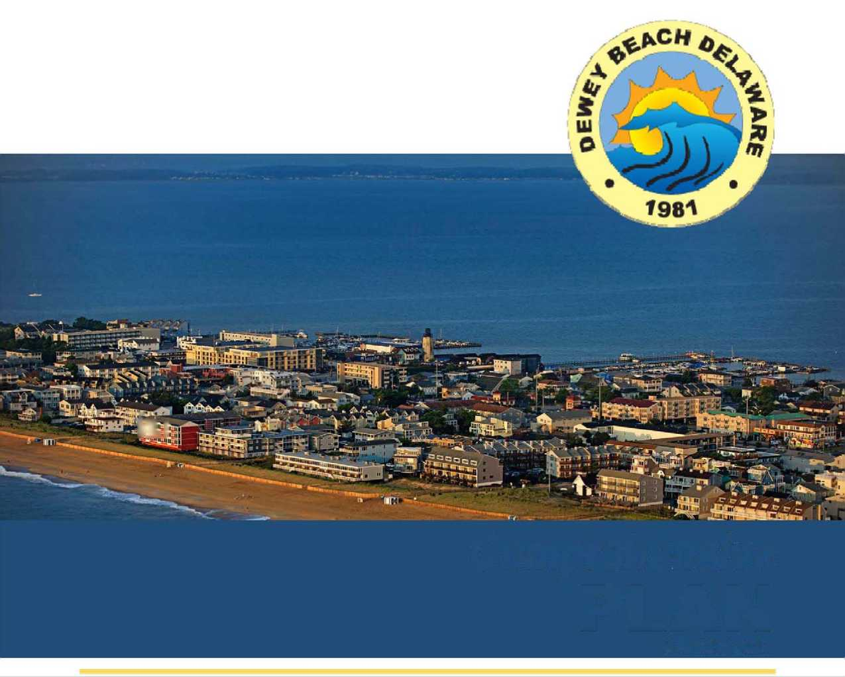

Comprehensive

PLAN

MARCH 2017



(302) 266-0212
University Office Plaza, Bellevue Building 262 Chapman Road, Suite 105 Newark, Delaware
(302) 266-6208
www.rve.com

RV
Remington
Vernick
&Beach

ENGINEERS



Town of Dewey Beach, Delaware
2017 Comprehensive Plan

Planning Commission Recommendation of Approval
TBD 2017

Mayor and Council Approval
TBD 2017
Delaware Office of State Planning Coordination Approval
TBD 2017



Mayor and Commissioners
Dale Cooke, Mayor
Mike Dunmyer
Diane Hanson
Gary Persinger
Courtney Riordan
Town Officials
Marc Appelbaum, Town Manager
Jim Dedes, Assistant Town Manager
Mary Dunmyer, Project Director
Ashleigh Hudson, Town Clerk
Planning and Zoning Commission
Marty Seitz
Mike Harmer
Chuck McKinney
Jim Dedes
Jim Bielicki
Don Gritti
Working Group
David King
Bill Lower Jimmy O'Conor* TJ Redefer Mark Richardson Paul Roessel
Comprehensive Plan
Elaine Bole, Chair* Beth Caruso*
Dave Davis*
Jim Dedes*
David Ferry, Jr.
Julie Johnson*
Steve Judge*
Comprehensive Plan Working Group Ad Hoc Members
Jim Tyler
Rob Marshall
Consultant
Remington, Vernick, and Beach Engineers
Christopher J. Fazio, P.E. - Project Manager
Stuart B. Wiser, P.P., AiCP
Tamika K. Graham, AICP


TABLE OF CONTENTS
PREFACE
Foreword
Definitions
Table of Contents
Acknowledgments
EXECUTIVE SUMMARY
- INTRODUCTION: LIVABLE DELAWARE
  - House Bill 396
  - Managing Growth in 21st Century Delaware
  - House Bill 255
- SUSSEX COUNTY COMPREHENSIVE PLAN
  - Background
  - 2018 Plan Update
  - Relationship of County Plan to Dewey Beach Comprehensive Plan
- DEWEY BEACH COMPREHENSIVE PLAN
  - Statutory Requirements
  - Population Threshold
  - This Document
  - Community Profile: Town of Dewey Beach
    - Location
    - History and Cultural Resources
    - Update Since the 2007 Plan
  - 2017 Plan Development Process
    - Comprehensive Development Plan Committee and Working Group...
    - Vision, SWOT Analysis, and Planning Objectives
  - Demographics and Population Growth
  - Housing
  - Economic Conditions
    - Economic Development Initiatives
  - General Uses of Land
    - Existing Land Use
    - Future Land Use
  - Expansion of Boundaries/Development of Adjacent Lands..
  - Development/Redevelopment Potential
  - Transportation
- Regional Roadways
- Municipal Roadways
- Parking
- Public Transit
- Alternative Transportation
  - Infrastructure
    - Water and Wastewater
    - Stormwater Management
    - Utilities
  - Quality of Life
    - Culture
    - Natural Environment
  - Town Services and Facilities
    - Public Safety
    - Facilities
    - Emergency Fire and Rescue, and Emergency Care
    - Emergency Management Plan
    - Financial Soundness
- CRITICAL COMMUNITY DEVELOPMENT CHALLENGES
  - Climate Change and Sea Level Rise
  - Overcrowding
  - Bayside Protection
  - Preservation of Nature
- IMPLEMENTATION
  - Activities Initiated by the Planning Commission
  - Policy Enacted by Town Council
- Collaboration on Regional Efforts
TABLES AND MAPS
Table 1: SWOT Analysis
Table 2: Industry of Workers, 2011-2015
Table 3: Place of Work, 2011-2015
Map 1 Aerial View and Roads
Map 2 Adjacent Areas
Map 3 Delaware Strategies for State Policies and Spending
Map 4 Effective Zoning Map
Map 5 Environmentally Sensitive Areas
Map 6 Existing Land Use
Map 7 Future Land Use
ADDENDA
A1. Demographics and Population Data
A2. Housing Data

FOREWORD
This Comprehensive Development Plan (“Comprehensive Plan” or "Plan”) is intended to serve as a policy guide for the future development of Dewey Beach. It has been adopted by the Dewey Beach Town Council and is given official recognition as a guide for future planning efforts of the community and its representatives.
The legal means for the implementation of the recommendations contained herein are to be addressed via Zoning Codes and other municipal codes and ordinances to be considered by the Town Council after adoption of this Plan. Such recommendations are intended to be flexibly interpreted within the context of the updated planning goals and objectives contained herein in order to insure that the planning program remains responsive to the changing needs of the community over the course of the ten year life of this Plan.
The public’s understanding of its role in, and contribution to, the efforts of the Planning Committee in developing this Comprehensive Plan is critical if municipal Policymakers are to insure that the community’s best interests remain aligned with the Town’s growth and development plans for the future. Community interest and cooperative commitment to practical planning, and the timely implementation of the goals and objectives of comprehensive development planning, will contribute to a higher quality of life in Dewey Beach.
In addition to the technical requirements of a Comprehensive Plan, this Plan serves as an informational document for the public. Citizens, business people and government officials can turn to the Plan to learn more about Dewey Beach and its policies for future land use decisions. Potential new residents and commercial operators can use the documents as an informational resource about the Town, its population, characteristics, business climate and facilities, to help them make decisions about moving to and remaining in Dewey Beach.
Finally, the Dewey Beach Comprehensive Plan is a legal document. The Delaware Code specifies, in pertinent part, that “...any incorporated municipality under this chapter shall prepare a Comprehensive Plan for the City or Town or portions thereof as the commission deems appropriate”, and further specifies, “after a Comprehensive Plan or portion thereof has been adopted by the municipality in accordance with this chapter, the Comprehensive Plan shall have the force of law and no development shall be permitted except as consistent with the Plan.”
DEFINITIONS
For the purposes of this Comprehensive Development Plan, and in addition to any terms defined within the body of this document, the following terms shall have the meaning as set forth in this section. Terms not defined herein shall have the meaning set forth in the Town Code. Terms presented as singular or plural, masculine or feminine, shall be construed within the context in which they occur.
- "Climate Change” shall mean major changes in temperature, precipitation, or wind patterns, among other effects, that occur over several decades or longer.
- "Dewey Beach” shall mean the Town of Dewey Beach, Sussex County, Delaware, and unless otherwise indicated, includes its Governing Body, elected officials, officers and staff.
- "Governing Body” shall have the same meaning as Town Council.
- "Planning Commission” shall mean the Dewey Beach Planning and Zoning Commission, established pursuant to section 23 of the Municipal Land Use Law and operating pursuant to the various regulations of the Town Code and other relevant ordinances and statutes.
- "Publication” shall mean the date this Comprehensive Development Plan was finalized for submission to the Planning Commission and certified by the Office of State Planning Coordination (see front cover).
- "Sea level rise” shall mean an increase in the volume of water in the world’s oceans caused primarily by two factors related to global warming: the added water from melting land ice and the expansion of sea water as it warms.
- "Shoulder Season” shall mean the travel season between the peak and off-peak seasons.
- "Stakeholders” shall mean, individually and collectively, the residents, property owners, business owners and visitors of/to Dewey Beach.
- "Sustainable Tourism” shall mean tourism that takes full account of its current and future economic, social and environmental impacts, addressing the needs of visitors, the industry, the environment and host communities.
- "Town” shall have the same meaning as Dewey Beach.
- "Town Code" shall mean the Dewey Beach Municipal Code, as same may be amended from time-to-time.
EXECUTIVE SUMMARY
More than ninety-nine percent of the land area in the Town of Dewey Beach is developed and in use for residences and business, and the general patterns of use are unlikely to change significantly in the foreseeable future. Despite this apparent stability, challenges related to sustainability and growth in tourism are likely to face municipal planners over the next several years.
Accordingly, while remaining consistent with the requirements for Comprehensive Plans under State law, this Comprehensive Development Plan focuses on four major threats and opportunities — the Town’s Critical Community Development Issues or Grand Challenges — that aim to be addressed by the Planning Commission and governing body over the next 10 years. Specifically, natural and man-made issues related to sea level rise and overcrowding, as well as opportunities presented on the bayside and the celebration of the Town’s natural resources will drive the evolution of Dewey Beach over that period and determine the Town’s sustainability into the future.
The continued sustainability of the vibrant commerce and culture of Dewey Beach will be determined by how the Town— both in terms of its governing body and its people — deals with these issues over the next 10 years.
Critically, the Town’s success in addressing sea level rise will determine whether Dewey Beach remains sustainable and vibrant into the future, as well as how the residents of and visitors to the Town will enjoy all that the community has to offer.
Issue: Climate Change and Sea-level Rise
In the State of Delaware, between 8% and 11% of land area, including wetlands, could be inundated by a sea level rise of 0.5 meters to 1.5 meters, respectively. These generally accepted estimates for the State use models that evaluate impacts out to the year 2100. Under such scenarios, significant portions of Delaware’s resort areas, coastal historic sites, and natural resources could be inundated or altered by sea level rise. Further, impacts could be substantial for the southern half of Dewey Beach. The lead time necessary to responsibly plan for, fund and implement strategies in accordance with State sea-level rise policy requires long-term thinking, especially when seeking to leverage competitive State and Federal resources.
SOUND PLANNING TODAY IS REQUIRED
TO AVOID TRAGEDY TOMORROW.
POLICY: The town should establish strategies for resilience that can be implemented within the next 10 years designed to protect the Town in the face of a potentially incremental rise in sea level.
Issue: Overcrowding
Increases in residential and commercial development countywide have resulted in ever- increasing levels of traffic through the Town, causing increased pollution and ever-increasing threats to the safety and well-being of pedestrians and bicyclists in Town. The Town is fully developed and an increasing number of daily visitors with the new interstate transportation hub in nearby Lewes, has resulted in and is likely to continue the increased congestion and overcrowding that is beginning to impact the openness and natural beauty of the community and its environs. Further, the population density per square mile of land is significantly higher in Dewey Beach in the summer, compared to Sussex County and the State.
POLICY: The town should establish policies and/or amendments to the Town’s Municipal Code that can be implemented within the next 10 years, designed to protect and strengthen the character of the local communities within Dewey, and protect against the overcrowding and promote sustainable tourism.
POLICY: The town should work with County and State agencies to establish policies, within the next 10 years, designed to fortify pedestrian and bicyclist safety in Dewey Beach.
Issue: Bayside Protection
The Town of Dewey Beach is bordered by two major bodies of water - the Atlantic Ocean and the Rehoboth Bay. Considering the vulnerabilities of infrastructure in this area as a result of climate change and sea-level rise, development along the Rehoboth Bay area should be carefully examined. The bayside presents an opportunity for increased resilience to rising sea levels. This will require working collaboratively with Town stakeholder groups and planning across various State and Federal agencies and local communities. Identifying fiscal resources for implementation is also key.
POLICY: The town should establish a coherent set of strategies for the stabilization of the bay shoreline and other activities that will sustain the nature of the bayside.
Opportunity: Preservation of Nature
Any point in Dewey Beach is only a block or two from a spectacular Atlantic Ocean beach, and a few blocks to beaches, wetlands and outlooks on the Rehoboth Bay. Between the various ocean and bay activities, there is something for nearly everyone. One of its most positive attributes is the natural environment, which the Town requires a mandate to protect and preserve. Opportunities, for example, include creating a network of rain gardens to responsibly manage stormwater and flyways for migrating birds and pollinators.
POLICY: Over the next 10 years, the Town should work collaboratively with the surrounding Coastal Delaware communities to engage all stakeholders in working positively for the preservation and improvement of our precious natural environment.

■i
- House Bill 396
INTRODUCTION: LIVABLE DELAWARE
In June of 1998, the Delaware General Assembly adopted House Bill 396 (“HB 396”), which provided for each municipality in the State to undertake a community-based planning process to develop a Comprehensive Plan regulating growth in the community. The Assembly’s goal in adopting HB 396 was:
to encourage the most appropriate uses of the physical and fiscal resources of the municipality and the coordination of municipal growth, development, and infrastructure investment actions with those of other municipalities, counties and the State through a process of municipal comprehensive planning.
HB 396 (b) defines a Comprehensive Plan as "a document in text and maps, containing at a minimum, a municipal development strategy setting forth the jurisdiction's position on population and housing growth within the jurisdiction, expansion of its boundaries, development of adjacent areas, redevelopment potential, community character, and the general uses of land within the community, and critical community development and infrastructure issues".
Once completed and adopted, a municipality’s Comprehensive Plan will be used as the basis for zoning decisions, infrastructure spending, annexation decisions and redevelopment and general growth policies.
HB 396 also requires that each municipality in Delaware review, fully revise, and readopt its Comprehensive Plan at least every ten (10) years.
The Town of Dewey Beach first adopted its first Comprehensive Plan in July 2007. That plan was reviewed and amended in 2013 (“Five-Year review”), and again in 2015 to amend the Town Zoning Map. This document will constitute the mandatory 10-year Comprehensive Plan revision and re-adoption.
- Managing Growth in 21st Century Delaware
In December of 1999, the Governor’s Cabinet Committee on State Planning Issues published a report focusing on how Delaware and its 57 individual municipalities can manage the explosion of growth occurring in the state. Policies related to sprawl management (“Smart Growth”), environmental issues and business concerns and their collective impact on public sector spending were addressed. The result was a series of initiatives designed to shape Delaware’s future. At its heart, these growth management initiatives are grounded in sound planning principles.
- House Bill 255
In July of 2001, House Bill 255 was signed into law. Said Bill amended various land use laws in the State of Delaware and, most notably, strengthened the role that Comprehensive Plans play in a county and a municipality. Such a document is required to, in general, review the existing conditions in a particular county and municipality, and outline community goals and objectives and state policies regarding how the community plans to achieve said goals and objectives.
SUSSEX COUNTY COMPREHENSIVE PLAN
- Background
Sussex County is the largest in land size, and southernmost of Delaware’s three counties. It is bordered on the north by Kent County, DE, the east by the Atlantic Ocean, on the west by Caroline and Dorchester Counties, and to the south by Wicomico and Worcester Counties of Maryland. The County is home to four cities, 21 incorporated towns, and six unincorporated communities. The County is largely rural in character and has approximately 221 people per square mile. In 2015, a total population of 206,665 was estimated with a total population of 215,622 projected into 2045. The County’s economy relies largely on agricultural activity.
- 2018 Plan Update
Under the State’s Municipal Code Requirements, the comprehensive planning process shall demonstrate coordination with other municipalities, the County, and the State. Accordingly, the framework for the Dewey Beach Comprehensive Plan is established using existing State and County policies that influence land use, growth and development.
Similar to municipalities, each County in Delaware is required under the State law to adopt a certified comprehensive plan every ten years and provide an annual progress report to the Delaware Office of State Planning Coordination.
In 2008, Sussex County underwent a major update of its earlier plan. The most recent update of the Plan is slated for adoption in March of 2018, just ahead of this Dewey Beach Plan. The Plan projects out to 2045, which coincides with other long-range planning efforts in the State. This County Plan was developed with a variety of stakeholder and public input, including its municipalities.
The Sussex County Plan’s vision is as follows:
Sussex County offers a unique quality of life for its residents and visitors alike. We appreciate and seek to preserve its unique natural, historical and agricultural character while fostering new economic opportunities and desirable growth. To accomplish this, Sussex County will balance the welfare of its citizens and its role as an agricultural leader and tourist destination with the most appropriate future uses of land, water and other resources.
While there are many economic and development opportunities in the coming years, addressing challenges of growth and adequate infrastructure should be coordinated with a variety of stakeholders. Sussex County aims to embrace these opportunities while preserving its rural character and farmland, maintaining beach, park, and open space access, conserving natural resources, meeting current and future needs, and directing growth within designated areas.
- Relationship of County Plan to Dewey Beach Comprehensive Plan
The Sussex County Comprehensive Plan provides implementation steps that require intra- jurisdictional cooperation among the County and its municipalities and unincorporated communities, and the State, on coordinated planning and development efforts.
For consistency and coordination, the Dewey Beach Comprehensive Plan was developed with input from incorporated jurisdictions, and requires intergovernmental coordination between the County and the Towns to implement a consistent vision. Sussex County and Dewey Beach share a similar vision and both comprehensive master plans set the overall tone and direction to take in the future.
Both plans, when being developed, referenced the Delaware Strategies for State Policies and Spending, developed through the Office of State Planning and Coordination. The most recent version adopted in 2015, lays out a policy framework for State planning and investment activities. This separate document also coordinates land-use planning with infrastructure and services at the local level, in a manner that balances growth and preservation.


DEWEY BEACH COMPREHENSIVE PLAN
  - Statutory Requirements
HB 396 (b) mandates that all municipal Comprehensive Plans address the jurisdiction's position on:
- Population and housing growth
- Expansion of its boundaries
- Development of adjacent areas
- Redevelopment potential
- Community character and general uses of land within the community
- Critical community development and infrastructure issues
For larger municipalities HB 396 (b) further requires:
The comprehensive plan for municipalities of greater than 2,000 population shall also contain, as appropriate to the size and character of the jurisdiction, a description of the physical, demographic and economic conditions of the jurisdiction; as well as policies, statements, goals, and planning components for public and private uses of land, transportation, economic development, affordable housing, community facilities, open spaces and recreation, protection of sensitive areas, community design, adequate water and wastewater systems, protection of historic and cultural resources, annexation, and such other elements which in accordance with present and future needs, in the judgment of the municipality, best promotes the health, safety, prosperity, and general public welfare of the jurisdiction's residents.
  - Population Threshold
The 2010 population for the Town of Dewey Beach as reported by the U.S. Census Bureau is 341. Based on the requirements of HB 396 and the population of Dewey Beach, specific issues to be addressed in this Comprehensive Plan include:
- A community profile, including a discussion of community character, Town vision and planning objectives, and important events of the past 10 years;
- An presentation of population and housing growth, community services, transportation, facilities and infrastructure;
- A discussion of general land uses and potential annexation/development of adjacent areas;
- Critical community development issues facing Dewey Beach over the coming decade; one of which includes redevelopment potential.
  - This Document
This document, entitled 2017 Comprehensive Plan, Town of Dewey Beach, Sussex County, Delaware (hereinafter referred to as the "2017 Comprehensive Plan” or "2017 Plan”), supersedes the Town's 2007 Comprehensive Plan (hereinafter referred to as the "2007 Comprehensive Plan” or "2007 Plan”), and provides a discussion of the major issues currently faced by the residents, property owners, and businesses in Dewey Beach and outlines strategies and recommendations to address those issues. The Plan was developed with the guidance of a committee/working group comprised of local property and business owners, the Town’s Planning Commission, and Dewey Beach’s Town Council. The recommendations contained herein, along with the maps developed for this Plan, are designed to assist Dewey
Beach’s leaders in their efforts to maintain and enhance the quality of life in the Town over the coming 10 years, and into the future.
  - Community Profile: Town of Dewey Beach
    - Location
38° 411 46" N, 75° 4 35" W
The Town of Dewey Beach is located along Delaware’s Atlantic coastline in eastern Sussex County. An aerial view of Dewey Beach and its system of roads is shown in Map 1. The Town’s municipal boundaries comprise approximately 300 acres. The Town is bounded on the east by the Atlantic Ocean, on the west by the Rehoboth Bay, and on the north and south by unincorporated Sussex County. The Town of Dewey Beach is located just north of the Delaware Seashore State Park, a protected natural area, and just south of the City of Rehoboth Beach. The map below places the location and municipal bounds of the Town of Dewey Beach in context with eastern Sussex County.
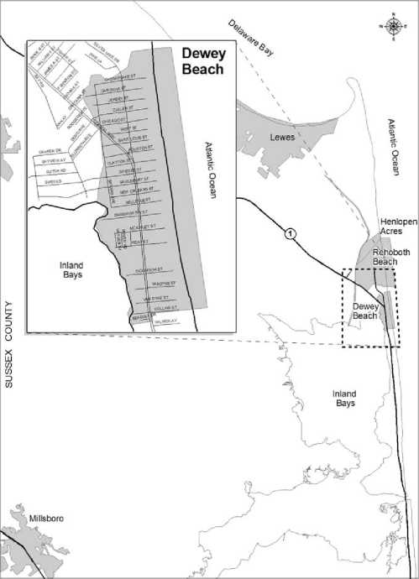
    - History & Cultural Resources On January 5, 1855, Clementine and Robert West bought 135 acres of what would become Dewey Beach from John Roades. Development in the town was sparse until Rehoboth by the Sea Realty Company began developing the northern portion of what is now Dewey Beach, then known as Rehoboth by the Sea. In 1915 Morgan T. Gum was commissioned by the State to produce a subdivision plan for what is now the southern portion of Dewey Beach. Gum’s design was based on the same grid system used in the development to the north in 1855. By continuing the northern grid system, Gum effectively completed the plan for what would later become Dewey Beach.
U.S. Life-Saving Station 141 was built on what is now Dagsworthy Street in 1879. At the time it was called the Rehoboth Life Saving Station, and those chosen to staff the station were drawn from local watermen. Over time a small community grew around the station, and in 1915 the U.S. Life Saving Service became the U.S. Coast Guard. In the wake of the Spanish-American War, many towns were named in honor of war hero Admiral George Dewey. Three history books, one written as far back as 1938, suggest that Dewey Beach can also claim the Admiral as its namesake.
While the Great Depression had a serious impact upon Rehoboth By The Sea Realty Company, surviving partners George A. McMahon and John E. Redefer retained the company and continued the town’s development. These efforts were greatly helped when Route 1 was built in 1944, providing greater accessibility to the town. The Great Nor’easter Storm of March 5th and 6th, 1962, brought high winds and ocean waves of 30 feet. The storm damaged or destroyed many buildings as the ocean and the bay met, engulfing the town. The "storm of the century,” as it was called at the time, caused an estimated $200-million-worth of damage (equivalent to about $ 1.6-billion today) across coastal communities in Delaware.
Following the storm, sewer and water systems were introduced, spurring increased interest in the town and a modest period of development through the 1960’s. By the mid-1970’s, the area had attracted the interest of several developers. Around this same time, the state banned drinking in Whiskey Beach. This occurrence, combined with the lack of structure, or a strong police presence in Dewey, which was still an unincorporated town, made it the new favored spot for the displaced Whiskey Beach crowd.
In response to these problems, Dewey Beach became an officially incorporated town in order to make laws against behavioral crimes and hire police to enforce them. Over the next ten years, town officials and local police worked hard to reestablish order and rid Dewey of its "frontier town” image, in favor of the more family-friendly lifestyle it had known in the past. Today,
Dewey Beach boasts a vibrant tourist trade and has become a popular summer destination for more than 30,000 visitors each week. These summer visitors are attracted to the wide array of entertainment opportunities and the spectacular natural beauty Dewey Beach has to offer.
Officially incorporated as a municipality in 1981, the Town of Dewey Beach was one of the last of the fifty-seven cities and towns formally recognized by the State of Delaware. However, the history and culture of Dewey Beach spans more than a century. Today, the Town of Dewey Beach hosts an eclectic mix of full-time and seasonal residents, as well as many tens-of- thousands of daily and weekly visitors. Some of Dewey’s historic cultural resources, such as the old Boat House Restaurant, have been lost to time. However, the town has a number of culturally important structures and hosts a variety of cultural events, including:
- The Dewey Beach Lifesaving Station - Dating back to the late 1800s, the lifesaving station was moved from Dagsworthy Street to Highway 1 in 1947 and painstakingly restored by the Reader family in the late 1990s. A replica of the original life guard station was completed in 1987 on the Dagsworthy Street property and today serves both as the headquarters for the lifeguards and a town meeting facility.
- The Lions Club John Waples Memorial Playground (McKinley Avenue) - The playground contributes significantly to Dewey Beach’s cultural identity as a family- friendly vacation destination, while also providing an amenity for full-time residents.
- The Lighthouse at Lighthouse Cove (Dickinson Avenue) - An iconic landmark and popular meeting place on the Bay surrounded by restaurants for live music and open air dining.
- The Town has two memorial parks on the Bay, Sunset Park (Dagsworthy Avenue) and Monigle Park (Read Avenue). While both offer the public seating, access to the Bay, and views of ospreys and sunsets, these parks need better maintenance by the Town and are thus underutilized.
- Families and Children - Dewey Beach offers weekly movies and bonfires with storytelling on the beach, organized sports on the beach in the early evening, a
Junior Lifeguard program, and environmental education programming. When space permits doing so safely, Dewey Beach also permits the following types of activities: ball throwing, volley ball, tether ball, kite flying, skim- and boogie boarding and surfing and surf fishing. Dewey Business Partnership hosts an annual Art Fair, Treasure Fest community yard sale, and Easter Egg Hunt on the beach (Spring), Summer Solstice Parade and kids’ party (Summer kick-off), Halloween Trick or Treat and a haunted beach bon fire (Fall), Christmas tree lighting, a New Year’s Eve "Surfer Drop” and New Year’s Day Dewey Dunk (Winter).
- Dogs - Dewey Beach permits dogs on the beach (properly registered and under an adult owner’s control) on mornings and evenings in the summer, and all day long in the off season. Dewey Beach also annually hosts a number of dog-oriented events, including weekend-long events for Greyhounds (Reach the Beach/twice a year), Golden retrievers (Golden Rush/twice a year), Chihuahuas (Cinco de Mayo Races), "doodles” weekend, and others, each attracting hundreds of canine registrants and their families. There are many, many dog-friendly accommodations to choose from, including motels and rental houses.
- Music - Dewey Beach is the home of several renowned music venues and events. On any given evening during the Summer season, one can enjoy a variety of live music in more than a dozen locations; music that ranges from acoustic guitar to the Island Boyz, from live jam sessions to popular up-and-coming Delaware bands. Annually, Dewey businesses host Music Fest and an Elvis Festival, and join with Rehoboth in its annual Jazz Festival.
- Relaxation - Dewey also has a culture of relaxing and enjoying the moment. Some typical events spread throughout the year include the Winter Gala, St. Patrick’s Day festivities, Starboard’s Opening, Running of the Bulls, Bacon Fest, and the property owners’ End of the Summer Party. Dewey is home to a number of group houses that embrace the Dewey vibe and take advantage of the benefits of ride/house sharing.
- Food and Beer - For a tiny town, Dewey has an eclectic mix of places to eat; 27 restaurants and eateries in its eight block "downtown” business strip. There is, of course, pizza and more pizza, but also healthy foods, a salad-focused restaurant, a raw bar, Mexican food, Thai food, your normal beach food, and many upscale specialties. Any given year one or more of these eateries/restaurants is recognized by local and State news outlets and associations as being the "Best in Delaware” for their breakfasts, salads, crab cakes, etc. A number of these restaurants focus on providing craft beers, and there are two brew pubs now operational in Town.
    - Update Since the 2007 Plan
In 2007 the Town adopted its first Comprehensive Development Plan. The 2007 Plan enumerated 57 planning objectives and recommendations. Over the past nine years about 25 of these have been achieved, while action on about 10 has not yet begun. For many of the latter, it was determined that County, State and/or Federal support would be necessary for making any significant progress. Some of these issues have been re-addressed in this 2017 update, recognizing the need for coordination and collaboration with the cognizant entities and agencies.
Since 2007 Dewey Beach has seen some major developments and events:
- Review and amend the Town’s Zoning Code (Chapter 185 of the Municipal Code) to align with the certified 2007 comp plan (2009).
- Plan updates. Interim reviews and certified updates of the 2007 comprehensive plan in 2013 (five-year update) and 2015 (change in zoning district boundaries).
- Update of the Town’s Flood Damage Reduction Code (Chapter 101 of the Municipal Code) to align with recent changes required by the Federal Emergency Management Administration (2015).
- Hurricanes Irene (2011) and Sandy (2012) - These events required the evacuation of the Town and provided successful tests of the effectiveness of the Town’s Emergency Response Plan. They also caused significant storm- and flood-related damage, emphasizing the reality of sea-level rise and resulting in a strategic focus on SLR issues and planning.
- Bayard Avenue Drainage Project - This was a million dollar infrastructure improvement project to alleviate chronic flooding in the Bayard/Bellevue Avenue area. Supported in part by monies from the Town’s Infrastructure Reserve Fund and a State loan, this project was preceded by numerous public meetings to discuss the problem and evaluate engineering options and studies.
- Ruddertowne Redevelopment (now Lighthouse Cove; bay block between Collins and Dickinson Avenues) continues redevelopment of the old “Ruddertowne” property. It is now in Phase I.6, continuing construction of the Hyatt Place Hotel and luxury Residences at Lighthouse Cove condominiums. The planned construction of retail space, three Dewey landmark restaurants and the Bay Center Conference Center, a re-nourished and expanded bayside public beach area at the end of Van Dyke Avenue, and an expanded public bay walk has not yet begun.
- Financial Soundness - In 2008 Dewey Beach suffered an approximate $800,000 budget deficit; in part a result of the widespread economic downturn around 2008. This was followed by the retirement of the long time Town Manager, appointment of three different Acting Town Managers, and two new Town Managers, each of whom resigned after only brief periods in office. With the appointment of its current Town Manager in 2012, Dewey has shown positive budget results each year since 2013 and the Town’s annual audits reflect that the General Fund and other self-committed funds are at adequate levels. The Town has an administratively restricted Beach Replenishment Fund of $3.2 million for repair and maintenance of its Atlantic Ocean beach.
  - 2017 PLAN DEVELOPMENT PROCESS
    - Comprehensive Development Plan Committee and Working Group
Established in January 2016, the Comprehensive Development Plan Committee and Working Group (Working Group) held its first meeting in February, and met in properly noticed public meetings once or twice a month thereafter. At the outset of this process the Comprehensive Development Plan Working Group and Committee established the following mission and overarching objectives:
Mission Statement:
The mission and purpose of the Comprehensive Plan Committee and Working Group is to fairly address the interests and needs of the town’s constituents, namely the residents, property owners, businesses, and visitors, in a way that results in a plan for Dewey's future that is balanced and ensures a stable and positive image and future for the town, optimizing its key attributes including a beautiful and healthy beach and bay, small town feel, vibrant family and social life, safety and quiet enjoyment, fiscal responsibility, and natural resources.
Objectives:
- Review the Town’s 2007 Comprehensive Development Plan and those of its neighboring Coastal Delaware municipalities and Sussex County.
- Establish a shared vision of Dewey Beach by 2035 that assures a stable and positive future for the Town.
- Develop an updated Plan that will engage all of the Town’s stakeholders to work together to move the Town forward over the next 10 years toward that vision.
The framework for the Dewey Beach Comprehensive Plan is also based on input received through the stakeholder and public outreach process. Through the course of over a dozen meetings in the spring and summer of 2016, the Working Group discussed the positive and negative attributes of the effective comprehensive plans of the municipalities of Lewes,
Rehoboth Beach, Bethany Beach, South Bethany, and Fenwick Island and discussed the Town’s and region’s future directions with guests, including our local Delaware State Senator and Representative Speaker, Center for the Inland Bays, Rehoboth Beach-Dewey Beach Chamber of Commerce, and the Secretary for the Delaware Department of Transportation.
While the committee and work group was the primary conduit for public input, other avenues were utilized to understand the needs and concerns of residents and local representatives. Input was also sought through meetings and presentations at Town Council. Combining a variety of input helped to make this document relevant to the needs of the community.
A comprehensive survey of property owners, businesses, and visitors was conducted to inform this plan update. The results of the three surveys were used to help shape the positions and recommendations of this plan to be submitted to the State. The survey was conducted from August through November 2016, using online, in-person, and paper-based formats. To reach a broad audience, they were directly mailing mailed to property owners, advertising posters were available throughout Town, and businesses distributed cards to their patrons with the link to the survey. In total, there were 300 respondents to the property owners’ survey and 100 respondents to the visitor’s survey. A summary of the survey results can be found in the Town’s website.
Highlights from the Property Owners’ Survey includes:
- Eighty percent (80%) think Dewey Beach’s image is better compared to five years ago.
- Eighty percent (80%) agree that Dewey is more family-oriented.
- More than 75% agree that Dewey Beach offers a vibrant and respectful environment for all age groups.
- Sixty percent (60%) agree that Dewey should strive to become a more year-round Town
- Eighty percent (80%) agree that efforts should continue to expand the "shoulder season” (spring and fall) activities.
- Eighty percent (80%) agree that that sea level rise and climatic change should be a high priority for the Town; more than half strongly agree with this priority.
- Eighty-five percent (85%) agree that the town should develop a long-term plan for adaptation to sea level rise; 55% strongly agree about such a long-term plan.
Highlights from the Visitors’ Survey includes:
The most positive characteristics noted about Dewey Beach were:
- Walking access to restaurants, eateries, and other food establishments
- Accessibility of ocean beach
- Nighttime entertainment
- Clean and safe beach
- Party atmosphere
- Safe and secure nighttime environment
Areas in need of the most improvements were:
- Pedestrian safety
- Availability of public restrooms
- More year-round restaurants
- More special events (Town or business-sponsored)
- Public transportation options
- Shopping and convenience outlets in Town
The most positive characteristics about Dewey Beach noted by owners and visitors were:
- Clean and safe beach
- Walking access to restaurants, etc.
- Accessibility of ocean beach
- Vision, Strengths, Weaknesses, Opportunities, and Threats Analysis, and Planning Objectives
As a result of extensive discussions, the Working Group established a consensus on a set of vision statements for the future of Dewey Beach to guide public policy.
OUR VISION:

The Town of Dewey Beach is widely recognized as a gem of a
Mid-Atlantic small beach town, characterized by a diverse
culture, prized natural resources, and small town ambience.
The Town’s vision seeks to fairly address the interests and
needs of the Town’s constituents, namely the residents,
property owners, businesses, and visitors, in a way that results
in a plan for Dewey's future that is balanced and ensures a
stable and positive image and future for the Town, optimizing
its key attributes including a beautiful and healthy beach and
bay, small town feel, vibrant family and social life, safety and
quiet enjoyment, fiscal responsibility, and natural resources.
SWOT Analysis
Below, an analysis of the Town’s Strengths, Weaknesses, Opportunities, and Threats (SWOT) was used to frame high priority recommendations. Recommendations were framed to leverage the Town’s strengths, to improve weaknesses, mitigate threats to the Town’s well-being, capture opportunities and/or further the Town governance goals identified in the Town Charter.
Table 1: SWOT Analysis
Strengths | Weaknesses
Unique Ocean beach / Bayside | Lack of Town gathering place(s)
Small Town ambiance | Route One congestion / division
Accessible / Walkable | Rowdiness image
Seasonal rhythms | Lack of coherent, shared vision
Relaxing / People and pet friendly | Variable revenue base
Threats | Opportunities
Increased congestion (Internal & External) | Proactive vision and Town planning
Sea level rise | Robust shoulder season
Rowdiness image | Leader in sea level rise mitigation
Conflicts between stakeholder groups | Iconic gathering place(s)
Diminishing property values

The goals and objectives listed below serve to implement our vision for the Town’s future, building on its current strengths and special nature, and preparing it for a future that optimizes Dewey’s potential and opportunities to succeed and flourish.
Goals of Governance
Section 4 of the Charter of the Town of Dewey Beach enumerates five overarching goals for the general governance of the town and its residents:
- Maintain peace and order.
- Protect and preserve all property, public and private.
- Provide for the Town’s sanitation.
- Provide for the health, safety, convenience, comfort, and well-being of the population.
- Protect the Town’s beauty.
Planning Objectives
Two sets of "planning objectives” are listed below. The first set is aimed at operational aspects of Town growth and governance that were developed within a vision of making Dewey Beach a better, safer, and friendlier town that serves all the Town’s constituents equitably and provides guidance for the next decade of the Town’s evolution; these can largely be implemented by the Town as part of ongoing efforts for continual improvement.
The second set is aimed at guiding solutions to the four Critical Community Development Challenges posed herein; these will likely take a decade of work in collaboration with external stakeholders and involving extensive community outreach and input.
Planning Objectives Related to Operational Improvements
- The Town of Dewey Beach is characterized by a respectful and diverse culture that values quiet enjoyment in harmony with vibrant day and evening activities.
- The Town of Dewey Beach enables all stakeholders to contribute to Dewey’s vibrancy, and to share in the costs and benefits of the Town’s culture and commerce in a balanced way.
- The Town of Dewey Beach enjoys financial sustainability based on stable and predictable revenue sources and reasonable and predictable expenditures.
- The Town of Dewey Beach invests in itself and becomes recognized as a gem of a Mid- Atlantic small beach town; clean, beautiful and vibrant.
- The Town of Dewey Beach provides for the security and safety of all stakeholders within Town limits, including on its beaches and ocean and bay areas, in residential and commercial areas, and along Coastal Highway (SR-1).
- The Town of Dewey Beach operations and governance will be recognized as efficient and effective in meeting the needs of its vibrant and evolving community.
- The Town of Dewey Beach has close working relationships with neighboring communities to improve the long-term viability of the area and to protect the surrounding natural resources.
- The Town of Dewey Beach works to preserve the existing character of the Town and the diversity of its surrounding natural resources, and protect them in perpetuity by appropriate municipal code and effective Town governance.
- The Town of Dewey Beach takes a leadership position in, and responsibility for, protecting and preserving the natural environment in and around Dewey.
- The Town of Dewey Beach develops and maintains a strategy for long-term adaptation to sea-level rise in concert with county and state.
- The Town of Dewey Beach’s culture and commerce extends increasingly further into the spring and fall shoulder seasons.
Planning Objectives Related to Critical Community Development Challenges
- Establish a strategy for a level of resilience to sea-level rise that will protect the Town’s most vulnerable resources and infrastructure.
- Protect against overcrowding through the promotion of sustainable tourism.
- Plan for the protection and preservation of the Rehoboth Bayside to maintain the Town’s local character.
- Preserve and replenish the precious, unique, and valuable natural environment.


- DEMOGRAPHICS AND POPULATION GROWTH
Based on U.S. Census data, the 2010 resident population of the Town of Dewey Beach was 341 persons, occupying 180 homes. This represents a decadal growth rate of 13%, a dramatic slowing realized in the prior 10 years between 1990 and 2000 (almost 50%). In 2015, the municipal five-year population estimate declined to 250 persons.
While trends would suggest continued population growth, the Town is largely built-out and has no plans to annex adjacent land areas. Therefore, the majority of future population growth will be less than the result of new-home construction as it is in Sussex County, and more the result of an increasing percentage of existing and new residents opting to live in Dewey Beach year- round.
The 2010 U.S. Census also indicates that the total number of dwelling units in Town ranges from 1,500 to 1,800 and various estimates place the population of property owners in the range of 1,700 (adults registered to vote in Town elections) to 3,250. Adding immediate family members might increase the population of Dewey Beach property owners and family to around 6,500. Based on residential rental data and hotel occupancies, the collective occupancy of the Town can accommodate more than 12,000 people, and some summer weekend days the number of people on the beach exceeds 30,000.
Finally, information regarding seasonal or occasional residents and visitors of all types is vital to a full understanding of the general service needs of the town. There is little data available, including the lack of US Census data regarding these populations, so it is important for the Town to create strategies for developing its own data in this regard for future planning and policymaking activities.
Because the value of Dewey Beach lies principally in its resort-like environment, careful planning is required to ensure that the Town’s infrastructure is capable of meeting the demands of its seasonal and transient populations, and that any growth in these populations does not place an undue burden on the community and its natural environment.
Objective:
Equitably address the needs of residents, business and property owners, and visitors when formulating public policy and strategic planning.
Action:
The Town should develop and implement a strategy for collecting and analyzing comprehensive data and information regarding its total population, including year-round residents, seasonal and occasional residents, business owners, and visitors.
HOUSING
Estimates from the 2010 Census indicate that there are roughly 1,490 dwelling units in Dewey Beach. In 2015, 1,532 housing units were estimated within the town limits, representing approximately 3% in growth. Housing, or dwelling units, are defined as one or more rooms, designed, occupied, or intended for occupancy as a separate living quarter, with cooking, sleeping, and sanitary facilities provided within the dwelling unit for the exclusive use of a single family maintaining a household and do not specifically include hotel, motel or bed and breakfast rooms. At just 10%, the housing growth rate in Dewey over the past decade has been markedly lower than the comparable housing growth rate in Sussex County at 32%, which has been driven by the development of large tracts of undeveloped land. This is not surprising since over 80% of the residential-use land area of the Town had been developed prior to the 1990’s.
According to U.S. Census data, almost two-thirds of the Town’s housing was built before the Town incorporated in 1981. Since that date, new housing growth occurred under a zoning code that recognized two residential districts (only permitting detached single family housing in the northern half of Town, and permitting detached single family and multi-family housing in the southern half), and a resort business district permitting single family and multi-family housing and housing in mixed-use structures.
Approximately 40% of all housing units are detached single family structures. This is a much lower ratio than in the surrounding coastal municipalities (60% in Rehoboth to 100% in Henlopen Acres). Interestingly, the housing stock in Dewey is significantly older than that in Lewes, Rehoboth Beach, Bethany Beach, South Bethany, and Fenwick Island, with approximately half of all housing built prior to 1970. This is likely due to much of the northern half of Town being developed in the 1960s on leased land, a situation regionally unique to Dewey. Additionally, the relatively large number of multi-family dwelling structures in Dewey sets the character of the Town’s housing stock apart from that of its’ neighbors.
Finally, the U.S. Census Bureau data suggests that the amount of housing occupied by permanent residents in Dewey (12%) is dramatically lower than in the neighboring coastal municipalities (20% in Bethany Beach to 56% in Lewes). Notably, small changes in housing use (from a second home to a permanent residence) can result in relatively large increases in the resident population.
There are less than a handful of empty lots in Dewey Beach; therefore, housing growth may be inconsequential in the future. However, much of the existing older, smaller housing is likely to be redeveloped or rehabilitated during the next 10 to 20 years; adding to the potential resident and seasonal population.
Further, the Town encourages inclusionary housing opportunities that are targeted toward providing affordable housing options. These housing opportunities are needed for low- and moderate-income persons, particularly as those that work at the Town’s service and retail establishments.
Objective:
Establishing a zoning code that encourages residential re-development and rehabilitation in ways that preserve the existing sense of community while protecting and preserving the natural environment.
Action:
The Town should work to identify and define the character of those residential communities within each zoning district, and establish zoning and other municipal code modifications that will allow architecturally interesting design options while preserving those elements of the built environment that support the existing sense of community.
Objective: Create affordable-housing opportunities using innovative techniques. Action:
Investigate a variety of tools and programs that create long-term housing affordability opportunities for low- and moderate-income persons.


3.8 ECONOMIC CONDITIONS
In 2014, tourism was cited as the State of Delaware’s fourth largest employment sector. Rated a five-star beach in terms of water quality , Dewey Beach draws in substantial revenue related to its status as a premier tourist destination. Due to the size of the Town, detailed data on economic characteristics is not available. However, the U.S. Census does provide select economic characteristics that helps to illuminate the economic profile of Dewey Beach. According to the 2011-2015 American Community Survey (ACS), the top two leading industries employment for the Town were: 1) arts, entertainment, recreation, and accommodation (33.4%) and 2) educational services, health care and social (11.8%). The arts, entertainment, recreation, and accommodation category is nearly tripled for Dewey Beach compared to Sussex County and the State of Delaware.
Table 2: Industry of Workers, 2011-2015¹⁰
 | Dewey Beach | Sussex County | Delaware
INDUSTRY
Civilian employed population 16 years and over | 119 | 90,239 | 433,816
Agriculture, forestry, fishing and hunting, and mining | 0.8% | 2.1% | 1.0%
Construction | 5.0% | 8.4% | 6.0%
Manufacturing | 10.1% | 10.0% | 9.1%
Wholesale trade | 0.8% | 2.0% | 1.9%
Retail trade | 10.9% | 14.2% | 12.3%
Transportation and warehousing, and utilities | 1.7% | 4.5% | 4.7%
Information | 0.0% | 1.3% | 1.7%
Finance & insurance, real estate, rental, leasing | 0.0% | 5.1% | 9.7%
Professional, scientific, management, and administrative | 10.9% | 8.2% | 10.0%
Educational services, and health care and social | 11.8% | 22.4% | 24.5%
Arts, entertainment, and recreation, and accommodation | 33.6% | 10.4% | 9.1%
Other services, except public administration | 3.4% | 5.7% | 4.5%
Public administration | 10.9% | 5.7% | 5.7%

Employment
Dewey Beach does not have larger employers that comprise the majority of its economic base, but rather is made up of small, local businesses. This mix of small businesses creates a unique identity which sustains the Town and keeps it competitive, particularly during the peak season. Many are located along the primary commercial corridor of DE-1/ Coastal Highway. Ensuring that these local businesses stay open, remain within the Town, and have realistic opportunities to expand, when and where feasible, is key to the future of Dewey Beach.
In 2010, Dewey Beach had 171 workers age 16 and over. Of those persons, an estimated 24.6% worked within Dewey Beach and 75.4% worked outside of the Town. For 2011-2015, Dewey Beach had 119 workers age 16 and over and an estimated 14.9% worked within the Town limits, representing nearly a 10% decrease in the total population employed. This shift may mirror a number of locales across the State, as the national economy has grown at a modest pace after the end of the latest economic recession in 2009. With this in mind, the Town should also have an awareness of the broader regional economy. Delaware’s overall economy is diverse and workers from Dewey Beach will benefit from employment in other places. For example, Rehoboth Beach is also a supplier of jobs for Dewey Beach as well as many areas throughout Sussex County. Further, based on educational attainment levels, the current workforce is adequately prepared to staff key jobs in the Town. In 2010, over one-third of workers have obtained a Bachelor’s degree.
Table 3: Place of Work, 2011-2015¹¹
 | Dewey Beach | Sussex County | Delaware
Worked in state of residence | 83.5% | 84.5% | 85.2%
Worked in county of residence | 66.1% | 75.7% | 78.2%
Worked outside county of residence | 17.4% | 8.8% | 6.9%
Worked outside state of residence | 16.5% | 15.5% | 14.8%
Living in a place | 100.0% | 25.0% | 43.0%
Worked in place of residence | 14.9% | 6.4% | 10.1%
Worked outside place of residence | 85.1% | 18.6% | 32.8%
Not living in a place | 0.0% | 75.0% | 57.0%

Place of work figures for Dewey Beach are also important to understanding commuting patterns and transportation needs of the Town, discussed under the position on Transportation, Section 3.12.
Additionally, the average Population/ Employment ratio for Dewey Beach was 50.2% for 20112015. This figure represents the ratio of total employment to the population and is an indicator of the labor market. This figure can also be used to track job creation. The unemployment rate is .8% compared to 4.4% for Sussex County, and 3.9% for the State of Delaware .
- Economic Development Initiatives
Economic development is a complex and multilayered process to improve the local economy in a way which allows growth to benefit both businesses and residents. Although the municipality is primarily residential, an economic development framework ensures that businesses are in place to meet the needs of the existing and future population and to continue to support a tourist base.
During the "Strengths, Weaknesses, Opportunities, and Threats” (SWOT) analysis for the planning process, there were a number of issues and concerns that emerged which overlap with and inform the economic development framework. Strengths and opportunities for Dewey Beach, include:
- Geographical location to population centers,
- Prospect of incentives to create new business growth, and
- Prospect of capitalizing on local, unique assets.
Threats and challenges that were identified that may impact the economic climate include:
• Need more diversity in use of commercial spaces.
The seasonal nature of Dewey Beach’s economy is challenging. Many businesses do well financially during the peak season, and struggle during the off season. Dewey Beach also aims to attract more full-time residents. A thriving business community is essential to support a year- round lifestyle in Dewey Beach. Furthermore, businesses that cater to everyday needs are needed to balance with businesses that cater to seasonal tourists.
An economic development strategy that is right-sized for Dewey Beach should be the result of a cooperative relationship with neighboring municipalities, the business community, and a variety of state and county agencies such as Delaware’s Economic Development Office, Delaware Tourism Office, and Sussex County Economic Development Office. The Town’s proximity to other beach municipalities creates competition among new businesses looking for an ideal place to locate. With the right partnerships and strategies, the opportunity is available to increase businesses and activities during the shoulder season.
The Town has the support of the Dewey Business Partnership that works in conjunction with the Rehoboth-Dewey Beach Chamber of Commerce to promote a positive business environment and that contributes to the community and enhances the quality of life. The mission of the Rehoboth Beach-Dewey Beach Chamber of Commerce and Visitor Center is to promote business, tourism and civic responsibility. In addition to services for its members, such as advertising opportunities and regular business and legislative updates, the Chamber collects important information such as annual visitation, website hits, and accommodation occupancy statistics. This information is used to track key tourism trends that will help inform businesses as well as municipal leadership in their planning activities.
Recommendations
Dewey Beach’s goal for economic development is to create an environment that protects and supports the long-term sustainability of the business community which effectively meets the needs of residents and visitors.
Strategically marketing Dewey’s unique assets will make it a more attractive place for new businesses to locate while maintaining competitiveness. Continuing this work that is presently conducted through the Dewey Beach Marketing Committee, which is responsible for enhancing a positive town image in public though both print and digital formats, is essential.
Objective:
Foster a positive climate that supports diverse businesses in summer seasons and promote DB unique assets.
Actions:
- Continue to work with existing Chamber of Commerce and Business Partnership to recruit new and retain existing businesses and create job opportunities.
- Support a mix of commercial development that contributes to the vitality of the Town through the creation of related local policies.
- Forge new strategic partnerships with external organizations that help to attract new businesses that enhance the Town’s image and unique assets, and promotes shoulder season and year-round economic activity.
3.9 GENERAL USES OF LAND
- Existing Land Use
Map 3 shows how each parcel in Dewey Beach is being used. Based on a walking survey by Townspeople, this map characterizes land usage as single family detached, single family attached, multi-family, commercial, institutional, or vacant. In 2004 only 10 parcels were listed as vacant; since then several have been developed. Map 4 shows the effective Zoning Map.
The Town has always had two distinct residential zoning districts, distinguished by the type of housing permitted. In the Neighborhood Residential (NR) district only one detached single family home is allowed per parcel. The Resort Residential (RR) district allows for detached single family homes and structures with multiple dwelling units, and/or for multiple dwellings on a single parcel provided the parcel is large enough (3,600 square feet of land area is required per dwelling unit built upon that parcel).
The purpose of the NR district is to provide for medium-density residential development - typically one dwelling unit per 5,000 square feet of land area (approximately 8 dwelling units per acre) - together with such recreational facilities and accessory uses as might be necessary or are normally compatible with residential surroundings.
The main purpose of the RR district is to provide for residential development that, while still of moderate density is of greater density than that provided for in an NR district (typically one dwelling unit per 5,000 square feet of land area, but up to one dwelling unit per 3,600 square feet of land area on larger parcels. Since most parcels are 5,000 square feet in size, this results in an effective average density of approximately 10 dwelling units per acre, together with such recreational facilities and accessory uses as might be necessary or are normally compatible with residential surroundings, and low-impact community and municipal functions. Consistent with these permitted uses, the current RR district includes two parcels used by the Town (Town Hall and the Lifesaving Museum) and one used by a non-profit institution, which includes a club house and children’s playground.
Up until 2009, when the Zoning Code was amended to align with the Town’s 2007 Comprehensive Development Plan, there was a single commercial zoning district designated Resort Business (RB). This earlier RB district permitted commercial-use, mixed residential and commercial use, and dedicated residential-use structures.
In 2009, three commercial zoning districts were created, designated as Resort Business - 1 (RB-1), Resort Business - 2 (RB-2), and Resort Business - 3 (RB-3). The RB-1 district is located in the south end of Town, containing two (2) hotels, four (4) restaurants, retail shops, a conference center, and a Marina. The purpose of this district is to provide sufficient space in appropriate locations for a wide variety of commercial and miscellaneous service activities. Intended to provide a "town center” environment, this district permits the most intense development of such activities.
The RB-2 district lines both sides of Coastal Highway (State Route 1). The purpose of this zoning district is to provide a middle level of commercial development intensity in a main-street like environment. A main feature of the RB-1 and RB-2 districts is that they provide for structures that are either entirely dedicated to commercial use or mixed, commercial and residential use. Purely residential-use structures are not a permitted use in either zoning district.
The RB-3 district occupies a mid-town area on the bayside of Coastal Highway that includes a Hotel, two (2) restaurants, a civic organization and a children’s park. While most of this district has always been zoned Resort Business, there are many detached single family and multifamily residential use structures within its boundaries. The purpose of this district is to provide for the lowest level of commercial development in coexistence with dedicated residential land use. Unlike the RB-1 and RB-2 districts, detached single family homes and dedicated multifamily residential-use structures are permitted, along with commercial and mixed-use structures. In this regard, the current RB-3 district is most akin to the earlier RB district.
The Town Zoning Code has provisions for planned development overlays in the two residential districts and in the RB-1 and RB-3 districts, including relaxed bulk standards to facilitate residential development (NR and RR districts) and commercial and mixed-use development (RB-1), and commercial, mixed-use and residential-use development (RB-3) for a large block of land (100,000 contiguous square feet required in NR and RR districts; 80,000 contiguous square feet in RB-1 and RB-3 districts) rather than requiring separate structures on individual lots or parcels. Which bulk zoning standards may be relaxed, and to what extent are defined within the Table 2 Bulk Zoning Requirements within the Zoning Code for each specific type of overlay.
- Future Land Use
Map 7 is the Town’s Future Land Use map. There are two changes in land use incorporated in this map relative to Map 6, the effective Zoning Map. The first is trivial, incorporating the institutional-use (Dewey Beach Lifesaving Museum) parcel at 1 Dagsworthy Street into the RR Resort Residential zoning district. The municipal use of this parcel is a permitted use in the RR district, and so doing avoids the need to define zoning code and define appropriate bulk standards for an “institutional” zoning district and dealing with the spot zoning concerns and treatment of other institutional use parcels that are already included in the RR district in Map 4.
The second change is to up zone those six residential-use parcels between McKinley Street and Rodney Avenue to RB-3 from RR. Briefly, this creates new opportunities for expansion of the Town’s commercial activities along the bayside while preserving the conforming status of the affected parcels.
As shown in the Map of Adjacent Areas, the land areas abutting the Town borders are all fully developed. Therefore, the Town has no plans for the development of adjacent areas.
The abutting neighborhoods are parts of unincorporated Sussex County. Each has its unique sense of community and would prefer to remain autonomous. There are no plans for annexation of these areas. However, as discussed below, there is a realization for engagement and cooperation with these communities to address critical issues surrounding the negative effects from projected sea level rise and regional growth.
In addition, the populations - residents and visitors - of these areas visit Dewey Beach to partake of the Town’s culture, commerce, and natural amenities. As such, Dewey Beach considers these areas as "areas of interest” as they place strain in the Town’s existing services, often without directly contributing to the associated costs of operations.

- DEVELOPMENT/REDEVELOPMENT POTENTIAL
There are no major parcels of undeveloped land in Dewey Beach, and so no opportunity for any substantial future development. Because of this situation, there are no locations suitable for a large development of housing sufficient to create affordable/workforce housing. However, Dewey Beach intends to implement alternative ways to foster affordable-housing opportunities, as defined under the position on Housing.
In addition, the Town recognizes the benefits of brownfields redevelopment. Brownfields present opportunities to revitalize communities and bring underutilized properties back into productive use. This is not applicable to Dewey Beach, as no brownfield redevelopment sites have been identified through the State’s inventory. However, other sites in Town may be recognized and qualify as a brownfield site for potential opportunities. In this case, the Town may explore any opportunities that may become available in the future.
One area considered in this Plan for redevelopment involves the re-zoning of six residential-use parcels, less than two-thirds of an acre total, from Resort Residential to a Resort Business designation (which permits dedicated residential development).

- TRANSPORTATION
Transportation is a part of a community’s fabric and character and is interconnected with various facets of society such as land use, housing, and economic development; thus an integrated multimodal transportation system is key to a prosperous future. Dewey Beach envisions itself as a community where residents and visitors, including adults, children, seniors and persons with mobility challenges, can safely reach key destinations in Town, including businesses and key points in the community. While automobile is the primary means of travel, the Town wants to encourage pedestrian and bicycle-oriented travel by providing a seamless non-motorized network that is free of mobility obstacles and enhances safety.
This Transportation section incorporates complete streets which is a policy and design approach that focuses on all modes of transportation in a holistic way. Using the assessment of local existing conditions, needs, concerns, a course of action for improvements is presented.
The most emphasis is placed on the pedestrian and bicycle environment as this appeared an emerging priority based on Work Group discussions. Dewey Beach recognizes that it will need to communicate with the Delaware Department of Transportation (DelDOT) and work collaboratively with other local entities to fulfill its transportation vision. Accordingly, a review of relevant state transportation policy was conducted, which included Delaware’s Long Range Transportation Plan (2010).
The Delaware Long Range Transportation Plan was adopted by DelDOT to guide transportation investment in the State, over a 20-year planning horizon. This Plan includes policies and improvements for roadways, transit, bicycle and pedestrian facilities, greenways and trails.
- Regional Roadways
Most State Transportation Departments assume the maintenance of roughly 20% of total roadway miles with the remaining mileage managed and maintained by county and local jurisdictions. In contrast, the Delaware Department of Transportation (DelDOT) maintains 87% of the statewide roadway network. As noted in the introductory chapter of this Plan, the main regional roadway in Dewey Beach is SR-1/Coastal Highway, which is maintained by DelDOT. SR-1 is a four-lane divided highway that extends almost the entire north-south length of the State. In Sussex County, this road received more than 30,000 vehicles for average daily traffic in 2015. Roughly one-mile of SR-1 traverses Dewey Beach.
- Municipal Roadways
Apart from SR-1, Dewey Beach has a dense network of local roadways that provide access to a variety of uses, including residential and commercial. The local government is responsible for the maintenance, major improvements, and enforcement activities of these local roadways. Many of these local streets do not have sidewalks, yet they carry a notable amount of pedestrian traffic. The pedestrian traffic, mixed with speeding motor vehicles, creates safety issues that should be addressed.
- Parking
As a small town and resort area, Dewey Beach struggles with parking management during the high-season which is May through September. It is important for Dewey Beach to have an effective parking management system, as inadequate parking could create a poor experience for visitors, whom the Town desires to have return and patronize local businesses. Also, parking availability is a consideration for businesses seeking a new operating location. To help manage demand, the Town requires parking permits from May through September. These designated parking areas are well-signed to assist visitors with usage. Metered parking spaces are also available. When demand decreases, parking is free on Monday, Tuesday, and Wednesday from 5:00 p.m. to 11:00 p.m. at permit and metered spaces. This creates an incentive for visitors to travel into Town during a less demanding time.
- Public Transit
In general, Sussex County is least served by public fixed route bus service compared to service throughout the State. Public transit in Dewey Beach is limited to seasonal resort bus service. The Delaware Transit Corporation (DTC) operates the Delaware Area Regional Transit (DART) Route 208, which is one of seven seasonal resort bus routes. It provides service between Ocean City, Fenwick Island, and Bethany, Dewey, and Rehoboth Beaches and operates during weekdays and weekends between the months of May and September. DART Route 208 also provides a critical regional mobility link for Dewey Beach residents and visitors by providing access to a connector DART route to Georgetown located in Rehoboth Beach. From there, a passenger could then travel to points throughout Sussex County and utilize the inter-county bus connecter DART Route 301 to access points north as far as Wilmington in New Castle County. Also, DART Route 305, commonly known as the Beach Connection, carries passengers between the Rehoboth Beach Park-and-Ride and the Amtrak Station in Wilmington.
Dewey Beach is also served by a seasonal private transportation service known as the Jolly Trolley. Service operates between Rehoboth Beach and Dewey Beach and generally runs between Memorial Day and Labor Day.
DART also manages the Park-and-Ride locations throughout the State. The most recent Park- and-Ride location is part of a three-phased project to construct a Transportation Center in Lewes, just south of the Five Points Town Center. In 2016, DART opened the Center with over 248 park-and-ride spaces. This is the first park-and-ride in Sussex County and is designed to help meet the growing demand of residents and visitors that desire to reach and enjoy Delaware beaches. The third phase of this project will include a public meeting space, improved passenger amenities such as public restrooms, canopied bus boarding/alighting areas, an information kiosk and local tourist information. This new project has begun to bring a notable amount of visitors into Dewey Beach, and has reduced the amount of automobiles in the Town. While the influx of tourists’ and their spending activities are welcome, the increased volumes of visitors has posed a new challenge of overcrowding in Dewey Beach. Efforts to coordinate with DART, including collecting ridership information, are recommended.
Using a bicycle in conjunction with bus and rail services is known to extend the travel shed, or geographic area where trips occur. Since data has demonstrated that people will travel three to four times farther by bicycle than walking to reach a transit stop or station, the link between bicycling and transit use is recognized at the State level. All DART buses are equipped with bike racks that can carry two bicycles and the Lewes Transit Center has bicycle racks and a bicycle repair station. Links between these two modes of transportation can reduce travel by single-occupancy vehicles in Dewey Beach.
Another transportation challenge for Dewey Beach is the high percentage of the senior citizen population. In order to age-in-place, seniors need high quality transit options as they tend to drive less or abandon altogether. Exploring the future transportation needs of seniors will allow the Town to sustain this population cohort.

- Alternative Transportation
Travel solely by automobile is not sustainable. The growing amount of congestion experienced by the Town has reinforced the need to accommodate multimodal travel. In addition to transportation goals, walking and bicycling facilities offer recreational, environmental, and health benefits. Dewey Beach is a compact community, which by design, accommodates walking and bicycling due to shorter distances between destinations. The Town has also experienced an ever increasing number of pedestrians, bicyclists, skate boarders, hover boarders, scooter riders, and other alternative forms of transportation in recent years. Thoughtful and coordinated transportation strategies and related capital investments will ensure that these various modes can interact harmoniously.
Pedestrian Circulation
Pedestrian facilities do exist in the Town. The main spines of sidewalks are along Coastal Highway (SR-1), and a short distance along King Charles Avenue (SR-1A) between Houston and Saint Louis Streets. There are 16 crosswalks along Coastal Highway between Collins and Bayard Avenues, about half of which are controlled by traffic lights.
Despite the pedestrian infrastructure in place, there are major safety-related issues with the existing sidewalks. Many of the crosswalks at intersections along SR-1 do not have traffic controls, making crossing Coastal Highway at these intersections dangerous due to the high volume of traffic, particularly during the summer season, and the lack of vehicles yielding to pedestrians in the crosswalks. Pedestrian crossings at controlled intersections is also difficult due to the signal timing, which is calibrated for vehicular traffic and therefore provides an inadequate amount of pedestrian crossing time. This tends to "encourage” pedestrians to cross in the middle of the block when they see an opportunity, rather than proceeding to the next intersection. Additionally, some sidewalks are not ADA-compliant and have curb cuts that provide an uneven surface along the length of the sidewalk. This poses a tripping hazard to many and the tactile-warning surface tiles for vision impaired persons have deteriorated or is missing at many intersections along Coastal Highway.
Many sidewalks are narrow and interrupted by utility poles and guy wires. There is insufficient space in many sections of sidewalk due to the number of pedestrians using them, as well as children on bicycles and families with strollers and wheelchair users. Another factor contributing to sidewalk congestion is high demand due to beach-goers and patrons enjoying restaurants, bars and night life activities during the evenings. From locally collected data, patron occupancy in the Town’s restaurants is approximately 9,000, patrons who are exiting these establishments and utilizing the sidewalks along Coastal Highway in the seven blocks between Dickinson Avenue and Saulsbury Street. Finally, sidewalk barriers and threats to pedestrian safety are also created by delivery trucks parked along Coastal Highway. To address the variety of deficiencies in the existing pedestrian network, solutions including but not limited to, expansions to sidewalks in high demand areas, are recommended.
Bicycle Circulation
Similar to most beach towns, Dewey Beach has a bicyclist presence. The skill level of these bicyclists vary and they are often competing with other modes of travel within the public right of way. In addition to sidewalks along Coastal Highway, the Town also has striped bicycle lanes which are maintained by DelDOT and designated as a statewide bicycle route. These bike lanes are significantly wider than the dedicated DelDOT bike lanes along Coastal Highway north and
south of Town. The bicycle lanes in Town are often used by large delivery trucks. The result is that bicyclists are forced to ride in busy, and often fast moving travel lanes.
Like most, if not all, municipalities throughout Delaware, the Town lacks physical barriers between bicycle lanes and vehicle travel lanes, known as Separated Bicycle Facilities. This and other modern bicycle features are being employed in other States to separate different modes of transportation to enhance pedestrian and bicyclist safety. Some travel lanes may be difficult to retrofit in Dewey Beach, but there are some locations where a range of opportunities can be explored.
As with pedestrian behavior, bicyclist behavior in Town is often unpredictable. Public education programs can be used to promote safe behaviors which can reduce the chances of bicyclist injury or fatality often as a result of common causes such as riding against traffic, failing to stop at a stop sign, obeying traffic control devices, making unsafe lane changes, and riding at night without lights and reflective gear. It is recommended that Dewey Beach develop a comprehensive public education program that targets audiences of all ages and skill levels.
Recommendations
To support the goal of an enhanced, safe and coordinated transportation system that enables residents and visitors, including adults, children, seniors and persons with mobility challenges, to safely reach key destinations in Town, the objectives and suggested actions below outline broad desired outcomes that the Town wants to achieve over the next decade through the implementation of this Comprehensive Plan. These issues are high priorities for Dewey Beach.
Objective:
Adopt policies and projects to keep Coastal Highway as a safe, enjoyable way to get around Dewey Beach.
Action:
The Town should work with all entities, including DelDOT and Delmarva Power, to improve the efficiency and safety of the Route 1 transportation corridor.
Objective: Enhance the efficiency of motor vehicle travel, particularly during the peak season. Actions:
- Work with DelDOT to address seasonal peak-hour congestion.
- Work with DelDOT to re-examine and coordinate traffic signal timing along SR-1.
- Work with DelDOT to improve truck traffic circulation, loading zones, and to eliminate conflict- points between pedestrian and trucks.
- Consider technology upgrades to manage high parking demand during peak seasons
Objective: Develop a coordinated pedestrian and bicycle network that is safe, accessible, convenient, and provides intermodal connections.
Actions:
- Work with DelDOT to upgrade all pedestrian facilities to ADA-standards through major projects and regular roadway maintenance.
- Connect safe and adequate sidewalks with public transit facilities, as well as recreational, historic, and cultural resources in Town.
- Consider providing a pedestrian way-finding system to guide non-motorized travel to key points throughout Dewey Beach.
Objective: Develop a coordinated bicycle network that is safe, accessible, convenient, and provides intermodal connections.
Actions:
- Provide safely designed, well-marked, and maintained on- and off-street bicycle routes with appropriate signage.
- Consider providing adequate and secure bicycle parking at key destinations (i.e. Town Hall).
- Continue incorporating bicycle elements into planning activities and development (i.e. bike parking requirements for new/ re-development).
Objective: The Town should educate Dewey Beach residents and visitors on safe walking, bicycling, and scootering techniques and motor vehicle operations.
Actions:
- Educate motorists and bicyclists regarding traffic laws related to sharing the road.
- Provide educational messaging that emphasizes pedestrian and bicycle safety and laws.
a. Work with DelDOT to expand bike safety checkpoints held in beach areas.
Objective: Develop a comprehensive parking strategy to address parking issues, specifically in the Resort Business Districts.
Actions:
- Pursue funding for a comprehensive parking study for the Town.
- Consider increasing parking capacity in the form of a surface parking lot, a structured garage, or other means.


- INFRASTRUCTURE
Infrastructure is a broad term that covers a range of facilities needed to maintain community life, such as transportation (roads, bridges, and sidewalks), sewer and water systems, utilities, telecommunications, etc. As the basic building blocks of society, a strong infrastructure requires some level of initial investment and periodic and ongoing reinvestment. Dewey Beach recognizes that it has a positive financial standing and revenue growth, which provides the Town an opportunity to consider creating a new funding stream that would be directed towards strengthening the aging infrastructure in Town.
- Water and Wastewater
Municipal water and wastewater services are provided by Sussex County in conjunction with Rehoboth Beach. Sussex County maintains the water and wastewater infrastructure that serves Dewey Beach, and Rehoboth Beach supplies water and treats wastewater for Dewey Beach under a contract with Sussex County.
Water
Rehoboth Beach water supply service has a supply capacity of 6.5 million gallons per day (mgd). An additional 1.9 mgd is permitted. As the 2010 Rehoboth Beach Comprehensive Development Plan explains, "there is a notable seasonal variation in the demand for water - consumption [by the City of Rehoboth Beach] ranges from a low in March of 0.66 [mgd] to a high in July and August of nearly 3 [mgd]. Currently the City also serves an extensive area outside the City (The developments of Sea Air, North Shores, Breezewood, and the Dewey Beach Sanitary Water District). Water demand was estimated at 2.8 [mgd] in 1984 and is projected to rise in 2010 to an average of 4.6 [mgd] with a maximum daily demand of 6.9 [mgd].” And, "While current water supply and current water quality is not a constraint on future growth of the City, the new and growing land uses around the City’s well heads pose future problems for the aquifer from which the City’s water is drawn.” Also noted in the 2010 Rehoboth Beach Comprehensive Development Plan is that, "Several critical water system improvements have been made over the past few years including a new waterline under Silver Lake two new water wells and one relocated well at the Lynch Treatment Facility; the addition of fluoridation to all wells including the Lynch project”.
Dewey Beach’s water requirements are impacted by the seasonal influx of population during the summer months. During the fall and winter, the Town requires an average of 0.25 mgd with a peak usage of 0.30 mgd. This demand jumps to an average of 1.1 mgd and a peak of 1.2 mgd during the late spring and summer months. Growth projections by the City of Rehoboth Beach suggest that its wells should continue to adequately meet the demands of Rehoboth Beach and the surrounding areas that its water supply service supplies, including the Town of Dewey Beach. And therefore the supply of clean water should not pose any constraint on future growth and development in the Town. According to a report from Delaware Sea Grant College Program, the water provided to Dewey Beach meets or exceeds all federal and state requirements.
Wastewater
Wastewater treatment services for Dewey Beach are contracted in the same manner as its water services. The Town is within the Dewey Beach Water and Sanitary Sewer District managed by Sussex County. Sussex County contracts with Rehoboth Beach to treat the wastewater from Dewey Beach at the City of Rehoboth Beach Wastewater Treatment Facility (WWTF). The existing WWTF was built in 1989 and was upgraded in 1994 and 1997 to implement biological nutrient removal and chemical phosphorus removal. In addition to Rehoboth Beach, this facility serves the developments of North Shores (4% of flow) and Henlopen Acres (4% of flow), and the Dewey Beach Sanitary Water District (36% of flow). The WWTF is designed to provide advanced tertiary treatment to 3.4 mgd, and is capable of treating a peak demand of 5.4 mgd. Approximately 1 mgd of the facility’s normal operating capacity is allocated to serve Dewey Beach.
As cited in the 2010 Rehoboth Beach Comprehensive Development Plan, "The Federal Clean Water Act requires states to identify waterbodies that do not meet water quality standards and to impose a Total Maximum Daily Load (TMDL) on both the point and non-point sources that discharge to the water body. The TMDL is intended to limit the pollutant discharges so that the water quality will improve. In 1996, portions of both the Indian River and the Rehoboth Bay were listed as water quality impaired and subject to the development of a TMDL. The TMDL was issued in August 1998, and required that all point source discharges which are currently discharging into the Rehoboth Bay, and their tributaries shall be eliminated systematically. Thus, the Rehoboth Beach WWTF, which discharges into the Lewes-Rehoboth canal, had to find an alternative method to discharge its treated wastewater. The one operational and enforcement action for sewer and water in Rehoboth’s 2010 Comprehensive Development Plan is to identify and fund a wastewater discharge method.
Continued water and sewer service are critical for the sustained reputation of Dewey Beach as a National Five Star Beach and prime tourist destination. Rehoboth Beach’s effective comprehensive development plan calls for the City to cooperate and consult with the jurisdictions responsible to monitor and manage the land uses and impervious cover near their wells, including Sussex County and the State of Delaware, to protect these wells from new and growing land uses in the area. In a similar manner the City is working through selection, funding, and development of an effective method for the disposal of treated effluent from its WWTF. As a major customer of Rehoboth Beach’s water and sewage treatment facilities, Dewey Beach needs to be aware of the operational status of these facilities and cooperate with Rehoboth Beach as it works to maintain and improve its water and sewage treatment facilities.
- Stormwater Management
As stated in the Town’s 2007 Comprehensive Development Plan, “Stormwater Management continues to be a problem in Dewey Beach.” This still remains true at the time of developing this Plan.
The Town’s stormwater management system is comprised of two parts:
1) A network of stormwater catch basins, culverts and buried storm sewer pipes, and drainage ditches that direct stormwater from Coastal Highway (SR-1), Bayard Avenue, and the side streets between Coastal Highway and Bayard into Rehoboth Bay.
The Town had severe storm water drainage problems on Bayard Avenue (special flood hazard area). This street historically flooded during heavy thunderstorms and Rehoboth Bay tidal surges. The Town’s network of storm water catch basins, culverts, and buried storm sewer pipes needed substantial changes to adequately drain storm water. The area involved included several blocks (Bellevue, New Orleans, Saulsbury and Swedes Streets); three townhouse developments, single family homes and a motel. Standing water after storms left up to two feet of water and often took several days to drain. The Town worked with an engineering firm to develop a floodplain mitigation plan. Completed in 2012, the project included substantial changes to the water drainage system, installation of a water pumping station, restoration of Rehoboth Bay wetlands and resurfacing the street. The Town continues to maintain and operate the pumping station and has developed an emergency response plan when emergency operation of the pump fails.
In 2013, the Town commissioned a Storm Water Drainage Master Plan covering the flood hazard areas bordering the Rehoboth Bay west of Coastal Highway. While the Town is looking for ways to move parts of this plan forward, the Town Commissioners approved the improvement to a portion of the special flood hazard area at the Rehoboth Bay end of Read Avenue. The street ends on Rehoboth Bay and historically has had flooding due to storm runoff and tidal surges. The drainage system had "duck bill” discharge controls installed that have deteriorated and failed to prevent bay water from back filling the drainage system and failed to open during storm conditions. The Town worked with Sussex County to clean out the drains and engaged a contractor to replace the existing duck bills with inline check valves. The new system was in place by early 2015. The check valves helped to some extent, but has not alleviated the drainage issues, or major tidal surges.
In 2016, the Town partnered with the Delaware Center for Inland Bays (CIB) for a Surface Water Matching Planning Grant to develop a prioritized green infrastructure storm water master plan for the area adjacent to the Rehoboth Bay. The second phase will incorporate the best practices identified in the existing master plan and mapping efforts as part of a Clean Water Advisory Council Grant and Surface Water Matching Grant in 2012, which identified possible best management practices to address storm water management and nutrient reductions for water draining into Rehoboth Bay. The updated master plan will incorporate updated thinking with a bias for creating resilient living shorelines as part of the overall solution. This plan will also prioritize possible environmentally responsible solutions to mitigating particulates and pollution returned into the Rehoboth Bay following flooding events. The Town of Dewey Beach will partner with the CIB and Delaware Department of Transportation along with other local, state and county agencies. In the context of stormwater management, a comprehensive solution should both reduce flooding from rising tides and storm driven waters from the Bay, as well as treat flood waters - from Bay flooding and increasingly intense rain events - to remove particulates and pollutants prior to returning to the Rehoboth Bay and Lakes Gerar/Silver Lake. This grant includes funding to mitigate Bay flooding as a way to reduce the introduction of pollutants into the Bay.
In 2017, the Town partnered with The Center for the Inland Bays on two additional matching grants that will enable implementation of Living Shoreline test cases on Read Avenue and Sunset Park. The Read Avenue grant was awarded and work will begin in July, 2017. The grant for Sunset Park has not yet been finalized.
2) A network of catch basins, culverts and buried stormwater sewer pipes, and drainage ditches that drain side streets in the north end of Town and King Charles Avenue (SR-1A) into Lake Comegys/Silver Lake.
While some effort was undertaken to clean out stormwater sewer lines, there is no strategic plan on routine and/or recurring maintenance. In fact, the overall status of the catch basins, culverts, and stormwater sewer lines is unknown. Upon visual inspection, the drainage ditches in both drainage systems are impaired. To further complicate the situation, it is unclear who is responsible for maintenance, repair, and/or improvement of the various elements of these stormwater drainage systems. As if to emphasize the need for inspection and maintenance/improvement, in September 2016 high spring tides resulted in severe flooding on streets abutting Rehoboth Bay and heavy rains resulted in standing water on streets and in drainage ditches in other parts of Town.

- Utilities
Dewey Beach values its relationship with DelDOT and pledges to work closely with the agency where commonality with respect to roads, sidewalks, and stormwater management exists.
As stated in the Transportation Section of this Plan, certain existing sidewalks in the Town obstruct pedestrian traffic and create an unfriendly walking environment. Methods to address these issues are recommended.
Methods to finance the systematic replacement of overhead utility poles and guy wires with underground systems where possible is also recommended. Dewey Beach recognizes that roadway construction or reconstruction projects present the opportunity to relocate overhead utilities, but that such action requires effective coordination with DelDOT as well as each impacted utility company.
Recommendations
Objective:
Evaluate and provide a stormwater drainage system that reduces flood damage to properties due to excessive rainfall and maximizes the prompt removal of flood waters due to flooding, while contributing to the beauty of the Town’s natural environment.
Actions:
- The Town should consider negotiating and/or renegotiating appropriate Memoranda of Understanding with DelDOT and/or other State agencies for the routine inspection of, and repair, maintenance, and/or upgrading of the Town’s stormwater drainage infrastructure.
- The Town should continue to work with Center for the Inland Bays, DNREC, DelDOT, Army Corps of Engineers, and other State and federal agencies to ensure resources are available to develop, fund, and implement robust, aesthetically pleasing, and environmentally responsible solutions to stormwater management along the Town’s Rehoboth Bay shoreline and King Charles Avenue.
- The Town should pursue and implement green-stormwater infrastructure (GSI), where feasible, to reduce runoff issues created by impervious surfaces.
- The Town should pursue drainage easements along waterways and storm drains where needed.
- The Town should ensure that any stormwater system improvements will be capable of handling future anticipated sea-level rise during their design lifetime.
- The Town should implement a water pollution control strategy to reduce the pollution loading rate in order to meet TDML requirements.
Objective:
Enhance the quality and convenience of community life through the regular maintenance and upgrades of community infrastructure.
Actions:
- The Town should secure funding to improve the streetscapes and landscapes throughout Town.
- The Town should continue to implement efficiency improvements in residential trash and recycling services.
- The Town should establish a local funding stream to institute an Infrastructure Fund to address long-standing capital needs: drainage, electrical lines, lighting/safety, parking issues, and driveway encroachments.
- The Town should reconcile public lands to address rights-of-way and easement in residential areas.
- The Town should work with DelDOT to fund and eliminate traffic bottlenecks that contribute to seasonal congestion in key areas.
Objective: Ensure future buildings are properly proportioned and fit within the existing character of the Town.
Actions:
- The Town shoud review and revise bulk standards to preclude overbuilt buildings.
- The Town should consider introducing select NR zoning requirements into the RR zoning district.
- The Town should consider introducing building mass and density management across all three resort business districts.
- The Town should consider revised requirements for building construction to ensure maximum protection from flooding (i.e. building elevation and construction techniques and materials).
Objective: Enhance and protect investments in the Town’s built environment.
Actions:
- The Town should coordinate with DelDOT on the placement of utilities and other infrastructure for maximum efficiency and overall community aesthetics.
- The Town should ensure that future public infrastructure is outside of potentially vulnerable areas or built to withstand future impacts.
Obj. – Town Hall/Police Station – simply expand or rebuild



- QUALITY OF LIFE
Quality of life is a broad, subjective, and multifaceted term. In short, it can be defined as a state of well-being for people and place and characterized by a wide range of factors such as health and wealth, a safe environment, access to goods and services, social interaction, and much more. Quality of life is at the core of any Comprehensive Plan. In fact, the matter is such a priority to the Town that it has formalized various task forces and committees in the past to discuss quality of life issues in depth.
The leadership and residents of Dewey Beach have worked cooperatively and have thoughtfully defined what a high quality of life means for the Town: a unique mid-Atlantic barrier island with amenities, small-town ambience, seasonal rhythms, and a walkable community that is people- and pet-friendly. The following summarizes several dimensions of the issue, broken out into four broad areas, which will guide and undergird Dewey Beach as an increasingly vibrant place to live, work, shop, recreate, retire, and relax.
Culture
Quality of life includes values and cultural perspectives, which is how people shape their social environment and how the environment shapes them. As a resort destination, people from all walks of life and backgrounds intersect. Dewey Beach is a community that respects and values people and their diverse ideas, and how they relate and interact positively with one another.
Objective:
Strengthen and refine the Dewey Beach "a way of life” through ongoing efforts to improve quality of life and a harmonious experience among residents, property owners, businesses, and visitors.
Actions:
- The Town should continue efforts to transition to a public image that is a family-friendly resort by promoting respect for diversity and a vibrant summer season.
- The Town should c

- Continue efforts to meet and exceed public safety and security expectations for residents and visitors.
- The Town should provide special amenities to support a unique pet-friendly community.
- The Town should continue increased shoulder-season activity by working with many stakeholder groups and interested parties.
- The Town Should continue to offer high-quality park space and outdoor recreational opportunities that meet the shared goals of the State’s outdoor recreational plan.
Natural Environment
The natural environment provides another dimension of the complex state of well-being. To simplify, where we live defines the human experience. If the surrounding environment is poor, then the human experience is poor, but if the surrounding environment is of high-quality, so then is that of the human experience. A top priority for Dewey Beach is protecting the beach and the surrounding waters, so that future generations can enjoy them.
When the built environment is poorly planned and designed, inefficient development patterns arise which create more traffic and negatively impact air quality. These, in turn, may negatively impact the Natural Environment, often in ways that cannot be reversed.
Dewey Beach cannot preserve and protect its natural resources alone, but will work with state agencies and relevant external organizations.
Objective:
Establish Dewey Beach as a world-renowned Mid-Atlantic beach destination with pristine sand, world class lifeguards and beach patrol, and exceptional water quality.
Actions:
- The Town should maintain current open space, recreational resources, including marinas and other bayside amenities.
- The Town should continue efforts to improve water quality through nutrient reduction.



3.15 TOWN SERVICES AND FACILITIES
The Town of Dewey Beach was chartered by the state of Delaware in 1981. According to Section 3 of the Charter, "The government of the Town and the exercise of all powers conferred by [its Charter] ... shall be vested in the Commissioners of Dewey Beach. The Commissioners of Dewey Beach shall consist of five members .One of the said Commissioners shall have the title of "Mayor of the Town of Dewey Beach ...” The Town holds annual elections in which property owners, residents, and long-term lease holders are eligible to vote. Commissioners are elected to staggered two-year terms; the Mayor is chosen for a one-year term by a vote of the Commissioners, and serves as chief executive of the Town.
The management of Town operations is directed by a Town Manager, who is hired by the Commissioners, and is responsible to them for the proper administration of the affairs of the Town placed in his/her charge. The Town Manager currently supervises the Chief of Police (Police Division), and Director of Accounting and Human Resources, Director of Finance, Building Official, Lifeguard Captain, Maintenance Supervisor, Parking Supervisor/Code Enforcement, and a number of other town employees in the Administrative Division of Town Hall.
    - Public Safety
While major crimes are not an issue for the Town, a poor public image can have a harmful impact on other areas of the community. For example, a negative external reputation could stall attempts to attract new investments, businesses and residents. Building on the previous section on Quality of Life, the Town desires to address Public Safety from the perspective of crime and the perception of safety, major emergency response, and unsafe building conditions. To address these issues, additional resources may be needed.
Law Enforcement
Dewey Beach is responsible for a safe and orderly Town and this mandate falls under the Dewey Beach Police Department (DBPD). Presently, the DBPD is staffed with eight sworn, fulltime officers and three part-time officers. The Patrol Division consists of three shifts, and adds two additional shifts during the summer months to accommodate the increase in residents and visitors to the Town. Patrol officers are responsible for a variety of matters, including traffic enforcement and criminal investigations within the Town.
During the winter months, the patrol division works three 10-hour shifts, followed by three days off. In the summer months, the officers work five 8-hour shifts, followed by two days off. A Sergeant or Lieutenant serves as shift commander for each shift.
To assist with the increased population during the summer months, the Dewey Beach Police Department hires approximately 30 seasonal officers. These officers are part of the Community Foot Patrol Division and work a different shift rotation from the full and part-time officers. They are assigned to patrol one or two streets each, and actively work to detect and deter criminal activity. The foot patrol is the most visible division of the police force during the summer months. While the division effectively deploys officers throughout the beach area and neighborhoods to prevent crime, they also provide opportunities for officers to build relationships with residents and business owners, which enables information sharing that also supports crime prevention. Building upon the effectiveness of the foot patrols, Dewey Beach has a bicycle patrol integrated into the patrol division which permits officers to cover more ground and make more contact with the community.
In addition to foot and bicycle patrols, another approach to discouraging crime is the use of a surveillance camera system to monitor activity and relay real-time information to responding officers. Along with cameras, adequate lighting can greatly enhance public safety, especially in troublesome areas. It can also assist foot and bicycle traffic in commercial and residential areas when installed at the pedestrian-scale. Timed, pedestrian-scale lighting that directs illumination downward is especially key in residential areas, to limit any extraneous light into residences. Some areas that are served well by lighting in Dewey Beach include Coastal Highway. Other streets in Town that would benefit from lighting improvements include Bayard Avenue.
Community Programs
In addition to regular duties, Dewey Beach’s Police Department has a Winter Watch Program for property owners that have a primary residence elsewhere or are away for a short time. Anyone who wishes to participate can contact the DBPD and fill out a form with their property’s address and contact information. Officers will then make periodic checks on the property and contact the property owner if they notice any signs of damage or other issues requiring attention. This service is extremely beneficial after large storms or freezing temperatures if the owner is not able to check on their property themselves. It also serves to protect owners from thefts or burglaries, since officers are regularly checking various properties. With increased participation, the Winter Watch Program could be a new source of revenue.
Public safety can also be enhanced through the strengthening of social capital in the community. A sense of community stewardship should exist among the full-time residents. To instill a deeper sense of community, Dewey Beach could support residents working together through civic groups and Town committees. A Neighborhood Watch Network was previously discussed to enhance safety on a block-by-block basis. This type of civic engagement also involves continuous communication and coordination between the Police Department and residents, which reinforces the foot patrol activities currently underway.
Lifeguards
In addition to the Police Department, Dewey Beach’s Beach Patrol is responsible for the protection of life on the beach. They are managed by a Beach Patrol Captain who is an employee of Dewey Beach. The Beach Patrol employs nearly fifty Open Water Rescue Certified Lifeguards and Emergency Medical Responders during the summer season, from the Friday before Memorial Day through Labor Day. The Beach Patrol also has some limited extended season hours on weekends through September. In addition to their regular lifeguarding duties, the Beach Patrol runs a Junior Lifesaving Program for children ages 6 to 16, which is held two days a week for one hour. In the evenings on the beach, the Dewey Beach Patrol also holds youth recreational events such as whiffle ball, horseshoes, football and volleyball. For persons with mobility challenges, the Beach Patrol has beach wheel chairs that are available by advance registration which makes the beach accessible for all.
Public Realm
Dewey Beach has benefited from having a beautiful and natural environment that draws in visitors. These visitors also stay and patronize restaurants and bars and participate in night life activities. One result of this, however, is public behaviors related to intoxication that are categorized as a nuisance to the community at large.
Dealing with public nuisances as they occur and counteracting subsequent negative perceptions is a priority for the Town. Part of the process of addressing this issue will involve public education on the consequences of committing a nuisance offense. Also, educating local businesses that have liquor licenses, or upon approval of the liquor license, on the laws regarding the safe and responsible consumption and sales of alcohol. The local businesses through the Dewey Beach Partnership have an existing and effective program in place to provide training to staff. More efforts are needed.
In addition to public intoxication, nuisances also occur on private property in the form of a disorderly residence. Both are being addressed through pertinent ordinances, law enforcement, and education, and follow-up after reports of disturbances.
Trash Disposal and Recycling
Trash and recycling collections in Dewey Beach are provided by private companies under contract to individual property owners. The Town and a single-source trash collector provide for the disposal of bulk trash, yard waste and recycling materials. The Town has recently developed and implemented a plan in which a single vendor is responsible for town-wide bi-weekly trash and weekly recycling removal, of which the costs is paid for by individual property owners.
Code Enforcement
The Code Enforcement Office in Dewey Beach is tasked with enforcing parking, trash, dogs, smoking, and property maintenance regulations for the Town. A concern for public safety is the lack of accountability displayed by certain absentee, rental, or other property owners with regard to property maintenance. In addition to poor aesthetics, lack of maintenance can lead to unsafe conditions, both for residents of the subject dwellings and for neighboring properties. In an attempt to hold property owners responsible for the conditions of their properties, it is recommended that the Town strengthen its Code Enforcement efforts, specifically in areas with high concentrations of rental housing and in areas that display repeated violations.
Recommendations
Dewey Beach is a safe place to live and visit due to the collective hard work, skill, experience of the enforcement agencies and emergency responders. The Town is also receptive to more efficient ways to deliver these services and employ the best technology as it becomes available. The shoulder season, known as the travel season between the peak and off-peak seasons, is a timeframe with lower demand of tourists. When activity in the shoulder season increases, additional strain may be placed on existing levels of public services and facilities. As full-time residences and the shoulder season activities increase, the Town should look closely at the number of full and part time sworn officers to ensure that the personnel is adequate to maintain the level of safety and security currently enjoyed by its residents and visitors, as well as continued funding for sustaining and supporting these extra programs for police and lifeguards. Some recommendations to explore are:
Objective: Enhance public safety through preventive and responsive approaches of law enforcement and emergency response units.
Actions:

- The Town should expand and continue training so officers are effective, interacting with a wide range of beach visitors with various backgrounds.
- The Town should continuously monitor best practices in community policing to help address all forms of interaction between the police department and residents and visitors.
- The Town should consider ways to improve communications during emergencies and between various emergency response units.
- The Town should pursue resources for upgrading law enforcement holding facilities needed to process arrests.
Objective: Utilize environmental design techniques as a method to enhance safety and promote activities that strengthen community cohesion.
Actions:
- The Town should pursue funding to improve lighting in key areas to discourage illicit and unwanted activities.
- The Town should pursue funding to install more surveillance cameras in key locations.
- The Town should encourage neighbors to work together through a Neighborhood Watch Network.
Objective: Maintain a safe and pleasant public realm for all residents and visitors.
Actions:
- The Town should continue to revisit and refine local ordinances that govern disorderly and unkempt residential uses.
- The Town should continue to enforce noise code regulation to protect a peaceful and tranquil community.
- The Town should assist elected state and county officials to obtain additional funding to improve the public realm.
Objective: Strengthen code enforcement to protect public well-being.
Actions:
- The Town should continue technological solutions that would help improve code enforcement efficiency, such as an upgraded tracking system.
- The Town should provide educational resources to homeowners and landlords to assist them with their property maintenance.
- The Town should research programs that can be initiated by the Town that provides incentives for code compliance for rental properties.
    - Facilities
The Town maintains four facilities: Town Hall, the Town Hall Annex, the West Rehoboth Beach Annex, and the Lifesaving Museum. Town Hall is located at 105 Rodney Avenue and houses most administrative and police personnel and functions. It also houses Delaware Alderman’s Court No. 203 and a small second floor conference room. For at least ten years, Town officials have recognized that its personnel needs have outgrown this facility.
The Town Hall Annex is located adjacent to Town Hall at 1205 Coastal Highway. This facility was acquired in 2015, to serve as the site of a new and/or expanded Town Hall. Its current uses include a small conference room for Town committee meetings, a cashier’s office for parking permits, and a staging area for Maintenance and for Seasonal Police and Code Enforcement Officers.
The West Rehoboth Beach Annex is located 19807 Hebron Road in Rehoboth Beach. It is a two story structure that is regularly used for maintenance operations and the storage of seasonal equipment and lifeguard stands. It also serves as the Town’s off-site, Emergency Management headquarters as described in the Town’s 2008 Emergency Management Plan (EMP).
The Lifesaving Museum at the Atlantic end of Dagsworthy Avenue consists of a large meeting room, a pair of bathrooms, a smaller side room, and a large, outside deck. Its primary uses are as an operations base for the Dewey Beach Patrol during summer season days, for Town Commission and Committee meetings year round, and as a Town Polling Place during annual elections. Information regarding town services and regulations is available on the Town’s official website (www.townofdeweybeach.com).
Objective:
Ensure the Town’s facilities effectively support operations and services recognized as efficient and effective in meeting the needs of its vibrant and evolving community.
Action:
Evaluate space needs of the Town to initiate plans to acquire, sell, or modify any and all facilities as required for normal and emergency operations over the coming decade, and beyond.
    - Emergency Fire and Rescue, and Medical Care
Fire and emergency rescue services are provided by the Rehoboth Beach Volunteer Fire Company Station 1, located about one mile away from the center of Dewey Beach. These services appear to meet current and anticipated future demands.
There are a number of doctor’s offices and specialty medical facilities within five miles of Dewey Beach along SR-1 and SR-24. Additionally, there are several emergency medical care facilities within five miles of Dewey Beach, including those north of Town along Coastal Highway/SR-1. The closest major hospital facility to Dewey Beach is Beebe Medical Center, located approximately five miles to the north in Lewes. This facility provides healthcare and emergency medical services to all residents and visitors in the southeast Delaware region.
    - Emergency Management Plan
The Town established a DEMA-certified Emergency Management Plan in 2008. During Hurricanes Irene (2011) and Super Storm Sandy (2013) elements of this plan were followed to notify residents and visitors of State-mandated evacuations and the staffing of the Town’s EMP headquarters.
    - Financial Soundness
The Town’s financial standing is strong; an achievement the Town has proudly maintained without a traditional real estate tax for property owners. However, the Town has a variety of revenue streams that replaces the unconventional form of taxation, primarily collected in permits and fees from local business owners and residents. The Town operates on an annual budget of approximately $3 million. The major sources of revenue came from real estate transfer tax and building permits, accommodation tax and business licenses, parking (permits, meters and fines) and other fines (mainly ordinance and traffic violations), and dog licenses. On the expenditure side, costs are for year round Administrative Operations and Police Operations, and for Summer-season Lifeguard and Seasonal Police. The FY2015/2016 Audit showed an operational surplus of $300K. In addition, the Town annually collects approximately $184K through a Beach Replenishment Tax, which is based on real estate property values. These monies are in a fund established in and restricted by the Town Charter solely for the protection and preservation of the Atlantic Ocean Beach. This fund balance currently exceeds $3.5 million.
Parallel to fiscal soundness, the Town is facing a near term build out and the aging infrastructure is likely to require expensive repairs and improvements in future years. The Town doesn’t currently have a five- or ten-year capital expenditure plan. Thus, the Town is interested in researching each of its current revenue streams to determine if they meet present and future needs. A wide variety of revenue sources could be investigated including property tax, special assessments, and other mechanisms to promote long-term economic sustainability and fund infrastructure needed improvements.
Objective:
Maintain financial stability based on stable and predictable revenue sources and reasonable and predictable expenses.
Action:
The Town should undertake a comprehensive evaluation of infrastructure needs, and establish and fund an appropriate long-term capital improvement plan.

- CRITICAL COMMUNITY DEVELOPMENT CHALLENGES
There are four major challenges to address by the Town of Dewey Beach over the coming decade:
- Climate change and sea level rise
- Overcrowding
- Bayside Protection
- Nature Preservation
- Climate Change and Sea-Level Rise
The sea-level rise driven by global climate change is a potential threat to Dewey Beach that requires that the town consider the benefit of developing resilience measures.
In a DNREC report that analyzed sea level rise vulnerabilities across the State, a range of three scenarios was used because it is not possible to precisely predict future rates of sea level rise. Following the Assessment report, a Statewide Guide for Adaptation to Sea Level Rise was developed. The adaptation recommendations include policy changes and practices that will ensure that Delaware makes informed policy and investment decisions to prevent damage and losses to critical infrastructure and resources in the coming decades.
VISION: PREPARE FOR CLIMA TE CHANGE
Storm Severity and Major Flooding
The Town’s strategic response to climate change preserves its culture and commerce over the next 50 to 100 years.
Local flooding is also a major issue for Dewey Beach. This is not only an issue driven by rising sea level, but from intense rain events from increasingly severe storms. Following the heavy rains associated with Tropical Storm Julia (September 2016) there was extensive flooding on the streets outside of the Rehoboth Bay basin that persisted many hours after the storm passed due to degraded stormwater management systems.
This challenge is not unique to Dewey Beach. For example, Coastal Highway is an emergency evacuation route, and in the face of sea level rise and increasingly severe storms it is likely to face damaging inundation. The State and DelDOT will need to work collectively to keep Coastal Highway available for use for emergency evacuation and emergency responders. Other coastal communities such as Rehoboth Beach, Bethany Beach, South Bethany, and Fenwick Island may be affected at varying degrees in 2100 as well.
Between 2013 and 2015 the Federal Emergency Management Agency (FEMA) proposed and adopted a new set of Flood Insurance Rate Maps (FIRMs) nationwide. Dewey Beach participates in the FEMA Community Rating System (CRS) program, which enables property owners in Dewey Beach to purchase flood insurance through the National Flood Insurance Program at a marked discount from what one would have to pay sourcing such insurance
through a private third party. As part of the responsibilities to participate in the CRS, Dewey Beach was required to adopt a new Flood Damage Reduction ordinance, which it did by amending Chapter 101 Flood Damage Reduction of the Town Municipal Code in February 2015 so as to conform to the updated FEMA requirements.
The new FIRM for Dewey Beach became effective in March 2015, which shows about half of the Town is in a Special Flood Hazard area. The contours represent a 1% annual probability flood levels. The two major differences between the now effective and prior FIRMs are: inclusion of a VE special flood hazard area along Rehoboth Bay, and more convoluted boundaries between AE and AO special flood hazard areas.
Further, certain coastal areas of Dewey Beach may potentially be at a greater risk of flooding than other areas, which may require different regulations for coastal development. While permanent inundation is not projected, studies do point to the need to protect development that will become increasingly vulnerable as sea levels rise and impact both coastal and inland communities. Such a strategy should be aligned with the State’s sea-level rise policy and leverage State and Federal resources. It should responsibly address adaptation, protection and/or planned retreat.
Most actions to increasing resilience to sea-level rise include several options:
- Adaptation of zoning regulations and building practices to accommodate rising sea levels and increased storm severity,
- Protection of properties and resources, and
- Planned retreat in the face of rising sea level and the subsequent inability to provide infrastructure services to certain properties.
Protection and Planned Retreat
Establishing a policy for planned retreat is difficult as well. Therefore, any activities aimed at protecting flood prone areas along the Rehoboth Bay will require cooperation with a variety of State and Federal agencies and Center for Inland Bays, as well as coordination with neighboring Towns and unincorporated communities in Coastal Delaware. Hard armoring, such as seawalls, bulkheads, and tidal gates, as an approach to protection is discouraged in favor of alternative approaches such as beaches and living shorelines. Creating a living shoreline is a natural approach to bank stabilization that incorporates plants and sand and creates habitat for estuarine species, which is impeded by hard armoring. Establishing a living shoreline, possibly including bayside beaches and nature preserves, is an approach that might significantly extend the viability of Dewey Beach, and its neighboring communities.
Adaptation
Adaption, which is one response to the effects of climate change, is a set of actions that reduces the risks of an effected community and protects its vulnerable resources. This includes requiring new development to be constructed to withstand impacts while gradually relocating select elements of the built environment, including certain existing sidewalks and utility poles in the Town, that are in areas of high sensitivity and extreme vulnerability. Adaptation is challenging, but can be addressed through amendments to the Zoning Code to ensure that a house built today will be habitable and safe from flooding over the coming 30 to 50 years.
To help guide the future arrangement and intensity of development, it is recommended that the Town’s Zoning Ordinance be used as a tool to address the intersection of the Natural and Built Environments. Specifically, it is recommended that the Zoning Ordinance be reexamined to ensure that building regulations are appropriately tailored to the Natural and Built Environments where they exist (or are proposed). New regulations should consider geographic orientation, proximity to the inland, and potential for natural disaster within and across the various Zoning Districts so that requirements reflect the character of each Zone.
Residential Zoning
Dewey Beach continues to express concern as to how residential districts might be impacted by sea level rise, which State models suggest is likely by the year 2100. The Town’s existing zoning map includes three residential districts: Planned Residential (PR), Resort Residential (RR), and Neighborhood Residential (NR). Within these districts, future development and redevelopment activities should conform to the Town’s future vision and goals.
The purpose of the Resort Residential (RR) district is to provide for residential development of greater density than that provided for in the Neighborhood Residential (NR) district, together with low-impact community and municipal functions and services for adjacent resort business properties under the same ownership.
The RR Zone is the more flood-prone of the Town’s Zoning Districts. The current Zoning Ordinance includes requirements for all Special Flood Hazard Areas, which includes the RR District. However, the existing standards under this zone allow for larger buildings to be constructed (e.g., the maximum square footage for a residential use is 5,000 square feet). The NR district, which is located in the wooded northernmost part of the Town, has standards that are more restrictive.
Specific recommendations may, but need not be limited to, a downzoning of the RR Zone to reduce the intensity of development and thereby the risk of flooding, revisions to bulk standards and reductions of maximum building size, adjustments to definitions regarding how decks and porches are calculated into the gross area of a lot or parcel.
Commercial Zoning
Dewey Beach’s Resort Business (RB) zones are also in flood prone areas that expose them to potential risks. Alongside the recommended revisions to the Zoning regulations for the Town’s Residential districts, it is recommended that Resort Business Districts 1, 2, and 3 be treated with the same conservative approach to building mass and density management. It is recommended that the Zoning regulations for each of the three districts be re-examined to determine if there are minor or major revisions needed to simplify the development process while also achieving the overall land use goals of the municipality.
Recommendations
Objective: Establish a responsible strategy for resilience to rising sea levels that will protect the Town in the face of a rise in sea level, including through zoning.
Actions:
- The Town should determine Dewey Beach’s coastal adaptation goals (protection, accommodation, retreat, or preservation), which may be different for different sections of the Town.
- The Town should assess potential vulnerabilities (by area, number, and type of structures, etc.) to assist in future decision making.
- The Town should determine if and when regulations should incorporate more restrictive requirements (i.e. new structures should be designed to be more resilient to flooding and other impacts).
Objective: Ensure future development will be constructed in a habitable and safe way,
protected from flooding over the coming 30 to 50 years
Actions:
- The Town should examine the required amount of freeboard (currently 1’) and determine if additional freeboard is warranted.
- The Town should establish mechanisms by which houses built in any flood zone prior to the implementation of Dewey’s first Flood Insurance Rate Map (FIRM), may be elevated to the effective minimum building elevation as a protective measure.
- The Town should establish locally designated flood prone areas in anticipation of FEMA expanding its designated flood zones in the face of future sea level rise.
- Overcrowding
Based on recent population estimates, the state of Delaware has a population density of roughly 510 people per square mile and Sussex County has roughly 221 people per square mile. In comparison, the population density in Dewey Beach is roughly 876 people per square mile and an average density of 3,986 per square mile of housing units.
VISION: MANAGE OVERCROWDING Coastal Highway is a safe, enjoyable way to get around Dewey Beach. The Zoning Code fosters continuance of the character
of the local communities and protects against overcrowding

. . .. „ . ... .
through the promotion of sustainable tourism.
Externally, Dewey is bisected by Coastal Highway (SR-1). Increases in residential and commercial development countywide have been leading to ever increasing levels of traffic through Dewey Beach on SR-1. This results in increased pollution and unsafe conditions for pedestrians and bicyclists in Town.
Internally, the built environment of the Town is fully developed. Much of this housing dates back to the mid-1900s, and is composed of one to three bedroom homes ready for renovation and/or improvement, which are now being replaced by much larger homes. This, combined with the increasing numbers of day-trippers from the new interstate transportation hub in Lewes, is producing overcrowding in a place known for its openness and natural beauty.
A concern of the Comprehensive Development Plan Committee and Working Group members was that if all of the older housing stock in Dewey were developed to the maximum size and occupancy permitted by current zoning code (current zoning code has limits on size but not on occupancy) the transformation of the Town - Neighborhood Residential (NR) and Resort Residential (RR) districts alike - would be undesirable.
A significant source of potential future congestion is derived from high occupancy residential rentals, a potential problem similar to the mini-hotel issue being addressed in neighboring Rehoboth Beach. Another potential source is day trippers coming in on busses from the DART Transportation Center in Lewes, which is anticipated to be fully operational in 2017.
The Town desires to address the possible construction of excessively large homes and rental units that can act as mini-hotels through the Zoning Code, by examining bulk standards for residential structures regardless of usage, and potentially adding a new standard for occupancy of residential rentals.
An influx of day trippers from the new Transportation Center is contributing to increased tourism as well as congestion and demands for local services and accommodations. The Town aims to work with the Delaware Transit Corporation to incorporate bath houses, public toilets, and signage at the Transportation Center to accommodate patrons.
Objective:
Respect and maintain the character of the local communities.
Action:
Consider enacting policies that encourage suitable residential development and counterbalance overcrowding by encouraging sustainable tourism.
- Protecting the Bayside


In light of its desire to enhance life and tourism into the shoulder seasons, Dewey Beach discussed the potential major opportunity for development on the bayside. This option considered the possible expansion of bay side beaches and open space accessible, and the fostering of new businesses along the bay.
: BA YSIDE PROTECTION The natural and man-made elements of the protected to foster increased awareness
bayside are of nature.
The Town of Dewey Beach is bordered by two major bodies of water (the Atlantic Ocean and the Rehoboth Bay). The continued replenishment of the oceanside dunes should be supported and preserved in any manner necessary.
The Bayside presents an opportunity for increased resilience to rising sea levels. This will require working collaboratively with Town stakeholder groups and planning across various State and Federal agencies and local communities. Identifying fiscal resources for implementation is also key. The following are some high level opportunities and priorities that should be considered:
- The Bayside has the greatest opportunity to address resilience to sea-level rise and flooding dynamics;
- The Bayside has the greatest opportunity to address many of the quality of life issues for the preservation and improvement of Dewey Beach; and
- The Bayside presents an opportunity for the implementation of best practices with appropriate and right-sized regulatory tools.
In order to achieve the vision of bayside protection within the next 10 years, the Town should establish a coherent vision for the stabilization of the bay shoreline and other activities that will sustain the nature of the bayside.
- Preservation of Nature
Dewey Beach and the other coastal Delaware communities occupy an awesome and unique natural environment, nestled between pristine Atlantic Ocean beaches and the tranquil inland bays. This string of coastal towns occupies a strategic portion of the migratory path and breeding pattern of many kinds of birds and pollinators, marine mammals, and other fish and wildlife, and play a crucial role in protecting and preserving the water quality of the inland bays - so important for the species reliant on the bay waters and for enjoyment of so many water sports thereon. Further, Dewey Beach benefits greatly from its existing landscape of trees and ornamental shrubs that adds value to the Town’s visual appeal as well as complements the built environment. The Town is a participant in the Tree City USA program that helps to advance the vision to preserve its natural resources.
VISION: PRESERVATION OFNATURE
Delaware is a sustainable habitat for local and migratory
species, including birds, pollinators, fish and marine mammals
that is internationally recognized for its environmental
stewardship and year round eco-tourism destination.
Dewey Beach desires to take a leadership role among Coastal Delaware communities for the celebration and preservation of this unique environment. Some options for consideration include encouraging the expansion and improvement of open areas, establishing streetscapes bordered with native trees and plants that also serve as effective stormwater management systems that filter out pollutants and sediment prior to these waters being discharged into neighboring lakes and bays, and establishing flyways for migrating birds and pollinators. All of these activities enhance the natural beauty of the Town and serve as draws for tourism. Additionally, some portions of Dewey Beach are included as part of a larger habitat area identified in Delaware’s Key Habitat Wildlife Action Plan. This Plan can help guide the Town, where appropriate, as it strives to carryout wildlife conservation efforts.
Objective:
Provide a sustainable natural habitat that is recognized as a world-class eco-tourism destination.
Action:
The Town should positively embrace its environmental stewardship and engage all Coastal Delaware communities and stakeholders to become dedicated to protecting and improving the regional natural environment.
Objective:
To positively protect and improve the Town’s natural environment.
Actions:
- The Town should examine the Zoning and related Municipal Code to foster the creation and maintenance of open spaces, reduction of untreated stormwater runoff, minimization of water usage during the summer season, and planting of native plants and trees.
- The Town should continue to advance existing urban forestry planning and implementation efforts.
- The Town should implement regulations to protect freshwater wetlands where regulatory gaps exist.

IMPLEMENTATION
Implementation of this Plan will follow along the following three paths.
- Activities initiated by the Planning Commission
Many of the recommendations will require amendment of the Town’s Zoning Code and related codes. This process begins with the Planning Commission investigating the issue(s) involved, preparing a set of draft proposed amendments, holding a public hearing to assure public awareness and amending its proposed draft accordingly, and forwarding its final recommendation to the Town Commissioners for final action. The recommendations herein suggest the following Zoning Code amendments:
Residential Use
The Town should amend Bulk Zoning Standards in All Districts to:
- Review the maximum building size in all zoning districts from what is permitted by current code.
- Simplify the manner in which maximum building size is defined and regulated, unify how code requirements are applied to various architectural elements, e.g., roof decks, porches, and garages, across all zoning districts, and unify to the maximum extent possible all bulk standards for residential use across all zoning districts.
The Town should amend Chapter 185 Zoning as necessary to:
- Consider enabling a one-time expansion of not-to-exceed 50% habitable floor area of a nonconforming residential-use structure due to encroachment in any required yard and which cannot be relocated on the parcel so as to be conforming.
- Consider enabling a one-time expansion of not-to-exceed 50% habitable floor area of a nonconforming residential-use structure on a parcel wherein the number of dwellings exceeds the permitted dwelling unit density.
The Town should amend Chapters 185 Zoning and 101 Flood Loss Reduction as necessary to:
- Consider increasing the Town mandatory freeboard by an amount equal to the anticipated sea-level rise over the next 30 years.
- Permit housing in a flood zone built prior to the effective date of the Town’s first Flood Insurance Rate Map, to be elevated to the effective minimum building elevation as a protective measure against future flood damage loss.
- Establish locally designated flood prone areas to which regulations for buildings in FEMA designated special hazard areas may be applied.
Resort Business Use
The Town should amend Attachment 2 Town of Dewey Beach (Zoning Map) to:
• Incorporate the six residential use parcels fronting Rehoboth Bay between McKinley and Rodney Avenues into the RB-3 zoning district to establish a continuous resort business district along the majority of the Town’s bay shoreline.
Environmental Responsibility
The Town should amend the Zoning and related Municipal codes to:
• Positively protect and improve the Town’s natural environment.
In its overall review of the Zoning Code, the Planning Commission should seek to ensure the code is presented in terms that can be readily understood by the typical property owner, and to remove any potential ambiguities or contradictions therein. It should also seek to confirm that the residential and commercial uses listed within Table 1 Uses in Residential Districts and Table 3 Uses in Resort Business Districts are clearly defined and appropriate for the future Town vision.
- Policy Enacted by Town Council
The Town Commissioners provide the second review on the above mentioned zoning and flood
loss reduction ordinances, including debate and additional public input.
The Town Council should work with the Town Manager to establish policy and approve
operational procedures to:
- Develop and implement a strategy for collecting and analyzing comprehensive data and information regarding its total population, including year-round residents, seasonal and occasional residents, business owners, and visitors.
- Identify and define the character of those residential communities within each zoning district, and ensure zoning and other municipal code will encourage architecturally interesting design options while preserving those elements of the built environment that support the existing sense of community.
- Develop and implement standards limiting occupancy of rental accommodations.
- Establish policy related to day trippers from the new Transportation Center in Lewes; either working with the local and State entities to encourage day trippers to patronize State Parks, or committing to provide appropriate bath and sanitary facilities.
- Negotiate and/ or renegotiate appropriate Memoranda of Understanding with DelDOT and/or other State agencies for the routine inspection of, and repair, maintenance, and/or upgrading of the Town’s stormwater drainage infrastructure.
- Continue to work with Center for the Inland Bays, DNREC, DelDOT, Army Corps of Engineers, and other State and federal agencies to ensure resources are available to develop, fund, and implement robust, aesthetically pleasing, and environmentally responsible solutions to stormwater management along the Town’s Rehoboth Bay shoreline and King Charles Avenue.
- Ensure that any future stormwater system improvements will be capable of handling future anticipated sea-level rises during their design lifetime.
- Evaluate its space needs, initiate plans to acquire, sell, or modify any and all facilities as required for normal and emergency operations over the coming decade, and beyond.
- Undertake a comprehensive evaluation of infrastructure needs, and establish and fund an appropriate long-term capital improvement plan.
- Collaboration on Regional Efforts
Some of the objectives of this Plan, especially solutions to the Critical Community Development
Challenges, will proceed over an extended period of time and require close cooperation with
local, State and Federal entities and agencies, especially those to:
- Begin the process to discuss a responsible strategy for resilience to rising sea levels that will protect the Town and surrounding communities and environment in the face of an incremental rise in sea level.
- Begin the process to discuss a highway improvement plan for Coastal Highway in Dewey Beach that provides for the safe use by the volume of pedestrian, bicycle and scooter, and vehicular traffic typical during the summer season.
- Begin the process to discuss a regional plan that both provides viable alternative modes of transportation and significantly improves travel safety.


MAPS
Map 1 Aerial View Map 2 Adjacent Areas
Map 3 Delaware Strategies for State Policies and Spending
Map 4 Effective Zoning Map
Map 5 Environmentally Sensitive Areas
Map 6 Existing Land Use
Map 7 Future Land Use
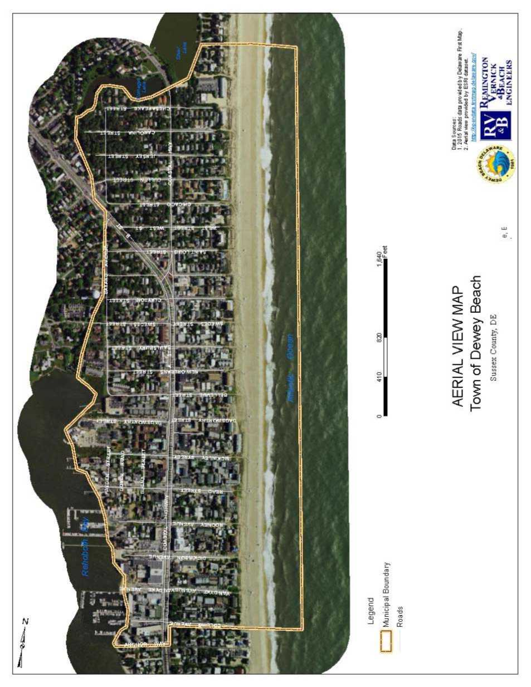

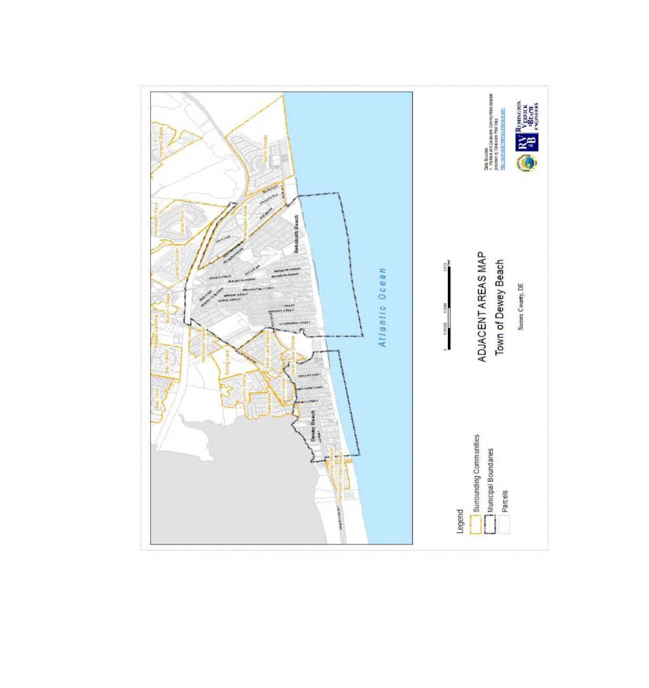
lAUW I'I™" ■ICWI-W nftfi
tc««»ru
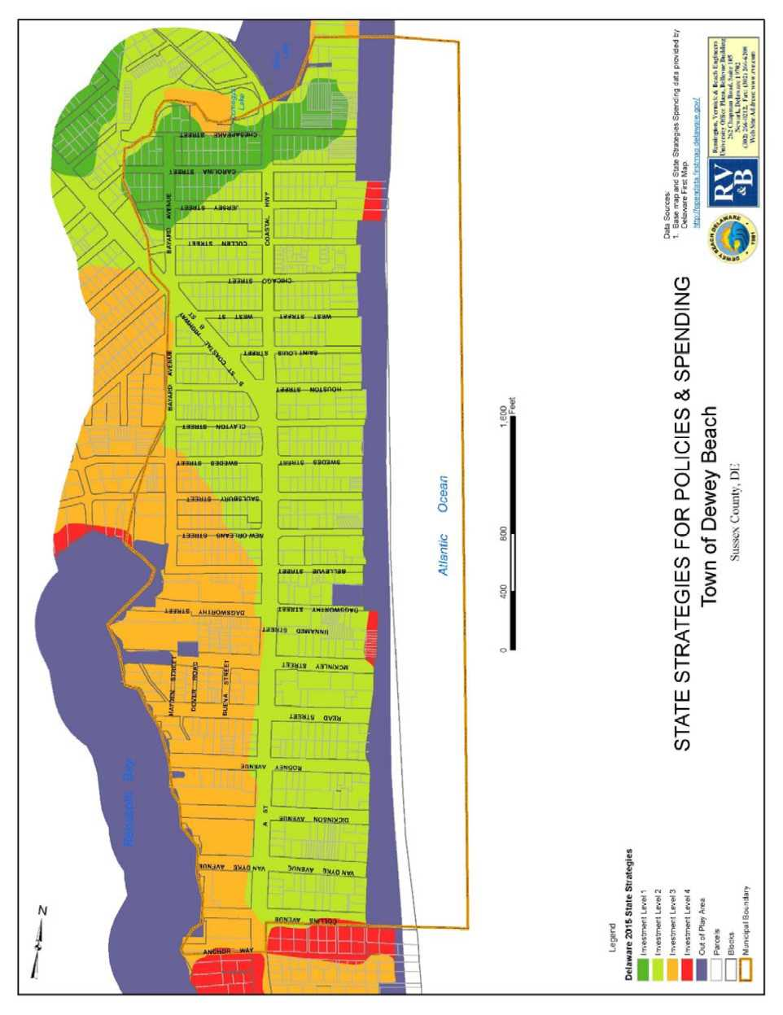

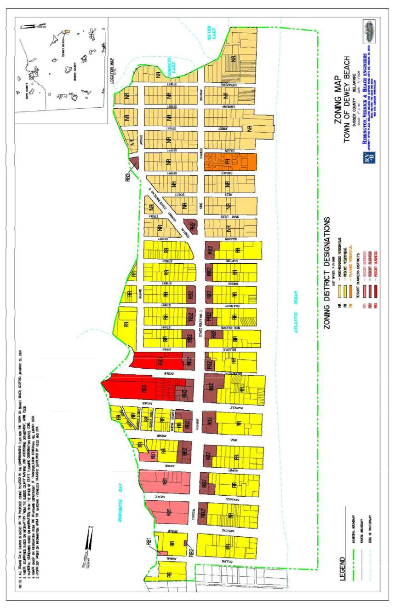

Legend
m Udal 0 pen Waters ^ Non Tidal Open .Vaters FEMA Flood Maps A
□ 193 yr toodplas' - base S<x>3 sev=6oit= aatermreo
El A£, FLOODWAY
AO loMpairi - fc»3 :epfts c<l to S1i
CftMi*H«4JOft*,wtin*looiyn«*rd<**saK»on)
X, 0.2 PCT ANNUAL CHANCE FLOOD HAZAftD Parcels | Blocks
la Municipal Boundary
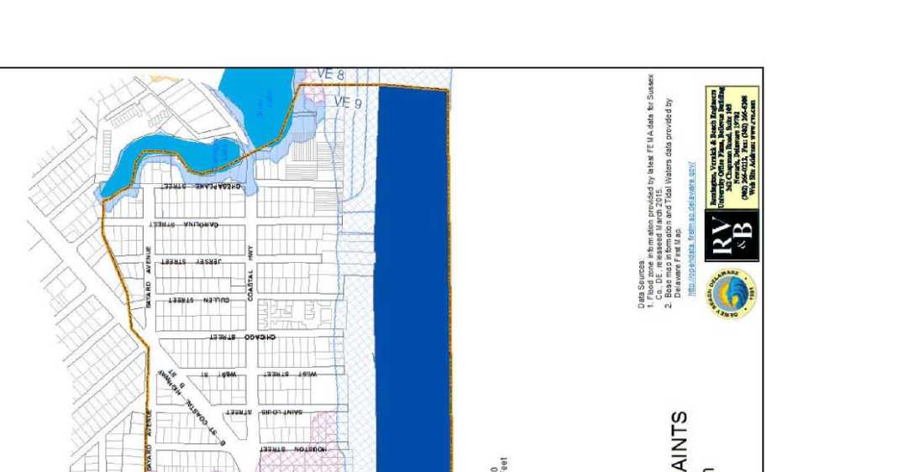
Town of Dewey Beach 71 2017 Comprehensive Plan Update
1,600
■ Feel

Map 5
ENVIRONMENTAL CONSTRAINTS
Town of Dewey Beach
Data Sources:
1 Flood rone information provided by latest FE M A data Ibr Sussex Co., DE , releaseed March 20f5.
2. Base map information and Tidal Waters data provided by Del a wire First M ap
nttc.j.dpendais tirsfan se.deiSY.are oov/
Sussex County? DH

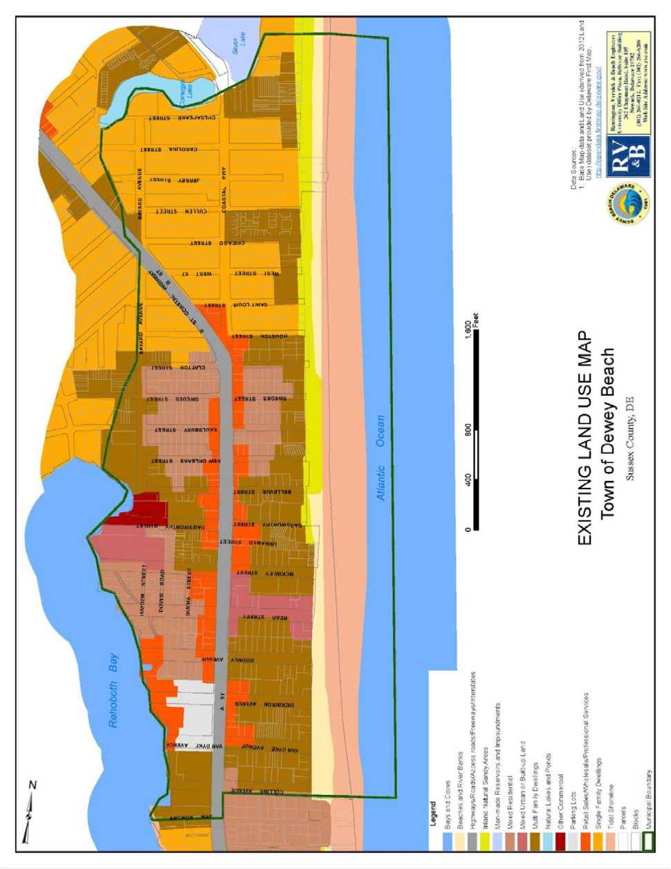

Data Sources.
1 635« M-ap dais and La*id Uso (denvod from 2015^ce-is) datasocprovided by Dal awareTirsi Map



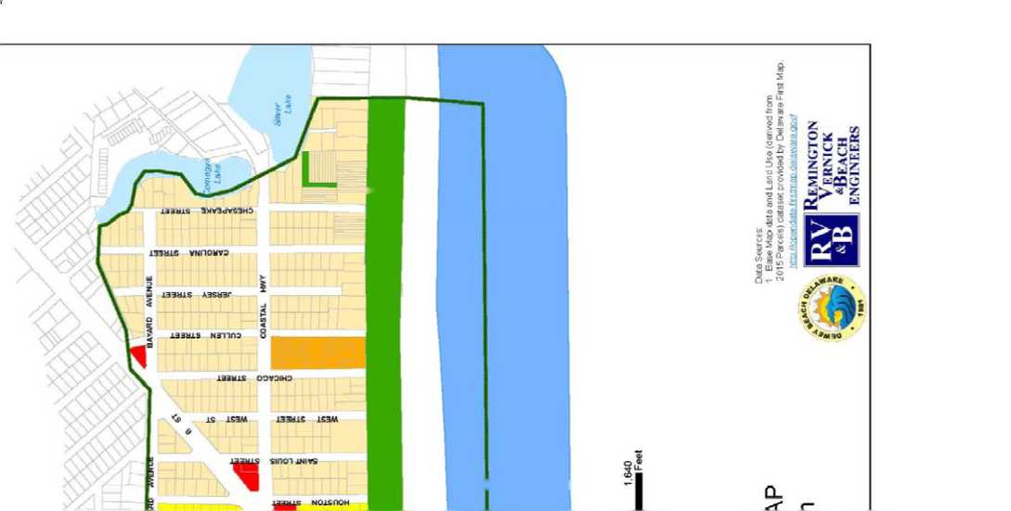
Town of Dewey Beach 73 2017 Comprehensive Plan Update

Map 7
Rehoboth Bay
Atlantic Ocean
Lege rid
] Municipal Boundary Lakes
Bays and Coves Parcels
Future Land Use
Neighborhood Residential Planned Residential Resort Residential | Commercial | Open Space
0 410
820
1.640
MFeel

FUTURE LAND USE MAP
Town of Dewey Beach
Sussex County, DE
irta ftopandata ftslrrap dataware govr
Remington
V FIRNICK
“Beach
ENGINEERS

ADDENDUM
A1. DEMOGRAPHICS AND POPULATION GROWTH DATA
19
Demographics of Resident Population
In 2010, the resident population of the Town of Dewey Beach was 341 and estimated at 250 in 2015. Having grown by almost 50% in the prior 10 years, from 2000 to 2010 the apparent population "growth rate” slowed as Dewey Beach’s year-round population grew by a mere 13%. This is approximately two-thirds that of Delaware as a whole (37%); a striking one-third that of Sussex County (20%). Unlike Sussex County where much of this population growth is driven by residential development of previously undeveloped lands, 99% of the parcels in Dewey Beach have already been developed; there is negligible space for new housing development. Therefore the increases in year-round population numbers, the "population growth” measured by census data probably reflects small changes in use of the 1,500 to 2,000 housing units from shorter-term rentals and second homes to permanent residences. Dewey Beach’s population growth rate between 2000 and 2010 is also significantly less than that for the neighboring communities of Rehoboth Beach (14%) and Bethany Beach (17%) which have similar demographics and housing. Table A1 displays population data for the Town of Dewey Beach, Sussex County, and the State of Delaware.
Table A1 - Total Population, 1960-20
Place | 1960 | 1970 | 1980 | 1990 | 2000 | 2010 | 2015
Dewey Beach | — | — | — | 204 | 301  (+47.5%) | 341  (+13.3%) | 250  (+/- 10.1%)
Sussex County | 73,195 | 80,356  (+9.8%) | 98,004  (+22.0%) | 113,847  (+16.2%) | 157,430  (+38.3%) | 215,622  (+37.0%) | 207,302 (+/- 0.1%)
Delaware | 446,292 | 548,104  (+22.8%) | 594,338  (+8.4%) | 669,069  (+12.6%) | 786,448  (+17.5%) | 945,934  (+20.2%) | 926,454 (+/- 0.1%)

Population Projection
Population projections are often difficult to accurately compose and are very unreliable for small geographic areas, because there is a large margin of error when manipulating relatively small numbers. Therefore, state sources do not typically calculate population projections for towns the size of Dewey Beach. One method of estimating future municipal population is to project it as a percentage of the growth projected for the larger surrounding area. Another is to project forward the existing trend line for growth within the municipality.
The first scenario uses the U.S. Census population data and estimates for Dewey Beach from 1990 to 2010, included in Table 1. The population counts for this period indicate that between 2000 and 2010 the residential population grew by an average annual rate of about 1.3 percent.
Using this figure as the standard for projection, a lower bound for the population projection can be derived.
The second scenario calculates the Town’s portion of the official county population projection to 2030 based upon the percentage of the total County population residing in Dewey Beach in 2010, approximately 0.16 percent. Reliable population projections for Sussex County are available and regularly updated by the Delaware Population Consortium. Using this method, a more aggressive population projection is derived.
Figure A1 and Table A2 display the results of these two scenarios. It is proposed that the future population of Dewey Beach will lie within the range shown by these two projection methods. However, it is again important to note that these projections are not necessarily reliable and are provided only for some basic information regarding the anticipated future of the Town and the content of its community. An important factor in the growth of the Dewey Beach community is the rate at which the Town transforms from a summer resort community to an increasingly permanent, year-round community.
Table A2 - Population Projection Scenarios, Town of Dewey Beach, 2000-2030
Growth Scenario | 2000 | 2010 | 2020 | 2030
Scenario 1: Trend Projection of Decadal Growth | 301 | 341 | 386  (+13.3%) | 431  (+13.3%)
Scenario 2: Portion of Projected Sussex County Population | 301 | 341 | 467  (+37.0%) | 639  (+37.0%)

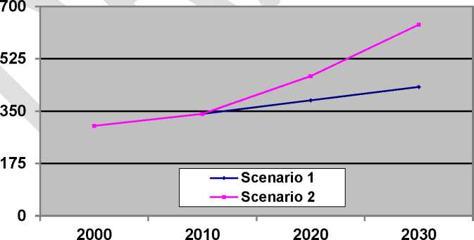
Figure A1 - Population Projection Scenarios, Town of Dewey Beach, 2000-2030
A parcel survey completed in 2005 showed that the town has little undeveloped land. This seems to indicate that population growth in the future will likely be driven by existing seasonal residents or rental property owners relocating permanently to Dewey Beach or selling their existing property to year-round owners, rather than new residential developments. However,
individual tastes and market forces, both of which are impossible to predict, will continue to determine future trends in population and development.
Racial Composition
Tables A3 and A4 detail the racial composition of the Town of Dewey Beach as compared to Sussex County and the State of Delaware. Dewey Beach’s population includes a greater proportion of non-minority persons than Sussex County or the State of Delaware. Diversity, has not increased significantly. While this data does not directly indicate any need for policy changes or specific public service needs, the relative diversity of the Town’s population in comparison to the surrounding area is an important part of a comprehensive profile of the community.
Table A3 - Racial Composition (%) by Place²⁰
Race | Dewey  Beach  2000 | Dewey  Beach  2010 | Dewey  Beach  2015 | Sussex  County  2010 | Sussex  County  2015 | Delaware  2010 | Delaware  2015
White | 91.7 | 93.3 | 99.6 | 80.9 | 81.5 | 71.0 | 69.4
Black | 0.3 | 3.5 | 0.0 | 14.0 | 12.7 | 22.9 | 21.6
Asian | 3.7 | 0.3 | 0.4 | 1.3 | 1.1 | 1.1 | 3.6
Other | 4.3 | 2.9 | 0.0 | 3.8 | 4.7 | 5.0 | 5.4

Table A4 - Hispanic or Latino Population, (%) 1990-2015
 | Dewey  Beach | Sussex  County | Delaware
1990 | 0.5 | 1.3 | 2.4
2010 | 5.9 | 8.6 | 8.2
2015 | 2.4 | 9.2 | 8.7

Age
Tables A5 and A6 provide some basic information regarding the age of persons living in Dewey Beach, Sussex County, and the state of Delaware.
Table A5 - Age Groups (%) by Place, 2010²¹
Age Range | Dewey Beach 2000 | Dewey Beach 2010 | Sussex County 2010 | Delaware  2010
0-19 years | 8.3 | 12.0 | 22.5 | 26.0
20-64 years | 63.5 | 60.7 | 56.7 | 59.5
65+ years | 28.2 | 27.3 | 20.8 | 14.5

Table A6 - Age Profile of Adult Population (%) by Place, 2010
Age Range | Dewey  Beach  2000 | Dewey  Beach  2010 | Sussex  County  2010 | Delaware  2010
20-29 years | 13.3 | 5.3 | 10.7 | 13.4
30-39 years | 9.6 | 10.3 | 10.3 | 12.2
40-49 years | 16.9 | 16.2 | 13.1 | 14.3
50-59 years | 15.0 | 16.5 | 14.6 | 15.7
60-69 years | 16.6 | 18.2 | 15.1 | 10.6
70-79 years | 13.6 | 12.1 | 9.0 | 6.1
80+ years | 6.6 | 7.3 | 4.7 | 3.7

The Town’s population is relatively older than the population of either Sussex County or the state. The proportion of Dewey Beach residents under the age of nineteen is about half that of the county and the state. More important than the proportion, the total number of residents who are 19 years of age or younger suggests minimal needs for educational facilities, daycare services, and other child-related institutions. The proportion of adults 20-64 years of age in Dewey Beach is relatively similar to that of Sussex County and the state as a whole. Regarding seniors, Dewey Beach’s proportion of persons 65 years of age or over is substantially higher than in the County, and nearly double the proportion in the state. While high (36.8%), the proportional distribution of residents who are in their 60s, 70s, and 80s has not changed significantly in the past decade, Overall, the town displays the characteristics of a relatively older community that can be expected to require services conducive to the needs of seniors.
Education
Table A7 presents data regarding the educational attainment of persons over the age of 25 living in Dewey Beach (262), Sussex County (137,183), and Delaware (587,903). As shown, the most common educational level of attainment for the Town of Dewey Beach is a bachelor’s degree. The most common highest level of educational attainment for the county and the state is a high school diploma. Nearly four-fifths of the working-age population of Dewey Beach has education beyond the high school level. At 58.4%, the proportion of individuals in Dewey Beach with a college education or higher is more than double that of the state as a whole (27.7%), and almost triple that of Sussex County (21.2%). This data suggests a significant potential within the resident population for contributive public involvement in knowledge-intensive project design and implementation.
Table A7 - Educational Attainment (%) by Place
Highest Level Achieved | Dewey  Beach  2000 | Dewey  Beach  2010 | Dewey  Beach  2015 | Sussex  County  2010 | Delaware  2010 | Delaware  2015
No High School | 2.0 | 0.0 | 7.0 | 5.1 | 4.2 | 4
Some High School | 0.0 | 5.0 | 1.3 | 9.7 | 8.7 | 7.7
High School Diploma | 19.4 | 14.1 | 9.7 | 37.4 | 32.2 | 31.1
Some College | 19.0 | 18.7 | 13.2 | 19.0 | 19.8 | 19.7
Associate Degree | 11.7 | 3.8 | 10.6 | 7.6 | 7.4 | 7.5
Bachelor’s Degree | 26.6 | 36.3 | 36.1 | 12.7 | 16.6 | 17.8
Graduate or Professional  Degree | 21.3 | 22.1 | 22 | 8.5 | 11.1 | 12.2

Income and Poverty
Table A8 shows median-household-income data for Dewey Beach, Sussex County, and the state of Delaware.
Table A8 - Median Household Income, 2010
Dewey  Beach  2000 | Dewey  Beach  2010 | Dewey  Beach  2015 | Sussex  County  2010 | Sussex  County  2015 | Delaware  2010 | Delaware  2015
$79,471 | $71,667 | $66,875 | $51,046 | $81,183 | $57,599 | $60,509

Personal income in Dewey Beach did not grow significantly between 2000 and 2010, but in 2010 was significantly higher than that in Sussex County and the State. In 2015, household incomes declined in Dewey Beach by roughly 7%. While more recent figures outpace the State median, the County had the highest median income. While this does not necessarily translate into direct benefits to the Town, the higher income levels enjoyed by residents in Dewey Beach facilitate property maintenance and improvements that allow for the preservation of the town’s community environment more easily than in other communities in the state. The relatively high amount of disposable income held by local residents may also make Dewey Beach an attractive
location for economic development, which provides residents and local officials with significant power to carefully define and attract the businesses and commercial services that are truly desired and beneficial for the local and regional community.
Table A9 displays data regarding poverty status among the populations of Dewey Beach, Sussex County, and the state of Delaware. Poverty status is determined by the U.S. Census by the use of specific poverty thresholds identified and refined each year by the federal government. Poverty thresholds are the statistical version of the poverty measure and are issued by the U.S. Census Bureau. They are used for calculating the number of persons in poverty in the United States or in states and regions
Table A9 - Poverty Status (%) by Age Group and Place, 2010-2015
Age Group | Dewey  Beach  2010 | Dewey  Beach  2015 | Sussex  County  2010 | Sussex  County  2015 | Delaware  2010 | Delaware  2015
All Ages | 5.1 | 12 | 11.7 | 12.6 | 11.0 | 12
0-17 years | 0.0 | 26.7 | 20.4 | 21.6 | 16.3 | 17.5
18-64 years | 1.6 | 10.5 | 10.4 | 12.2 | 9.8 | 11.4
65+ years | 7.1 | 11.7 | 6.5 | 6.1 | 7.3 | 6.8

As shown, the Town hosted a much lower percentage of persons living in poverty in 2010 as compared to 2015, as well as the County and State as a whole. Considering the large proportion of seniors living in the Town, nearly 12% over 65 years of age were reported as living in poverty in 2015. This information is helpful when developing policies, services, and facilities necessary to provide support to the impoverished population.
A2. Housing and Housing Growth
This section of the plan addresses the current and future housing needs of Dewey Beach, including a detailed analysis of the Town’s housing stock and a plan for future housing.
Total Housing Units
Housing, or dwelling units, are defined as one or more rooms, designed, occupied, or intended for occupancy as a separate living quarter, with cooking, sleeping, and sanitary facilities provided within the dwelling unit for the exclusive use of a single family maintaining a household. Table A10 displays some basic data on total housing for the town, county, and state over the past five decades. These data do not include hotel, motel or bed & breakfast rooms, nor do they include institutional structures such as hospitals. The data for Dewey Beach indicates relatively slow growth in total housing as compared to the County. This should not be
surprising since over 80% of the residential-use land area of the town had been developed prior to the 1990s. Assuming that this is the case, policies and regulations regarding local housing and residential areas should be aimed at preserving the integrity, quality, and sustainability of the existing housing stock of Dewey Beach.
Table A10 - Total Housing Units, 1960-2015
Year | Dewey  Beach | Sussex  County | Delaware
1960 | -- | 29,122  (--) | 143,725  (--)
1970 | -- | 34,287  (+17.7%) | 180,233  (+25.4%)
1980 | (see Table 11) | 54,694  (+59.5%) | 238,611  (+32.4%)
1990 | 1,314  (--) | 74,253  (+35.8%) | 289,919  (+21.5%)
2000 | 1,356  (+3.2%) | 93,070  (+25.3%) | 343,072  (+18.3%)
2010 | 1,490  (+9.9%) | 123,036  (+32.2%) | 405,885  (+18.3%)
2015 | 1,532 | 127,680 | 414,416

Housing Types
Table A11 and A12 provide data regarding the types of residential structures located in Dewey Beach.
Table A11 - Housing Types, (%) by area, 2010
Housing Type | Dewey | Sussex | Delaware
 | Beach | County
Single Family, Detached | 38.3 | 59.3 | 60.9
Single Family, Attached | 14.6 | 4.8 | 14.5
Multi-Family | 46.1 | 9.7 | 18.7
Mobile Home, Boat, Other | 1.0 | 26.2 | 8.3

The Town has a relatively small proportion of single-family dwellings and a relatively large proportion of multi-family dwellings compared to the State, Sussex County, and neighboring coastal Towns. This makes sense in consideration of the town’s location and its history as a traditional coastal resort community. The relatively high proportion of multi-family dwellings in
Dewey Beach potentially creates some unique issues for the Town regarding residential management and public policy. For example, depending upon the tastes and preferences of potential residents, this housing stock may directly impact the number and type of individuals, groups, and families who visit or relocate to Dewey Beach in the future.
Table A12 - Housing Types for Delaware’s Coastal Towns and Cities (%), 2000²³
Housing  Type | Dewey  Beach | Bethany  Beach | Fenwick  Island | Henlopen  Acres | Lewes | Rehoboth  Beach | South  Bethany
Single  Family,  Detached | 38.3 | 72.1 | 88.6 | 100.0 | 68.6 | 60.1 | 97.4
Single  Family,  Attached | 14.6 | 18.6 | 6.4 | 0.0 | 11.6 | 3.8 | 1.3
Multi-Family (2-9 Units) | 37.1 | 8.5 | 0.7 | 0.0 | 15.6 | 9.9 | 1.1
Multi-Family (10-19 Units) | 5.9 | 0.3 | 1.2 | 0.0 | 2.4 | 2.0 | 0.0
Multi-Family (20-49 Units) | 2.9 | 0.2 | 0.0 | 0.0 | 0.9 | 3.1 | 0.0
Multi-Family (50+ Units) | 0.2 | 0.0 | 0.3 | 0.0 | 0.0 | 18.1 | 0.0
Mobile  Home, Boat, Other | 1.0 | 0.3 | 2.8 | 0.0 | 0.9 | 3.0 | 0.2

Age of Housing Stock
Tables A13 and A14 outline recent data regarding the age of local housing stock compared to the county and state as well as the region’s other local beach towns. In general, the housing in Dewey Beach is relatively older than that in the county and state. The majority of the local housing was built before 1970, and the median year for housing built in Dewey Beach is 1969, earlier than that of Sussex County and the state by over 10 years.
²³ U.S. Census Bureau, 2000
Table A13 - Age of Housing (%)
Period Built | Dewey  Beach | Sussex  County | Delaware
2000-2010 |  |  | 17.0
1990-2000 | 20.1 | 28.9 | 16.5
1980-1989 | 17.5 | 23.7 | 15.5
1970-1979 | 10.2 | 18.3 | 13.6
1960-1969 | 33.0 | 9.8 | 11.6
1950-1959 | 11.4 | 6.7 | 10.7
1940-1949 | 5.0 | 4.3 | 5.2
1939 or Earlier | 2.8 | 8.3 | 9.7
Median Year Built | 1969 | 1981 | 1980

The Town of Dewey Beach experienced its most significant housing boom in the 1960s. This was a period following the devastating Easter 1962 ‘Noreaster which destroyed much of the prior housing in Dewey and throughout the region. It is also a period during which a particular Builder developed a significant portion of the northern half of Dewey Beach, building five different styles of one and one-and-a-half story beach cottages. While Dewey Beach does not host a significantly historic housing stock, such as that found in Lewes, the maintenance and redevelopment of housing in the town is increasingly becoming an issue as the existing housing stock ages and ground leases expire.
Period Built | Dewey  Beach | Bethany  Beach | Fenwick  Island | Henlopen  Acres | Lewes | Rehoboth  Beach | South  Bethany
1990-2000 | 20.1 | 22.4 | 14.9 | 5.2 | 25.6 | 5.3 | 23.6
1980-1989 | 17.5 | 32.8 | 26.8 | 16.5 | 17.8 | 8.0 | 32.6
1970-1979 | 10.2 | 24.4 | 24.9 | 8.2 | 9.8 | 30.0 | 18.1
1960-1969 | 33.0 | 8.6 | 9.2 | 21.1 | 8.3 | 15.2 | 16.4
1950-1959 | 11.4 | 2.7 | 15.8 | 32.0 | 5.8 | 14.0 | 8.9
1940-1949 | 5.0 | 5.0 | 4.2 | 5.7 | 7.2 | 12.8 | 0.4
1939 or  Earlier | 2.8 | 4.1 | 4.2 | 11.3 | 25.5 | 14.7 | 0.0
Median | 1969 | 1982 | 1977 | 1960 | 1973 | 1966 | 1982
Table A14 - Percentage of Housing Stock Built by Decade
24
²⁴ U.S. Census Bureau, 2000

Occupancy and Use
Table A15 includes 2000 data regarding the occupancy and use of vacant housing units in Dewey Beach and in other towns along the Delaware coast. The term "vacant housing” refers to housing that is no longer occupied by full time residents. Dewey Beach hosts the largest portion of vacant housing units found on the Delaware seashore. Of the unoccupied units in Dewey Beach, more than two-thirds are used as seasonal or occasional residences, and nearly a third are used as rental units.
Table A15 - Occupancy Status for Delaware’s Coastal Towns and Cities (2000)²⁵
Housing  Status | Dewey  Beach | Bethany  Beach | Fenwick  Island | Henlopen  Acres | Lewes | Rehoboth  Beach | South  Bethany
Occupied  Units | 180  (12.1%) | 476  (20.0%) | 184  (26.6%) | 72  (37.1%) | 1,333  (56.4%) | 852  (27.0%) | 280  (24.6%)
Seasonal or  Occasional  Use | 1,310  (87.9%) | 1,903  (80.0%) | 508  (73.4%) | 122  (62.9%) | 1,030  (43.6%) | 2,300  (73.0%) | 857  (75.4%)
Total  Housing | 1,490  (100.0%) | 2,379  (100.0%) | 692  (100.0%) | 194  (100.0%) | 2,363  (100.0%) | 3,152  (100.0%) | 1,137  (100.0%)

Value
Tables A16 and A17 show 2000 data regarding the value of housing in and around Dewey Beach. The median housing value in Dewey Beach is approximately twice that of Sussex County and the State.
Table A16 - Median Housing Value (2000)
 | Dewey  Beach | Sussex  County | Delaware
Median Value | $215,200 | $99,700 | $122,000

Among the towns along Delaware’s coast, however, Dewey Beach hosts the second-lowest median housing value. This may imply that housing is relatively more affordable in Dewey Beach for those who wish to purchase housing in the region. However, proximity to the Atlantic
²⁵ Data in Tables A15 - A17 from Dewey Beach 2007 Plan, not updated.
Ocean has a marked impact on local property values and it is difficult to compare relative values for a similar property from this coarse-grained data.
Table A17 - Median Housing Value for Delaware’s Coastal Towns and Cities (2000)
 | Dewey  Beach | Bethany  Beach | Fenwick  Island | Henlopen  Acres | Lewes | Rehoboth  Beach | South  Bethany
Median  Value | $215,200 | $184,000 | $283,300 | $558,800 | $243,500 | $296,000 | $242,600





Comprehensive Plan Working Group Members who are also on the Comprehensive Plan Committee.
“Preparing for Tomorrow’s High: Sea-Level Rise Vulnerability Assessment for the State of Delaware”, Delaware Coastal Program of the Delaware Natural Resources and Environmental Control’s (DNREC), July 2012.
HB 396 (a)
US Census Bureau, American Community Survey, 2011-2015 Five-Year Estimates.
2018 Draft Sussex County, Delaware Comprehensive Plan Update, accessed via www.sussexplan.com February 2017
Dewey Beach Financial Information - http://www.townofdeweybeach.com/Financial-Information/
U.S. Census Bureau’s American Fact Finder at www.factfinder.census.gov
U.S. Census Bureau, 2011-2015 American Community Survey 5-Year Estimates
Delaware Economic Development Office (DEDO)
DEDO via the U.S. Natural Resources Defense Council rating
American Community Survey 5-Year Estimates; Selected Economic Characteristics
American Community Survey Five-Year Estimates; Selected Economic Characteristics
Bureau of Labor Statistics, Unemployment Rates for Counties in the Delmarva Peninsula, December 2016.
A guy wire or guy is a tensioned cable designed to add stability to a free-standing structure. Guy wires are commonly seen on utility poles to support unbalanced lateral loads due or to resist ground movement.
"The Contribution of the Coastal Economy to the State of Delaware”, released by the Delaware Sea Grant College Program at the University of Delaware, June 2012.
“Preparing for Tomorrow's High Tide: Sea Level Rise Vulnerability Assessment for the State of Delaware”, 2012
“Preparing for Tomorrow's High Tide: Recommendations for Adapting to Sea Level Rise in Delaware Executive Summary”, September 2013
US Census Bureau, American Community Survey, 2011-2015 Five-Year Estimates.
Delaware Wildlife Action Plan 2015-2025, DNREC Division of Fish and Wildlife
U.S. Census Bureau, see www.factfinder.census.gov
2015 Figures from U.S. Census Bureau, 2011-2015 American Community Survey 5-Year Estimates
Age group and age profile figures are available through the U.S. Census Bureau, 2011-2015 American Community Survey 5- Year Estimates; however, the age ranges have changed and do not provide a side-by-side comparison with 2000 and 2010 figures.
Data from U.S. Census Bureau, see www.factfinder.census.gov, and 2007 Plan.

