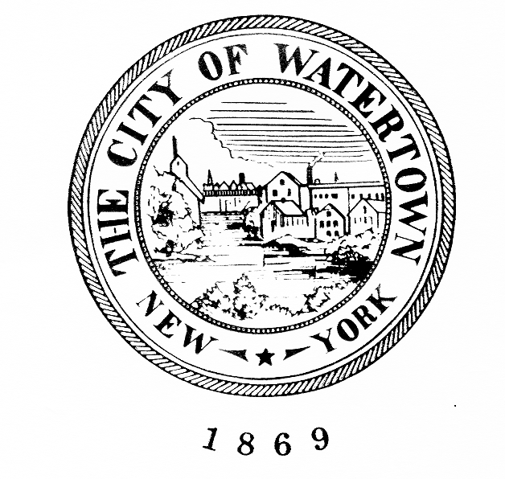
CITY OF WATERTOWN, NEW YORK
ROOM 302, WATERTOWN CITY HALL
245 WASHINGTON STREET
WATERTOWN, NEW YORK 13601
(315) 785-7730

KENNETH A. MIX

City Manager

PRESS RELEASE

May 4, 2021
For Immediate Release
Contact: City Manager’s Office

CITY COUNCIL SCHEDULES SEVERAL
BUDGET WORK SESSIONS

MAYOR SMITH AND CITY COUNCIL MEMBERS
HAVE SET A SERIES OF WORK SESSION MEETINGS

Several Work Sessions have been scheduled to discuss the Fiscal Year 2021-2022 Proposed Budget as follows:

May 7, 2021 4:00 p.m. Parks & Recreation, Water and Sewer
May 8, 2021 9:00 a.m. Police, Fire, Department of Public Works, Flower Memorial Library
May 10, 2017 6:00 p.m. General Government Support

All meetings will take place in City Council Chambers on the third floor of City Hall. For further information or questions, contact the City Manager’s Office at 315-785-7730.

