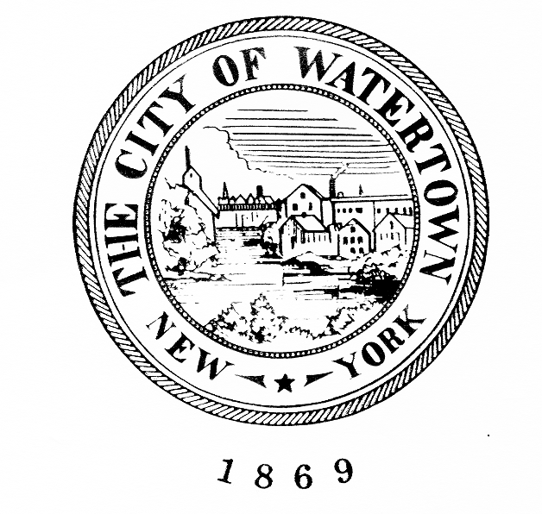City Of Watertown, New York

City Planning Commission

Room 305, Watertown City Hall

245 Washington Street

Watertown, New York 13601-3380

(315) 785-7741

**Planning Commission Meeting Minutes**

**September 3, 2025**

|  |  |
| --- | --- |
| Present:  Michelle Capone, Chair  Peter Monaco  T.J. Babcock  Maryellen Blevins  Lynn Godek  Absent:  Linda Fields  Scott Garrabrant | Also:  Michael A. Lumbis, Planning & Community Development Director  Geoffrey Urda, Senior Planner  Joseph Albinus, Planner  Kerinne O'Donnell, Secretary |

Planning Commission Chairperson, Michelle Capone, called the September 3, 2025, Planning Commission meeting to order at 6:00 p.m. Ms. Capone asked for a motion regarding the minutes of the August 5, 2025, meeting. Timothy Babcock made a motion to accept the minutes as written. Maryellen Blevins seconded the motion, and all voted in favor.

**SITE PLAN APPROVAL –**

**1068 ARSENAL STREET – PARCEL NUMBER 8-47-106.200**

The Planning Commission then considered a request for site plan approval for the request submitted by Brian Evans of Brew Team NY, LLC to construct a 510 square foot, drive through coffee shop, a 338 square foot storage building and associated site improvements at 1068 Arsenal Street, Parcel Number 8-47-106.200.

Larry Adler attended to represent the request. Mr. Adler addressed the Planning Commission and began by giving an update on the revised plans, which were based on comments from the previous review. Mr. Adler said that his team made revisions based on New York State Department of Transportation (NYSDOT) feedback and City Engineer, Thomas Compo, also communicated his approval. Mr. Adler then asked the Planning Commission if there were any questions.

Mr. Monaco asked about the sign detail. Mr. Adler confirmed that it would be a Type A sign detail. Ms. Capone then confirmed that the requirements for obtaining permits as outlined in the staff report would remain as a condition of approval.

Ms. Capone also noted that the State Environmental Quality Review (SEQR) Short Environmental Assessment Form (EAF) had already been completed by the Planning Commission at the August 5, 2025 meeting and the board issued a negative declaration according to the requirements of SEQR. She noted that the minor changes to the site plan did not affect the determination that the project would not have a significant impact on the environment.

Hearing no further discussion, Mr. Babcock made a motion to grant Site Plan Approval to Brian Evans of Brew Team NY, LLC to construct a 510 square foot, drive through coffee shop, a 338 square foot storage building and associated site improvements at 1068 Arsenal Street, Parcel Number 8-47-106.200, as shown on plans submitted to the Planning and Community Development Department on August 26,2025, contingent upon the following:

1. The applicant shall revise the break-away signpost detail to a Type A sign support detail.
2. The applicant must obtain the following permits, minimally, prior to construction: Building Permit, Sanitary Sewer Connection Permit, Water Supply Permit and a Zoning Compliance Certificate.
3. The applicant must obtain a Highway Work Permit from the New York State Department of Transportation (NYSDOT) for any work to be performed within the Arsenal Street Right-of-Way.

Mr. Monaco seconded the motion, and all voted in favor.

**PUBLIC HEARING – SPECIAL USE PERMIT**

**400 WASHINGTON STREET, PARCEL NUMBER 10-15-120.100**

Ms. Capone then called a public hearing to order at 6:05 p.m. for a Special Use Permit to allow an accessory drive-through at 400 Washington Street, Parcel Number 10-15-120.100. She began by reading the legal notice for the public hearing that had been published in the *Watertown Daily Times* and asking if there were any comments from the public. Hearing none, she closed the public hearing at 6:06 p.m.

**SITE PLAN APPROVAL AND SPECIAL USE PERMIT**

**400 WASHINGTON STREET, PARCEL NUMBER 10-15-120.100**

**CARTHAGE SAVINGS BANK**

The Planning Commission then considered a request submitted by Mark Tompkins, P.E. of GYMO, D.P.C. on behalf of Carthage Savings Bank for Site Plan Approval to construct an approximately 8,600 SF office building and associated site improvements, and a Special Use Permit to establish an accessory Drive-Through use at 400 Washington Street, Parcel Number 10-15-120.100.

Mark Tompkins, P.E. of GYMO, D.P.C, attended to represent the request.

Mr. Monaco asked why a Special Use Permit was needed if the property had previously been a bank. Mr. Urda replied that while the bank use is allowed by-right, the accessory drive-through use would require a Special Use Permit in an Urban Mixed Use zoning district.

Mr. Tompkins was then invited to speak on the project. He presented the plans while Mr. Urda displayed them on screen. Mr. Tompkins began by stating that the new driveways would be two lanes instead of four and that vehicles existing from the property would only be permitted to turn right existing Washington Street. He then said that all new utility connections would be installed, using the same sewer lateral and water connections as the neighboring property. Mr. Tompkins also shared a street view rendering of the proposed building and opened the floor for questions.

Ms. Blevins asked about discharged pipes. Mr. Tompkins confirmed that he would coordinate with the City Engineering Department, and that the only summary item that he was requesting to revise was regarding the bio-retention area.

Ms. Blevins also inquired about fire truck access. Mr. Urda replied that Code Enforcement Officer, Mike Compo was satisfied with the current plan. Mr. Urda then asked Mr. Tompkins to confirm whether stop bars would be added to the plans, as required by Summary Item 5. Mr. Tompkins confirmed that stop bars would be added to both driveways.

Ms. Capone then asked about the first summary item in Staff’s memorandum, which required the applicant to mow the bio-retention area once per year, in the fall, to prevent weed trees from growing and interfering with runoff diversion. Mr. Tompkins requested that the Planning Commission re-word that condition to state that the applicant shall conduct selected weeding and trimming instead of mowing, given some of the species scheduled for planting.

Ms. Capone then asked about the second summary item, which required the applicant to clarify the data conveyed in Section 4.3 of the Engineering Report to the satisfaction of the City Engineer. Mr. Tompkins replied that he would be working with the City Engineer and the City and clarified all the changes to the storm water quantity that was approved by the City Engineer.

Mr. Tompkins did mention the third summary item, which required the applicant to clarify if there were any ATM lanes proposed as part of the accessory drive-through, and whether they would be 24 hours a day. Mr. Tompkins said that one ATM drive-through lane was proposed that would be adjacent to the building and it would be 24 hours.

Mr. Tompkins then addressed the fourth summary item, which required the applicant to conduct a traffic study to determine whether sufficient gaps exist in Washington Street traffic for a left-turn exit lane to operate successfully. Mr. Tompkins said his team was no longer proposing to allow left turns onto Washington Street and that egress point would allow right turns only.

Having addressed the fifth summary item regarding stop bars when asked by Mr. Urda earlier, Mr. Tompkins then addressed the sixth summary item, which required the applicant to indicate on the plans where the existing sanitary and water utilities tie into City utilities and provide details for cutting and capping these utilities prior to demolition. Mr. Tompkins acknowledged the condition

Ms. Capone then asked about the seventh summary item, which listed all the permits that the applicant would need to obtain. Mr. Tompkins acknowledged the need for all the permits.

Ms. Capone then stated that the Planning Commission would need to consider the SEQR review. The Planning Commission then proceeded to complete Part 2 of the Short EAF, answering “No” to all the questions contained in Part 2. Lynn Godek then made a motion to issue a Negative Declaration pursuant to SEQRA. Mr. Babcock seconded the motion, and all voted in favor.

Hearing no further discussion, Ms. Capone then asked for a motion to approve the Site Plan and Special Use Permit.

Mr. Babcock then made a motion to grant Site Plan Approval to Mark Tompkins, P.E. of GYMO, D.P.C. on behalf of Carthage Savings Bank for Site Plan Approval to construct an approximately 8,600 SF office building and associated site improvements, and to grant a Special Use Permit to establish an accessory Drive-Through use at 400 Washington Street, Parcel Number 10-15-120.100, as shown on plans submitted to the Planning and Community Development Department on August 18, 2025, contingent upon the following:

1. The applicant shall conduct selected trimming and weeding of the bio-retention area once per year, in the fall, to prevent weed trees from growing and interfering with runoff diversion.
2. The applicant shall clarify the data conveyed in Section 4.3 of the Engineering Report to the satisfaction of the City Engineer.
3. The applicant shall add a painted and labeled stop bar to the plans in addition to the breakaway stop sign at the point where the drive-through exit lane crosses the Washington Street sidewalk.
4. The applicant shall indicate on the plans where the existing building’s sanitary and water utilities tie into City utilities and provide details for cutting and capping these utilities prior to demolition.
5. The applicant must obtain the following permits and other documentation, minimally, prior to construction: Demolition Permit, Building Permit, Zoning Compliance Certificate, Sidewalk Permit, and a General City Permit for work within the ROW.

Ms. Blevins seconded the motion, and all voted in favor.

Mr. Babcock then moved to adjourn the meeting. The motion was seconded by Mr. Monaco and all voted in favor. The meeting was adjourned at 6:20 p.m.

Respectfully submitted,

Kerinne O'Donnell

Secretary