MEMORANDUM

TO: Cape Elizabeth Planning Board
FROM: Maureen O'Meara, Town Planner
DATE: April 14, 2021
SUBJECT: Commercial space market assessment

Introduction

A member of the Planning Board has asked for information from commercial realtors about commercial space market conditions and how much change is expected post-covid.

Data Source

Realtors are selling a product, and inherently skew to be optimistic about future market conditions. The Planning Board has received comments from several commercial real estate brokers, including Greg Boulos (The Boulos Company), Brandon Mitchell (Malone Commercial Brokers) and TC Haffenreffer (The Dunham Group).

The Boulos Company annually collects real estate data and provides a market forecast. Because the data is not collected in relation to a specific project, it should be a relatively objective assessment of market conditions.

Class A and Class B office space

The following information is from the 2021 Greater Portland Market Outlook
prepared by the Boulos Company.

The Cape Elizabeth Town Center is too small to be included in the report as a suburban submarket. The chart does include a category for "all suburban markets" which might provide some insight into how commercial space in the Town Center will compete.

The report notes that existing leased space may be offered to sublease (gray space) in the short term, so actual vacancy rates may be higher. As a reference, The Portland downtown market typically absorbs 40,000+ sq. ft. of space annually and there is 270,000+ sq. ft. available now, plus gray space.
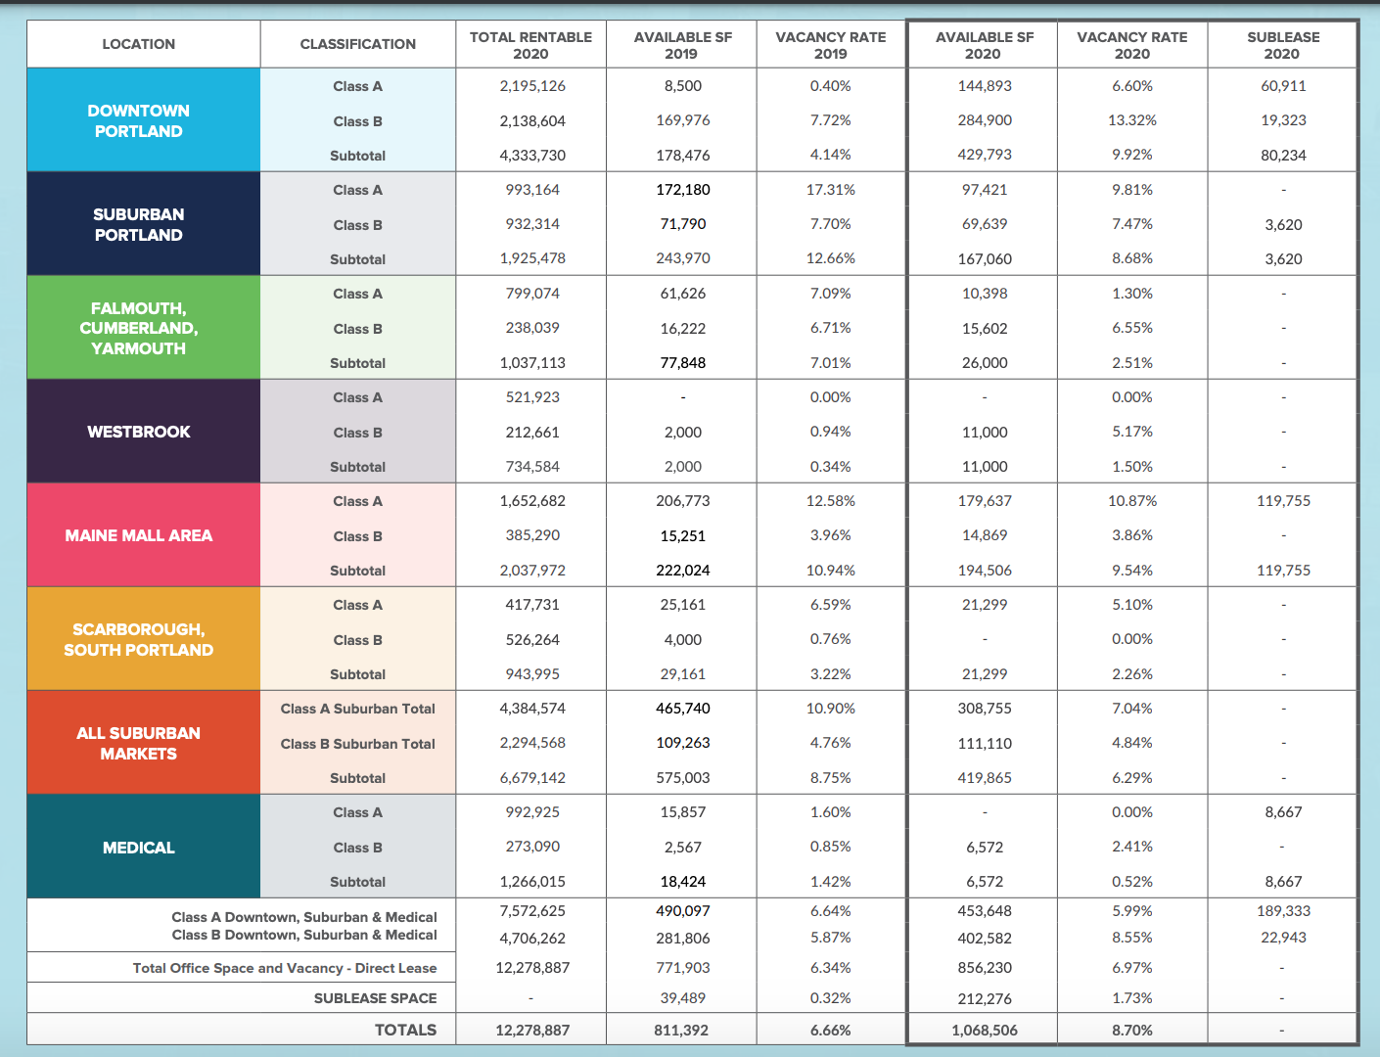

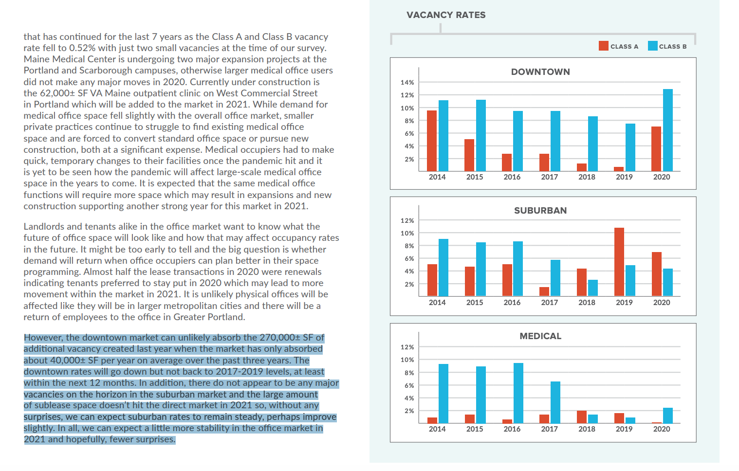

What to Expect Post-Covid

