Queen Acres Free Library
1 message

Maureen O'Meara <maureen.omeara@capeelizabeth.org>

Rachael Flaxman <rachael.flaxman@gmail.com> Wed, Apr 14, 2021 at 6:12 PM To: maureen.omeara@capeelizabeth.org

Hello Ms. O'Meara,

Thanks for filling me in on the ins and outs of the process to try to get our neighborhood book swap approved. I would like to present this to the conservation committee on 5/11 if possible.

I have attached 2 pictures of a similar library that my friend built for his neighborhood (theirs included a bulletin board on half, which we would not need) as well as a picture of the proposed location. My friend is willing to build ours. I've reached out to neighbors on our neighborhood Facebook page and all responses have been very positive and supportive.

I propose we place this on the green space (or, as we refer to it, "the oval") across from our house at 16 State Ave. This could be either close to, or on the more mature maple tree, or close to the newer yellowwood tree that was planted within the last few years. It would be far enough off the street and away from the corner where snowbanks build up. The structure could be attached to the mature maple tree or a free-standing post.
Please let me know if you have any questions at all. Thank you for your help in getting this on the agenda. Rachael Flaxman
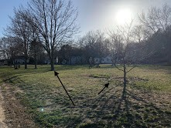
16 State Ave.

3 attachments

IMG_4227.jpeg
5031K

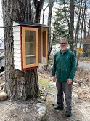
3E070E90-91B1-4C2E-84D1-E884EF8BF8C0.heic
2833K

7ED80796-BCF8-47E6-85A2-E98695583AC4.heic
2301K

