MEMORANDUM

TO: Cape Elizabeth Planning Board
FROM: Maureen O'Meara, Town Planner
DATE: May 18, 2021
SUBJECT: 287 Ocean House Rd Site Plan Amendments

Introduction

Yam Yams LLC is requesting amendments to the site plan approved for 287 Ocean House to alter outdoor storage and eliminate a finish pavement coat. The application will be reviewed for compliance with Sec. 19-9, Site Plan Regulations

Procedure

•The Board should begin by having the applicant introduce the amendments.
•The Board should allow public comment on completeness.
•The Board should then make a finding of completeness. If the application is deemed incomplete, board members should identify the information needed to make the application complete and no substantive review of the application should occur. If the application is deemed complete, review may begin.
•If the application is deemed complete, the Board should decide if a site walk and/or public hearing will be scheduled.
•At the end of discussion, the Board has the option to approve, approve with conditions, table or deny the application.

Summary of Completeness

The Completeness checklist, the comments of the Town Engineer, and the Public Works Director are attached.

The 287 Ocean House Rd site plan was approved by the Planning Board on July 21, 2020. Two sets of de minimis changes were approved by the Planning Board Chair on September, 2020 and October 5, 2020. When plan amendments are requested, submission items are limited to the information related to the changes because all other information has been submitted and approved by the Planning Board in the original approval.

The applicant has not submitted the proposed changes on the approved site plan. The submitted Site Plan Amendment plan is missing information which is relates to the amendments requested, specifically Note 8 describing outdoor storage and display materials. The following checklist gives credit to information submitted in the original site plan approval. For administrative clarity, the requested amendments should be shown on the approved "Site and Layout Plan."
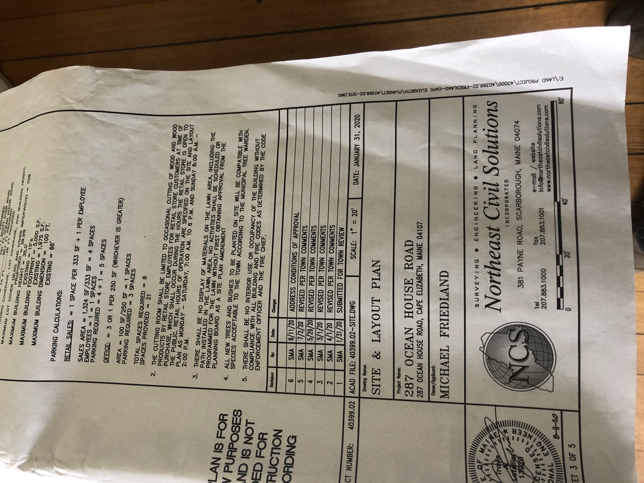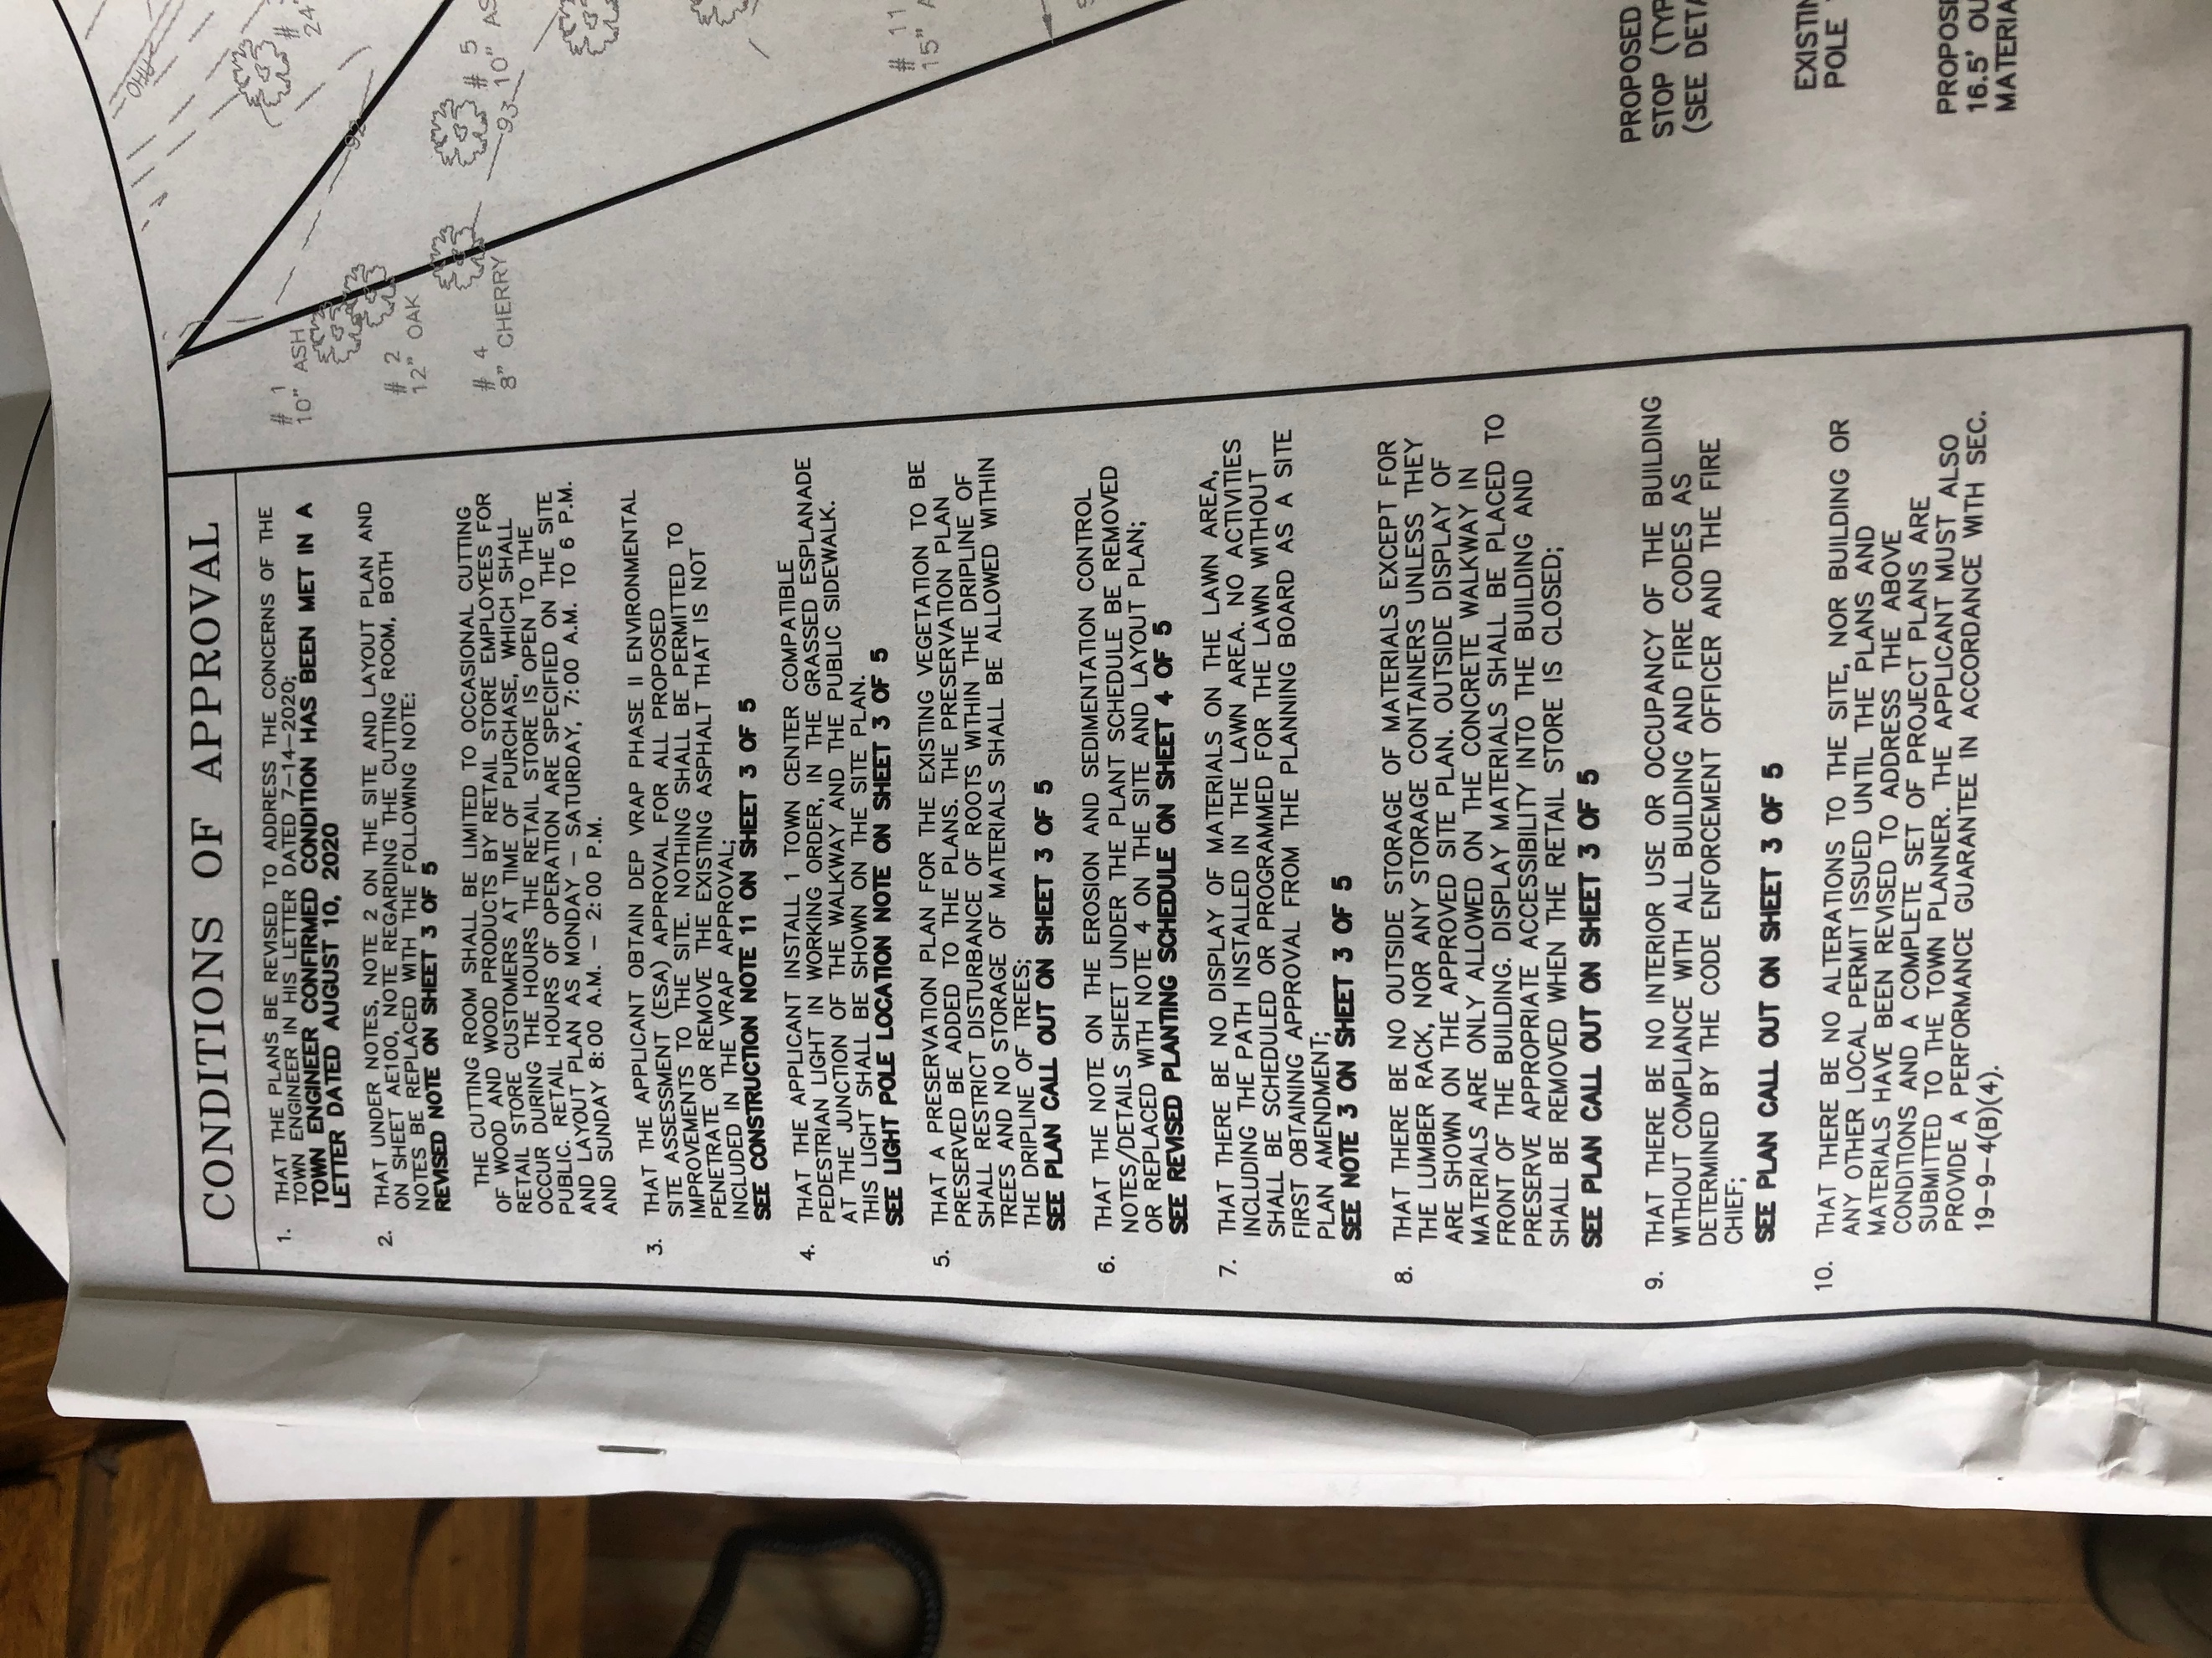

Title Block from original Site Plan Notes on original approved Site Plan,
approval including Note 8

The following items are potentially incomplete:

e. Existing Conditions. The Site Plan Amendment Plan is not a complete copy of the approved site plan with added proposed amendments. In particular, the note describing outdoor storage and display is missing.

q. Financial Capability. The applicant is requesting release from applying a topcoat to the parking area for financial reasons and the Planning Board might want up-to-date information on the applicant's financial capability.

Discussion

Beyond the level of completeness, the Planning Board may want to discuss the following items if the application is deemed complete.

1. Pavement requirements. The applicant is requesting elimination of the surface course pavement requirement. Sec. 19-9-5 (2), Traffic Access and Parking,(b) (vi) as follows:

vi. Construction. Road, driveway and parking lot construction comply with the construction and design standards in Sec. 16-3-2 of the Subdivision Ordinance.

Sec. 16-3-2 (B) (4) Paving as follows:

4. Paving.

a. HMA. Paving shall be of Hot Mix Asphalt (HMA) meeting the requirements of Section 401 and 403 of said MDOT Specifications. Placement of HMA shall conform to MDOT Specifications (Section 401). Sidewalk HMA shall be placed in two (2) one and one quarter (1.25) inch lifts using 9.5 mm mix. HMA thickness shall be as follows:

 | Base Course  19 mm Mix unless otherwise noted | Surface Course  12.5 mm Mix, except local roads which shall be 9.5 mm | Surface Course  9.5 mm fine Mix | Total
Arterial | 2.5 inches | 1.5 inches" | -- | 4 inches
Collector | 2.5 inches | 1.5 inches | -- | 4 inches
Rural Connector | 2.5 inches | 1.5 inches | -- | 4 inches
Feeder | 2.5 inches | 1.5 inches | -- | 4 inches
Local Roads | 2.5 inches of 19 mm | 1.5 inches | -- | 4 inches
Sidewalks | -- | -- | 2.5 inches | 2.5 inches

b. Base Course. The HMA base course shall be 19 mm mix for all classes of roads, except local roads and sidewalks which shall be 9.5 mm mix as defined in Section 703.09 of said MDOT Specifications. Sidewalk paving shall be 9.5 mm (fine) mix.

c. Placement. Placement of all HMA shall be in compliance with the technical requirements of Section 401 of said MDOT Specifications.

d. Driveways. Driveway entrances shall include a paved apron starting at the edge of road pavement and extending four (4) feet toward the property being served.

At the workshop, the Planning Board asked for information about paving specifications required on other approved projects. Below is a summary of projects with pavement construction in the Business districts.

2. Outdoor storage. Two different types of outdoor storage are allowed. Display storage is allowed in front of the building on the concrete walk with the limitation that the storage be removed when the business is not open. ADA access must also be preserved. The applicant is requesting that outdoor display be allowed to remain outdoors when the store is not open.

Site Plan requirements include screening of outdoor storage. The original approval included a storage shed to the north of the building which has not been constructed. The applicant is requesting that an expanded outdoor storage area be approved on the north side of the building, which will be screened with a wood stockade fence. It may be worth noting that outdoor storage is occurring on the site beyond the area that would be screened by the proposed fencing.

The applicant is also proposing to add a section of fencing on the back south side of the building to screen outdoor storage at the rear the building. The site plan should label the rear area as outdoor storage.

Motions for the Board to Consider

A. Motion for Approval

BE IT ORDERED that, based on the plans and materials submitted and the facts presented, the application of Yam Yams LLC for amendments to the site plan approved for 287 Ocean House Rd to alter outdoor storage and eliminate a finish pavement coat be deemed (complete/incomplete).

B. Motion to Table

BE IT ORDERED that, based on the plans and materials submitted and the facts presented, the application of Yam Yams LLC for amendments to the site plan approved for 287 Ocean House Rd to alter outdoor storage and eliminate a finish pavement coat be tabled to the June 15, 2021 meeting of the Planning Board [at which time a public hearing will be held.].

Site Plan Review Submission Checklist
[Section 19-9-4(c)]

Date: May 18, 2021
Project: 287 Ocean House Rd Site Plan Amendments
Applicant: Yam Yams LLC

Y a. Evidence of right, title, and interest in the property

Y b. Written description

Y c. Name of project/applicant

N/A d. Survey

P e. Existing conditions

Y f. Topography

Y g. Buildings

Y h. Traffic access and parking

N/A i. Stormwater

N/A j. Erosion

N/A k. Utilities

Y l. Landscaping

N/A m. Lighting

N/A n. Signs

N/A o. Noise

Y p. Exterior storage

P q. Financial and Technical Capability

Y Yes, complete
N No, not complete
W Waiver
P Partially complete
N/A Not applicable

