To: Conservation Commission for review at the June 8th Conservation Commission meeting

From: Cross Hill Residents

Purpose of Proposal: To seek approval for a book library on the green space in Cross Hill

We request the Conservation Commission grant permission for the residents of Cross Hill to install a proposed book Library on the Green Space in Cross Hill. While there are several options, we are interested in installing one like the while house in the photo below. This would be installed on a post after calling dig safe. The post style library would limit impact on the trees in the green space. We feel this would increase the use of the common space and add value to our community.

The attached Map are proposed sites for your review. We request option A or B as locations.

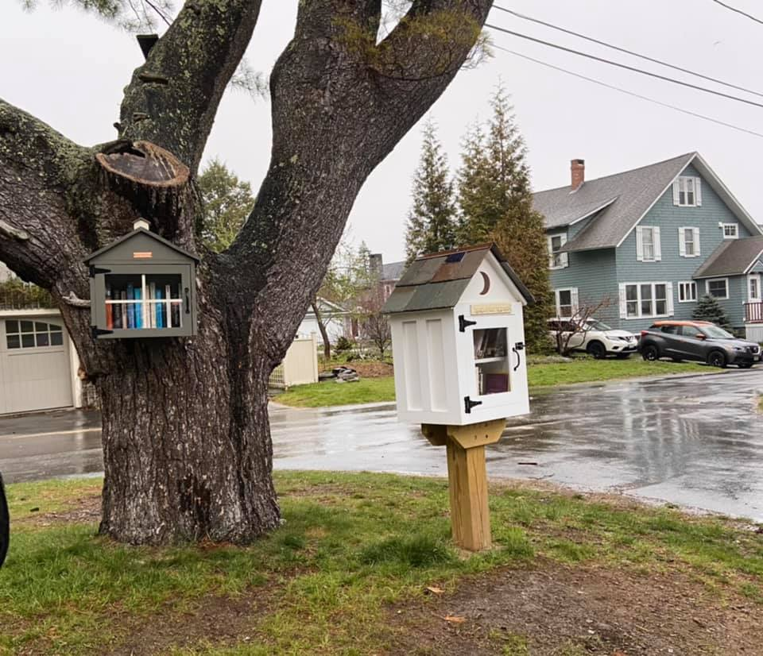

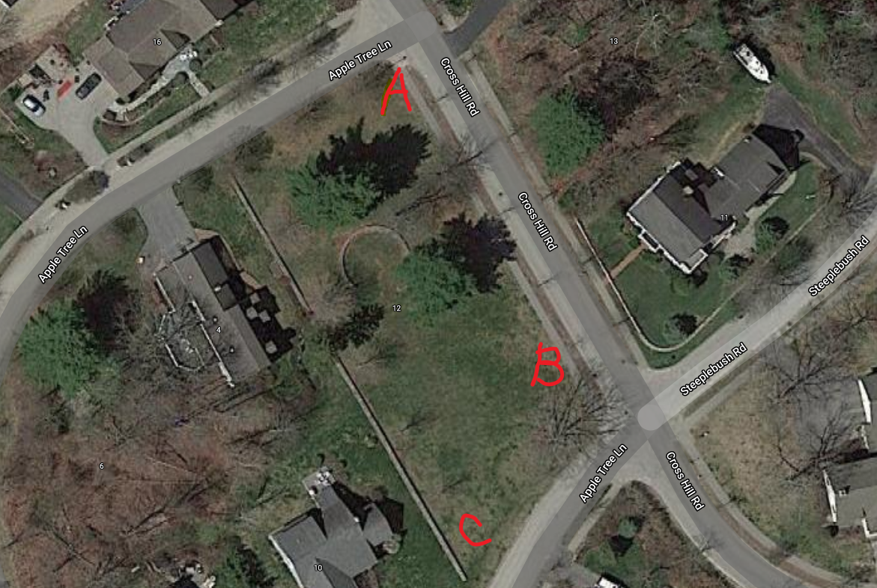

Site Map of proposed book Library

Respectfully submitted for your review,

Meredith Beauregard

Andie Mahoney