MEMORANDUM

TO: Matthew Sturgis, Cape Elizabeth Town Manager
Tom Hall, Scarborough Town Manager
FROM: Maureen O’Meara, Cape Elizabeth Town Planner
Jay Reynolds, Cape Elizabeth Public Works Director
Jami Fitch, Scarborough Sustainability Coordinator
DATE: January 27, 2022
SUBJECT: Sawyer Road/Street Culvert Evaluation

Introduction

The Towns of Cape Elizabeth and Scarborough are collaborating on future strategies for Sawyer Road (Cape Elizabeth) and Sawyer Street (Scarborough), which includes a 1,400’ long section of road crossing the Scarborough Marsh. Sawyer Street floods multiple times a year, the most recent event occurring on Monday, January 17th, 2022. The existing culvert is restricting tidal flows, resulting in scouring pools.

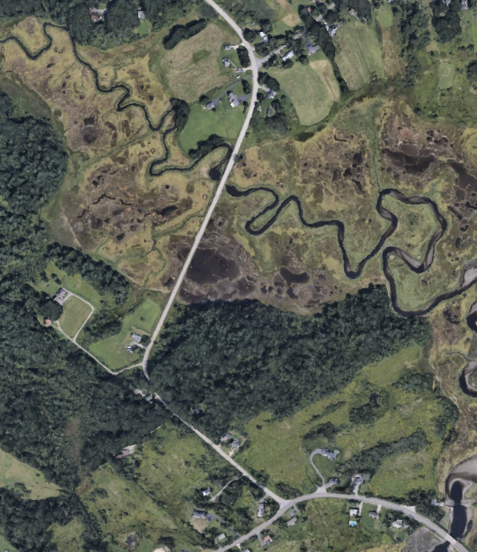
Background information

Culvert Assessments:

- In 2017, The Maine Department of Transportation inspected the culvert and noted the following deficiencies:
  - Holes in the top of the culvert,
  - Pipe corrosion along bolt lines,
  - Need for additional rip-rap at inlet/outlet.

- In 2018/2019, Cape Elizabeth performed a Town-wide culvert and habitat assessment study to inventory and evaluate critical infrastructure. Sixteen culverts/crossings were studied in the report, one of which was the Sawyer Road culvert. The report notes that the Culvert’s features are as follows:
  - Installation date: 1997
  - Pipe Type: Corrugated Metal Arch Pipe
  - Size: 11”-6” Wide by 10’-6” High

As a result of the 2017 and 2019 assessments, this culvert was referred for additional study.

• 2019 Sawyer Road Culvert Tidal Crossing Assessment:

With funding from the Maine Coastal Program, Acadia Civil Works was retained to study the Sawyer Road culvert. The report includes valuable hydraulic modeling of the marsh, a range of sea level rise predictions and two scenarios to replace the culvert. Option A (80’ span) has an estimated cost of $2 - 3 million. Option B (140’ span) costs range in the $3.5 - 5.5 million. Both options would need to include an additional $600,000 - $900,000 in road improvement costs.

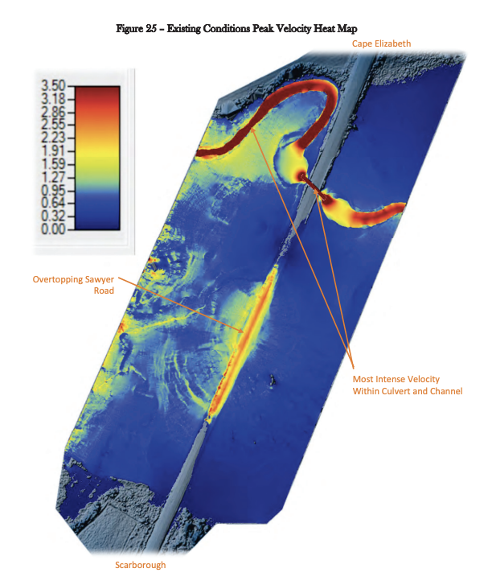

Climate Change:

A key takeaway is that given sea level rise increases, even with this magnitude of infrastructure investment, Sawyer Street is likely to continue flooding. The more ambitious Option B may not preserve the roadway past 2080. Adding 7’ of fill needed to raise the road above 50-year flood levels, estimated at 12.8’ (see page 5-9 of report), would become problematic as that quantity of fill would sink into the marsh.

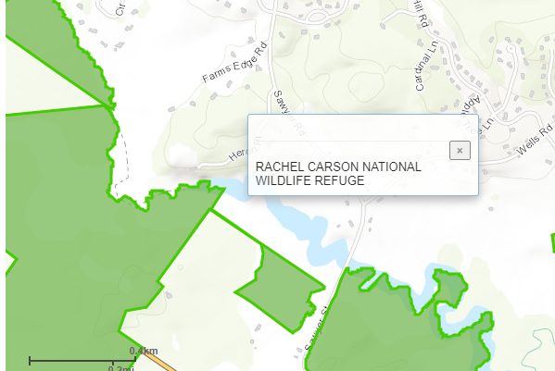
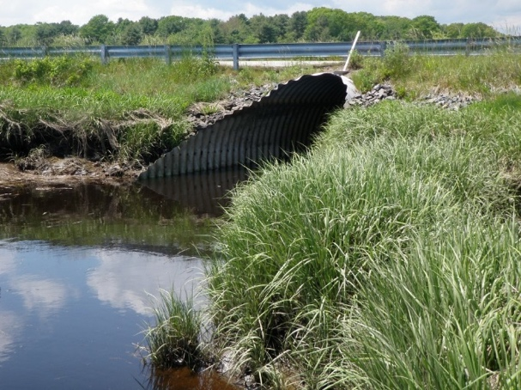
Sawyer Road Culvert (outlet/
downstream side)

Surrounding Area Info:

Several tracts of land within the floodplain are part of the Rachel Carson National Wildlife Refuge. The Spurwink River is considered a habitat area for:
- Fish and aquatic organisms,
- Wading waterfowl and birds, and
- Other wildlife

Capital improvement Pause:

If there is interest in reliably preserving access across the marsh in this location, a causeway is a better approach, both from an infrastructure life span and environmental impacts perspective. (It is assumed a causeway will cost more that Option A or B). With the large amount of funding investment and limited life span under discussion, it makes sense for the communities to pause and consider how important Sawyer Street/Road is to the transportation network in both communities.

Joint staff meeting:

On January 12, 2022, Scarborough and Cape Elizabeth staff met (via zoom) to jointly talk about Sawyer Road/Street. Attending the meeting from Cape Elizabeth included Town Manager Matt Sturgis, Public Works Director Jay Reynolds, and Town Planner Maureen O’Meara. Attending the meeting from Scarborough included Town Manager Tom Hall, Public Works Director Mike Shaw, Town Engineer Angela Blanchette and Sustainability Coordinator Jami Fitch.

Town Council Discussion Topics

Accessibility: The municipal boundary follows the river, resulting in approximately 1,100’ of the marsh portion of Sawyer Road in Scarborough and 300’ in Cape Elizabeth. There are 8 homes accessing Sawyer Street on the Scarborough side and 3 homes accessing Sawyer Road on the Cape Elizabeth side. Vehicular access for all of these homes can be maintained without retaining the portion of Sawyer Street/Road located in the marsh.

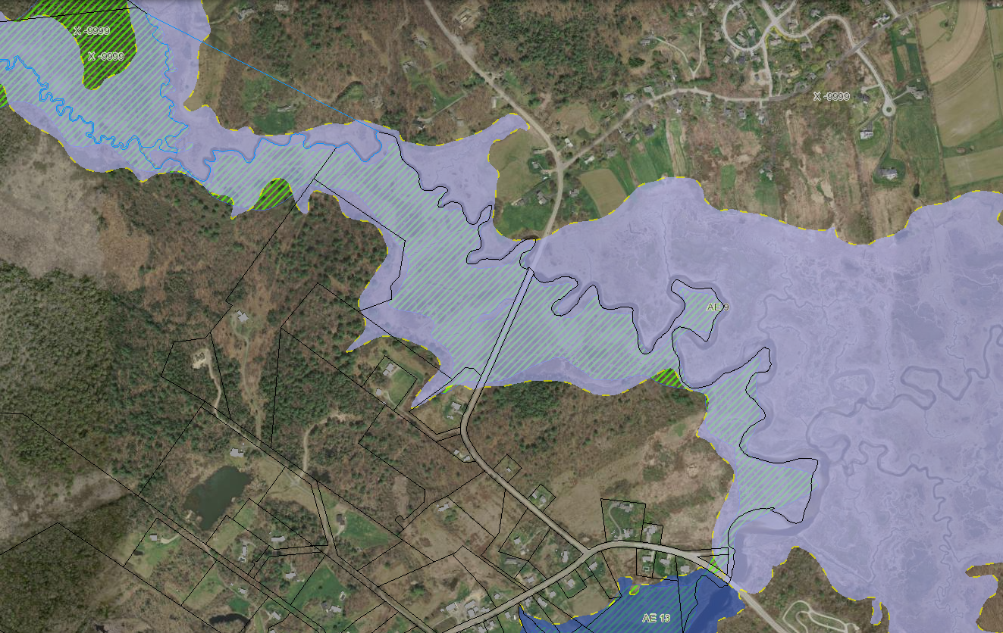
FEMA Flood Mapping (Existing and Proposed)

Vehicular Traffic Information: Sawyer Road’s historical traffic counts have resulted in the following Average Annual Daily Traffic Volumes (AADT), which appear to suggest a downward trend:
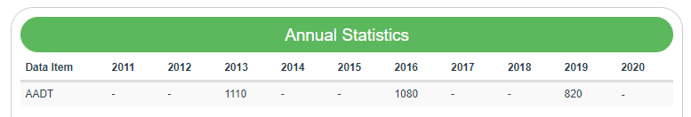

Prioritization: Is infrastructure investment in Sawyer Street/Road the highest priority as we adapt to sea level rise? In Cape Elizabeth, Spurwink Avenue is also threatened by sea level rise and any infrastructure funds not invested in Sawyer Road can be redirected to improvements and protection of Spurwink Avenue. Additionally, Spurwink Avenue ranks higher from an emergency management standpoint, as flooding at this location would cut off several essential services to the community and is also considered locally as an evacuation route (reference: Cumberland County Hazard Mitigation Plan). Additional prioritization can be evaluated utilizing the recent Cape Vulnerability study. In Scarborough, significant existing infrastructure along major arterials like Route 1 will need to be adapted for sea level rise.

Next Steps

Both municipalities may want to jointly agree to study the option of planned removal of the portion of Sawyer Road/Street located in the marsh. A study should include:

•Traffic study of impacts on area circulation, including emergency services (note that Sawyer Street is currently impassable during certain weather emergencies)
•Environmental impacts
•Public information/outreach
•Conceptual Project Scoping:
  - What would a road closure would look like? (Removal of road base, abandon in place, turnarounds, trail/river access, other?)
  - Conceptual Timeline and Opinion of Cost
  - Summary of Funding Opportunities

•Presentation meetings with both communities

Given the significance of the Scarborough Marsh as a Focus Area of Statewide Ecological Significance, staff are optimistic that grant funding can be obtained for the bulk of the study.
Jacob Aman, with the Wells National Estuarine Research Reserve (WNERR), has been instrumental in obtaining funding for infrastructure assessments and is on standby to assist with this study.

