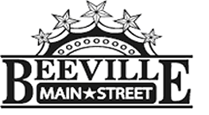

Beeville Main Street Advisory Board
Beeville Community Center
111 E. Corpus Christi Street

July 31, 2017 @ 12:00pm
Special Called Meeting
Agenda

- Call To Order.
- Hearing of Visitors.
- Discussion and possible action on approval of minutes.
- Discussion and possible action on recommendation to TIF for The City of Beeville Main Street Business Improvement Grant in the amount of $5,907.15 submitted by Hattie & Hazel's Catering.
- Discussion and possible action on recommendation to TIF for The City of Beeville Main Street Business Improvement Grant in the amount of $4,924.85 submitted by Glamour Bee.
- Discussion on developing long and short term goals for Beeville Main Street.
- Adjournment.
Next Meeting: August 25, 2017 at 12:00pm.

