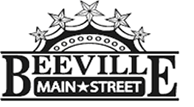

Beeville Main Street Advisory Board
Beeville Community Center
111 E. Corpus Christi Street

March 24, 2017 @ 12:00pm
Agenda

- Call To Order.
- Hearing of Visitors.
- Discussion and possible action on approval of minutes.
- Discussion and possible action on façade alterations at 115 N. Washington Street for Certificate of Appropriateness.
- Discussion and possible action on recommendation for TIF Business Improvement Grant application for Travis Arreaga at 115 N. Washington Street.
- Discussion of Beeville Main Street Community Survey.
- Discussion on developing long & short term goals for Beeville Main Street.
- Discussion and action on activities for National Preservation Month in May.
- Adjournment.
Next Meeting: April 28, 2017 at 12:00pm.

