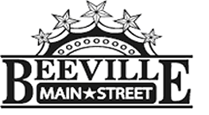

Beeville Main Street Advisory Board
Beeville Community Center
111 E. Corpus Christi Street

June 24, 2016 @ 12:00pm
Agenda

- Call To Order
- Hearing of Visitors
- Discussion and possible action on approval of minutes.
- Discussion and possible action on Business Façade Grants and New Business Growth Downtown Incentive.
- Adjournment.
Next Meeting: July 29, 2016 at 12:00pm.

