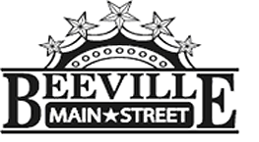

Beeville Main Street Advisory Board
Beeville Community Center
111 E. Corpus Christi Street

May 27, 2016 @ 12:00pm
Agenda

- Call To Order
- Hearing of Visitors
- Administer the Oath of Office to members of the Beeville Main Street Advisory Board.
- Discussion and possible action on approval of minutes.
- Discussion and possible action on developing Beeville Main Street’s Core Values.
- Discussion on possible action on Bee City USA and National Pollinator week.
- Adjournment.
Next Meeting: June 24, 2016 at 12:00pm.

