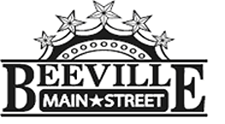

Beeville Main Street Advisory Board
Beeville Community Center
111 E. Corpus Christi Street

April 1, 2016 @ 12:00pm
Agenda

- Call To Order
- Hearing of Visitors
- Discussion and possible action on approval of minutes.
- Discussion on the promotion & recruitment activities for Main Street Volunteers.
- Discussion on establishing a Design, Organization, Promotion, and Economic Committees.
- Discussion on developing Beeville Main Street’s Core Values.
- Discussion and possible action on National Preservation Month activity for Beeville Main Street.
- Discussion and Action on Bee City USA.
- Adjournment.
Next Meeting: April 22, 2016 at 12:00pm.

