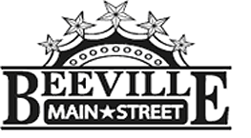

Beeville Main Street Advisory Board
Beeville Community Center
111 E. Corpus Christi Street

December 18, 2015 @ 12:00pm
Agenda

- Call To Order
- Hearing of Visitors
- Discussion and possible action on approval of minutes.
- Discussion on Small Business Saturday Campaign on November 28th.
- Discussion and possible action of Shop Downtown Campaign Logo.
- Discussion on Façade Business Improvement Grants for Beeville.
- Discussion with planning activities that coincide with the Texas Mile and Bee County Historical Society’s Living History Celebration Events.
- Adjournment.
Next Meeting: January 22, 2015 at 12:00pm.

