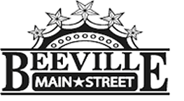

Beeville Main Street Advisory Board
Beeville Community Center
111 E. Corpus Christi Street

October 29, 2015 @ 12:00pm
Agenda

- Call To Order
- Hearing of Visitors
- Discussion and possible action on approval of minutes.
- Discussion on the Main Street Advisory Board Work Plans and 4 Point Approach Committees.
- Discussion and possible action of Shop Downtown Campaign Logo.
- Discussion of Small Business Saturday Campaign.
- Adjournment.
Next Meeting: November 20, 2015 at 12:00pm.

