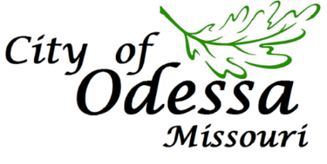
PO Box 128 • 125 S Second • Odessa, MO 64076
Phone: (816) 230-5577 • Fax: (816) 633-4985 • www.cityofodessamo.com

NOTICE OF BUDGET WORK SESSION

NOTICE is hereby given to all citizens and parties in interest that the Odessa Board of Aldermen will meet for a Budget Work Session at 5:30 pm on Monday, February 8,2021, at Dyer Park Community Building, 601 West Main Street, Odessa, Missouri 64076

CALL TO ORDER | Mayor Stephen Couch
ROLL CALL | City Clerk Peggy Eoff
DISCUSSION: | Employee recruitment/retention  - Salary schedule update  - Insurance cost impacts  - LAGERS options  Organizational Chart/Reconfiguration  Personnel Needs  Long term debt obligations
February 8, 2021 – Board of Aldermen Regular Session – 7:00 pm Community Building
February 15, 2021 – President’s Day – City Offices Closed
February 16, 2021 – Municipal Court – 1:30 pm Community Building
February 18, 2021 – Planning & Zoning Commission Regular Session - 7:00 pm Community Building
February 22, 2021 – Board of Aldermen Regular Session – 7:00 pm Community Building
February 23, 2021 – Parks & Recreation – 7:00 pm Community Building

ELECTED OFFICIALS
 | Mayor Stephen Wright | steve.wright @cityofodessamo.com | (816) 918-6634
Ward 1 | Alderwoman Mickey Starr | mickey.starr@cityofodessamo.com | (816) 260-8448
Ward 1 | Alderman Steve Lockhart | steve.lockhart@cityofodessamo.com | (816) 263-3939
Ward 2 | Alderman Ron Finn | ronald.finn@cityofodessamo.com | (816) 564-9709
Ward 2 | Alderman Tom McElwee | tom.mcelwee@cityofodessamo.com | (816) 305-8784
Ward 3 | Alderman Ray Harves | ray.harves@cityofodessamo.com | (816) 524-6311
Ward 3 | Alderman Mike Stevens | mike.stevens@cityofodessamo.com | (816) 674-6222

Posted February 5, 2021
Copies of this agenda may be obtained by contacting:
Peggy Eoff, City Clerk
Phone: (816) 230-5577 | Fax: (816) 633-4985 | www.cityofodessamo.com

